A compressed variance component mixed model framework for detecting QTNs, QEIs, and QQIs in GWAS
Yuan-Ming Zhang*, Mei Li, Ya-Wen Zhang and Ya-Hui Zhou
Huazhong Agricultural University, China
Abstract
Although genome-wide association studies are widely used in mining genes for quantitative traits, effects to be estimated are confounded and methodologies of detecting interactions are imperfect. To address these issues, first, the mixed model proposed here estimates genotypic effects, while genotypic polygenic background replaces additive and dominance polygenic backgrounds. Then, genotypic effects estimated are partitioned into additive and dominance effects using one-way ANOVA model. This strategy was further expanded to cover QTN-by-Environment Interaction (QEI) and QTN-by-QTN Interaction (QQI). Thus, a three variance components mixed model was integrated with mrMLM to establish a new methodological framework that detects all types of loci and estimates their effects, conditional on fully controlling all the possibly polygenic backgrounds. This method named 3VmrMLM (Figure 1). In Monte Carlo studies, 3VmrMLM correctly detected all types of loci and almost unbiasedly estimated their effects, with high powers and accuracies and low false positive rate. In the re-analyses of ten traits in 1439 rice hybrids, 269 known genes, 45 known gene-by-environment interactions and 20 known gene-by-gene interactions strongly validated 3VmrMLM. Further analyses of known genes showed more small (67.49%), minor allele frequency (35.52%), and pleiotropic (30.54%) genes, with higher repeatability across datasets (54.36%), and more dominance loci. Heteroscedasticity mixed model and dimension reduction methods in multiple environments were developed to detect QEI, while variable selection under polygenic background was proposed to detect QQI. To facilitate the implement of the 3VmrMLM method in GWAS, we developed IIIVmrMLM as R and C++ tools, which can be downloaded from GutHub website (https://github.com/YuanmingZhang65/IIIVmrMLM). Meanwhile, the compressed mixed model was incorporated into our GCIM to propose GCIM-QEI-random and GCIM-QEI-fixed, respectively, under random and fixed models of genetic effects in immortalized F2 and F2:3 designs. GCIM-QEI-random was slightly better than GCIM-QEI-fixed. This study provides a new approach to reveal the genetic architecture of quantitative traits.
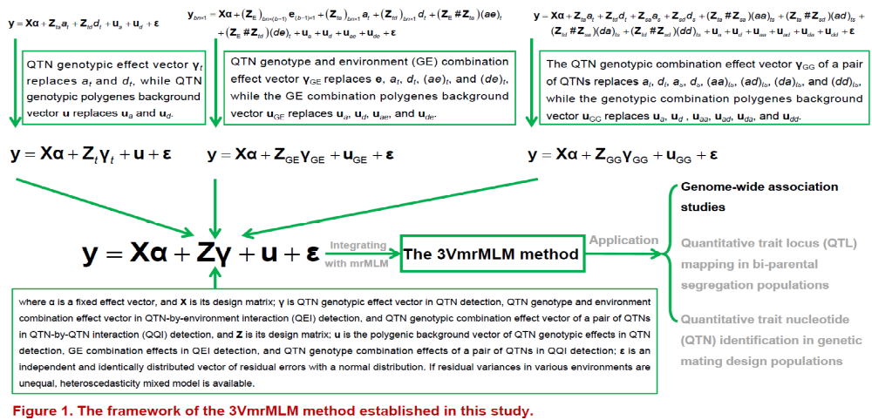
Figure 1. The framework of the 3VmrMLM method established in this study.
Biography
Yuan-Ming Zhang is currently a Professor of College of Plant Science and Technology at Huazhong Agricultural University in China. He received his M.S. and PhD at Nanjing Agricultural University in 1992 and 2001, respectively. He received a B.S. from Southwest Agricultural University at Agronomy in 1986. His research interest includes quantitative genetics and bioinformatics. He is a director of Crop Information Center at Huazhong Agricultural University. He is the author or coauthor of more than 90 SCI papers in international refereed journals. He has given several talks at international conferences. He is also Associate Editor of Heredity and BMC Genomics.

