Characterization of Oreochromis niloticus fish species of Lake Kariba, Zambia, using morphological, meristic and genetic methods
Mauris Chinyama Makeche¹*, Tamuka Nhiwatiwa¹, Joseph Ndebe², Malala Mulavu², Cynthia Sipho Khumalo², Edgar Simulundu², Katendi Changula², Simba Chitanga², Benjamin Mubemba³ and Walter Muleya²
¹University of Zimbabwe, Zimbabwe
²University of Zambia, Zambia
3Copperbelt University, Zambia
Abstract
This study aimed at characterizing Oreochromis niloticus fish species of Lake Kariba and was premised on the hypothesis that there are different types of O. niloticus fish species in Lake Kariba. O. niloticus fish specimens (n=409) were collected from both culture fisheries (Yalelo fishery, Fwanyanga fishery and Choombwe fishery) and capture fisheries (Siavonga and Sinazongwe) based at Lake Kariba from April to November, 2020. All the collected fish samples were used for phenotypic characterization while 98 were used for genetic characterization. A total of 23 morphometric measurements and 7 meristic counts were used to generate morphometric data which was analyzed using multivariate analysis. In order to delineate the sampled specimens, dendrograms were generated. Further, microsatellite data was generated from 98 samples using a panel of 5 microsatellite [Table 1] markers and analyzed using microsatellite toolkit, GenAIEx, Fstat, and LIAN software’s. Meristic results of culture fisheries showed that the sampled fish could be characterized into two strains while samples from capture fisheries could be characterized into four strains. On the other hand, morphometric characterization of fish from both culture and capture fisheries grouped the fish into three strains. In addition, population genetic analysis also showed that aquaculture farmers of Lake Kariba are rearing three populations of O. niloticus while those from capture fisheries are composed of many distinct variant fish strains but can be roughly grouped into two types of O. niloticus fish species. The population of O. niloticus from the wild are genetically diverse, sub-structured with an absence of panmixia and are present in all fisheries. In conclusion, the fisheries understudy possessed potentially three strains of O. niloticus segregated in approximately three populations [Figure 1].
Table 1. Panel of microsatellites used in this study.
Primer  name | Primer sequences (5’ to 3’) | Chromosome | Base-pair range | Annealing  Temperature (℃) | Fluorescent dye type
UNH172 | F: AATGCCTTTAAATGCCTTCA  R: CTTTTATAGTCGCCCTTTGTTA | LG 3 | 119-194 | 52 | PET
UNH178 | F: GTCACACCTCCATCATC  R: AGTTGTTTGGTCGTGTAAG | LG 11 | 114-144 | 50 | VIC
UNH203 | F: CACAAAGATGTCTAAACATGT  R: GAATTTGACAGTTTGTTGTTTAC | UNK 1 | 65-97 | 58 | VIC
UNH858 | F: TTCAAACAGCTTCACGGTCA  R: CTATGCCATGGCTAAAGTCAC | LG 7 | 196-252 | 44 | 5-FAM
UNH991 | F: AAGCCTTGCATAAAACAGCA  R: AAAGTTTGCTGCCCTCAGTG | LG 5 | 150-182 | 44 | 5-FAM
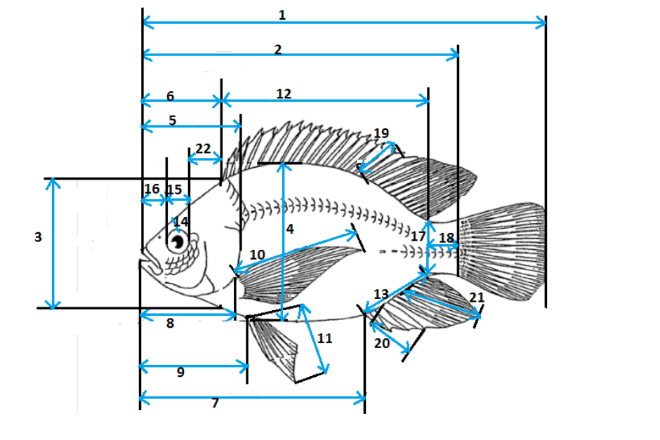
Figure 1. Diagram of fish morphometric measurements.
Biography
Mauris Chinyama Makeche was born on 19th March, 1985 in Mufumbwe, North-Western Province in Zambia. He started his primary School at Kashima West Basic School in 1992. He then proceeded to Kabompo Boarding Secondary School in 2001. He was enrolled to the University of Zambia in 2005 and graduated in 2009 with a Bachelor of Science in Biology. He worked as a Teacher of Biology at Arakan Boys Secondary School in Lusaka, Zambia from 2010 to 2019. He enrolled for his Master of Science in Tropical Ecology and Biodiversity at the University of Zambia and graduated in 2017. He is currently studying his Doctor of Philosophy (PhD) of Science at the University of Zimbabwe. He is working as a Lecturer of Biology at Levy Mwanawasa Medical University in Lusaka, Zambia.

