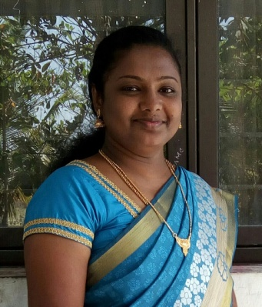
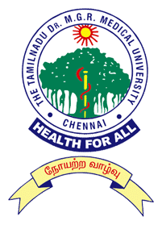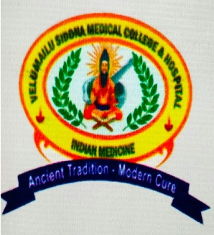
Paste your Photograph Here

Title: An Open Clinical Trial of Psoriasis with Siddha (Herbal) Medicine and Yoga Therapy.
Name: Dr. R. Ramya,M.D(Siddha)
Velumailu Siddha Medical College, Sriperumbudur,
The TamilnaduDr.M.G.R. Medical University, Chennai-32, Tamil Nadu, India

Psoriasis (Kalanjagapadai) is a chronic skin disease that can have substantial psychological and social impact on a patient's life, similar to the effects of other chronic diseases such as depression, myocardial infarction, hypertension, etc. Psoriasis represents a significant public health challenge, affecting approximately 125 million people globally.

In an open clinical trial, 40 psoriasis patients of both genders underwent Siddha treatments, 20 patients in IPD and 20 in OPD. The level and stages of infection varied among the patients that were part of the trial.

Out of the 20 IPD patients who took ThippiliyathiChooranam (an herbal formulation of piper longum, piper nigrum, zingiberofficinale and other ingredients), and externally applied ValuzhuvaiThylam (contains celastruspaniculatus, foenicum vulgare, cyperusrotundus amongst others), 10 patients underwent yogam treatments, in addition to the same internal medicine treatment as other patients.
It was found that yogam treatments, along with siddha medicine,were much more effective in the treatment of psoriasis. Both stress and clinical symptoms were reduced to a much greater extent after yogam therapy.

The results were observed by PASI score. Among the 40 cases treated, 57.5% cases had shown Good improvement, 22.5% cases had shown Moderate Improvement and 20% had shown Poor improvement. Out of the patients who underwent yogam therapy along with the medication, it was found that 85% responded well.

Biography

Dr. R. Ramya completed her Doctor of Medicine M.D. (Siddha) at the age of 25 from National Institute of Siddha. She did her Bachelors of Siddha Medicine and Surgery (BSMS) at Velumailu Siddha Medical College, which she qualified with distinction and stood first in the University (Tamil Nadu Dr. M.G.R. Medical University). She is now working as the Assistant Professor at Velumailu Siddha Medical College. She has published few papers in reputed journals and presented papers in different forums and conferences. Mail ID ramyamanic@gmail.com Contact No 8056255072.

