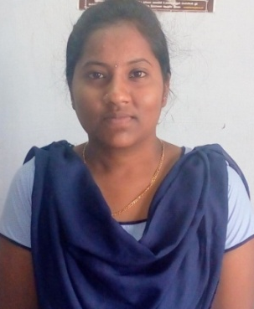
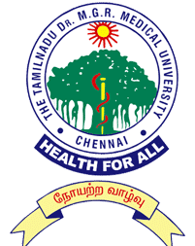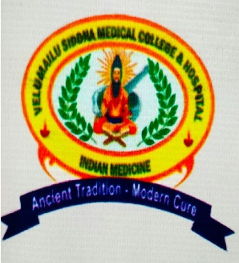
Title: A Review on Integrative Psychiatry in Siddha System
NAME: Rohini Priya. R
Velumailu Siddha Medical College & Hospital, Sriperumbudur- 602105, The Tamilnadu Dr. MGR Medical University, Chennai, Tamil Nadu, India.

Siddha system of medicine is one of the ancient systems of medicine practised in southern part of India. The state of complete physical, mental and social well being of a person is defined as health. Impairment of personal functioning, disordered behavioural and mental pattern is termed as psychiatric disorders which occur due to bio psychosocial illness. Globally an estimation of about 322 million people is reported to be affected by mental illness. It is a major public health problem contributing to significant morbidity as well as mortality along with significant socioeconomic losses. The Siddha psychiatry is based on mind (manam), thought (buththi), mood (ahangaram) and physical behaviour (siddham). According to Siddha system, psychiatric diseases are treated by enhancing the power of brain by external therapeutic measures like Thuvalai (herbal powder with oil applied all over the body), Pugai (fumigation), Nasiyam (Nasal drops), and Kalikam (external medicines of eye) unlike conventional system of medicine which depresses the brain activity. The therapeutic application of these methods and certain yoga procedures opens up an innovative window for the treatment of psychiatric disorders via therapy involving Central Nervous System. Upon analysing this procedure it has been found that these siddha external therapies are formulated in such a way to alleviate the altered humors (mukkutram) and to strengthen the saptha thadhus (Physical constituents). Hence the review about these traditional methods can contribute better quality of life to Psychiatric patients and can provide a way out towards the prevention and management of Psychiatric diseases.
Biography:
Rohini Priya. R is presently graduating her UG degree Bachelor of Siddha Medicine and Surgery (BSMS) final year from Velumailu Siddha Medical College, The Tamilnadu Dr. MGR Medical University, India. She has published a paper during the year 2017 in a journal called Siddha papers. She has also performed a poster presentation at ‘National Conference on Pura Maruthuvam- External therapies in Siddha System of Medicine’ (NCPM-2017) and oral presentation at ‘World Congress on Holistic Health’-2018. Email ID: 13rohu@gmail.com , velumailusiddha@yahoo.in, Contact number: +919500783838.

