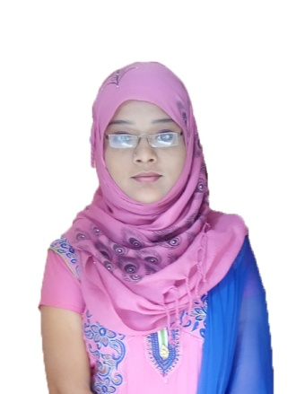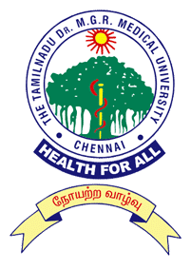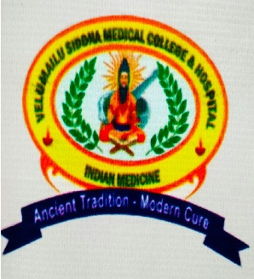

Title: Holistic Management of Cardiovascular Diseases, a Lifestyle Disorder- A Review
Name: Aathifa Anjum. K
Velumailu Siddha Medical College & Hospital, Sriperumbudur- 602105, The Tamilnadu Dr. MGR Medical University, Chennai, Tamil Nadu, India.

About thousands of years ago, an ancient traditional system of medicine emerged in the southern parts of India called Siddha system of medicine which treats not only the symptoms of a disease, but also brings the causative, mental, physical and social factors into account thus maintaining the mind-soul relationship. As per WHO, more than 17.7 million people died due to the catastrophic cardiovascular disease around the globe annually exemplifying 31% of all global deaths. Rather than much advancement in science and technology, the deaths are increasing day by day because of the sedentary lifestyle employed by human beings. The father of the Siddha medicine, sage Agasthiyar has indicated a medicinal formulation named SAARTHOOLATHI KULIGAI (based on Tamil literature) made from thirteen herbal drugs is found to have a stupendous effect on a CVD patient, as each of the herbal drug used in this combination has similar medicinal properties like anti-atherosclerotic activity, cardio-protective activity, anti-hypertensive activity, etc., that are necessarily required for the treatment of this disease. This work also compiled information from various literatures in Siddha system like yoga, pranayama, classical text of sage Thirumoolar and from various research articles to excavate the scientific correlation behind them. The goal of this literature review is to bring out a holistic approach for CVD patient by implementing the overall regimen used in Siddha system which will pave a better way for preventing and managing cardiovascular diseases.
Biography:
Aathifa Anjum. K is presently graduating her UG degree Bachelor of Siddha Medicine and Surgery (BSMS) final year from Velumailu Siddha Medical College, The Tamilnadu Dr. MGR Medical University, India. She has published a paper during the year 2017 in a journal called Siddha papers. She has also performed an oral presentation at ‘National Conference on Pura Maruthuvam- External therapies in Siddha System of Medicine’ (NCPM-2017) and oral presentation at ‘World Congress on Holistic Health’-2018. Email ID: aathifakhader96@gmail.com, velumailusiddha@yahoo.in , Contact number: +919751711874.

