Effect of Denosumab Versus Zoledronic Acid on Calcium Levels in Cancer Patients with Bone Metastasis. An Observational Retrospective Cohort Study
Sahar S Nasser, BPharm, PGY-1, HMC, Qatar
Arwa O Sahal, BPharm, PharmD, HMC, Qatar
Anas A Hamad, BPharm, PharmD, PhD, MSc, HMC, Qatar
Shereen A ElAzzazy, BPharm, PharmD, HMC, Qatar

Abstract (300 word limit)

Background: Bone-targeting agents (BTA) like Zoledronic acid (ZA) and Denosumab (DE) are approved for prevention of skeletal-related events (SREs) in patients with Bone Metastases (BM) including hypercalcemia of malignancy (HCM). Hypocalcemia has been observed with both ZA and DE. However, Studies showed a higher incidence of hypocalcemia with Denosumab. International guidelines do not favor one BTA over the other. Due to the differences in patients’ characteristics and treatment related factors; hypocalcemia incidence might differ in varying Cancer settings. The primary objective: to identify the incidence of hypercalcemia and hypocalcemia in ZA and DE groups. Secondary objective: to identify the correlation between calcium supplement and calcium level control. Methods: An observational retrospective cohort study, conducted by reviewing patients’ electronic records, laboratory and medication reports from August 1st 2015 till July 31st 2016. Adult Cancer patients diagnosed with BM secondary to a solid tumor or Multiple Myelomas and receiving either ZA or DE were included. Other indications for BTA were excluded. BTA administration visits were collected, evaluated and analyzed. Results: A total of 271 patients (1367 visits) were included in our study. Over Incidence of hypocalcemia in DE group compared to ZA was (4.1% vs 3%, OR=0.72, CI 95% [0.43 – 1.19]). Hypercalcemia was reported in both groups (3.5% vs 5.3% respectively, CI 95% [0.97 – 2.4]). Breast cancer was the most common malignancy associated with hypocalcemia (70%) followed by (10%) in both prostate cancer and Multiple myelomas. Patients received calcium supplement were 23% less likely to develop hypocalcemia (RR= 0.77, CI 95% [0.48 – 1.23]). Conclusion: Despite hypocalcemia was common in DE group, it was not statistically significant. Adequate calcium intake substantially reduces the risk of hypocalcemia. Our results highlight the importance of preventing hyper and hypocalcemia upon BTAs initiation and during treatment by regular monitoring of calcium levels, and providing calcium supplements accordingly.

Image
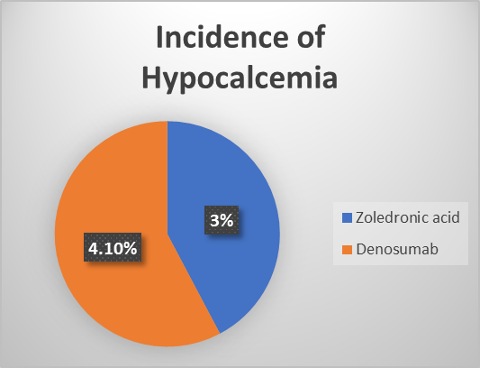

Recent Publications (minimum 5)
Non published yet

Biography (150 word limit)
Sahar Nasser received her bachelor degree in pharmacy from Qatar University, college of pharmacy (CCAPP accredited) in 2011. She began her pharmacy career in the National Center of Cancer Care and Research (NCCCR). She is also a clinical preceptor for undergraduate pharmacy students and got promoted to senior pharmacist in 2015. She is recently completing her post graduate year 1 (PGY1) pharmacy practice residency in Hamad medical corporation (in candidate status for accreditation by ASHP). Her early-career focus was on patient centered care practice and medication safety. Throughout her career, she participated in various educational activities directed to healthcare providers, students and patients. Her main research interest is in improving cancer patients’ outcomes and cancer epidemiology.
.
Email: snasser1@hamad.qa

Notes/Comments

