CLINICAL PHARMACIST’S INVOLVEMENT IN HYPERTENSION MANAGEMENT AMONG WOMEN IN TERTIARY CARE HOSPITAL

Jeevana Jyothi B. Ph.D, Sri Padmavati MahilaVisvavidyalayam (Women’s university); INDIA

ABSTRACT:
Hypertension is an important risk factor for cardiovascular disease (CVD), affects 31% of adults 18 years and older and contributes to coronary heart and cerebrovascular disease, the leading causes of death in women. The present study was to assess the effect of clinical pharmacist’s education and involvement in management of hypertension among women population in a tertiary care setting. The study was approved by the ethical committee (ECR/102/Inst/TN/2013). It was prospective interventional study was conducted for a period of six months in OBG department of a tertiary care hospital. Self-designed questionnaires were used to collect patient demographic and medical details from women at age group of 18 to 60 years. Participants were allocated randomly into test and control group. Student paired ‘t’ test was used to compare the groups before and after the intervention. p < 0.05 was considered statistically significant. A total of 125 hypertensive women were enrolled for this study. 64 patients enrolled in the test group and 61 enrolled in the control group. On measuring the baseline blood pressure, the mean systolic blood pressure (SBP) was 13.4 mmHg in test group and 9.0mmHg in control group. After intervention and education given through neatly prepared suuggestions about exercise, diet management and life pattern the mean SBP +-+ c The mean SBP in test group was found to be 4.5 in test group and 7.5 in control group. The study was found to be significant with p value <0.05. The study highlights the need of pharmaceutical care provided by a clinical pharmacist achieved a significantly greater benefit in blood pressure reduction and control.
Fig.1

HOW TO MANAGE BLOOD PRESSURE?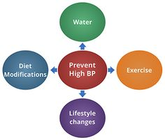  - Get adequate sleep at least 8 hours a night.  - Restrict salt intake upto 2-3 grams per day.  - Don’t allow yourself to be exposed passively to smoke.  - Avoid caffeine and artificial coloring in fluids  - Avoid oily, spicy food as well as excessive intake of sweets. | 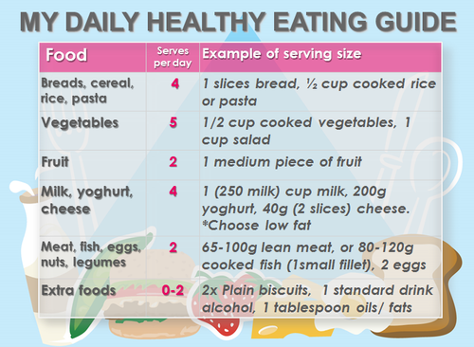 | EXERCISES FOR A HEALTHY POST- MENOPAUSE    Exercise increases your cardiovascular output.  Boosts your respiratory system.  Minimize midlife weight gain.  Increases bone mass.  Essential for Vulvo-vaginal health.  Reduces lower back pain.  Helps to reduce stress.  Increases your concentration.  Cuts down risk of mood swings.  Gives confidence.

RECENT PUBLICATIONS:
- Bateman BT, Shaw KM, Kuklina EV (2012) Hypertension in women of reproductive age in the United States, PLoS ONE 7; 361-71.
- Erdine S, Arslan E, Olszanecka A (2012) Hypertension in women-pathophysiological and clinical aspects, Przegl Lek 69;72-75.
- Mosca L, Benjamin EJ, Berra K (2011) Effectiveness-based guidelines for the prevention of cardiovascular disease in women 2011 update: a guideline from the American Heart Association, Circulation 123;1243-1262.
- Basu R, Franzini L, Krueger PM (2010) Gender disparities in medical expenditures attributable to hypertension in the United States, Womens Health Issues 20;114-125.
- Phayom Sookaneknun, Robert ME Richards, Jaratbhan Sanguansermsri, and Chai Teerasut (2004) Pharmacist Involvement in Primary Care Improves Hypertensive Patient Clinical Outcomes, The Annals of Pharmacotherapy 38;2023-28.

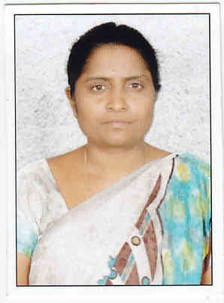Biography: Prof. B.JEEVANA JYOTHI completed B.Pharmacy and M.Pharmacy in Andhra University and Ph.D in Sri Padmavati Mahila Viswavidyalayam (Women’s university). She has teaching experience of 25 years. Expertise in development of nanotechnology based drug delivery systems and novel formulations of anticancer drugs. Her contribution towards the development of formulation of targeted drug delivery systems of curcumin and tenoxicam helps the present miserable and prevalent problem of rheumatoid arthritis. Published 19 research articles in Scopus indexed journals and one Book publication entitled “manual of Pharmaceutical Engineering” which is a prescribed book in INDIA and in use by all pharmacy students of INDIA. Served as Head of the Department of Pharmacy, Sri PadmavatiMahilaViswavidyalayam, during 2009 and 2012 and as BOS Chairperson during 2010 and 2013.

Contact number: +919705988430
Email Id: jeevanajyothi@yahoo.com
Category: Oral presentation (Poster)

