Transdermal patches of tenoxicam for treatment of Rheumatoid Arthritis
Jeevana Jyothi, B Ph.D, Sri Padmavati MahilaVisvavidyalayam (Women’s university); INDIA

ABSTRACT
Tenoxicam (TX) is NSAID indicated to treat rheumatoid arthritis (RA). It has drawbacks of poor solubility, GI irritation and first pass effect. Hence trandermal patches of tenoxicam were prepared and evaluated for treatment of rheumatoid arthritis. Initially to enhance solubility solid dispersions were prepared with polymers PEG 25000, sodium starch glycolate, PVPK-30 by solvent evaporation method. Three compositions were made with each polymer. Tenoxicam and PEG 25000 of 1:9 ratio exhibited highest percent drug release of 99.02±0.3% in 60 min. This dispersion equivalent to contain 20 mg of tenoxicam was prepared as transdermal patches by solvent casting method. Various formulations were tried using different ratios of polymers such as eudragit and HPMC K 400M. Dichloromethane: methanol (1:1) was used as solvent. Dibutyl phthalate and dimethyl sulfoxide were added as plasticizer and permeation enhancer respectively. Three formulations were obtained with optimum properties in terms of percentage drug content (97.04%-98.15%), thickness (1.147mm±0.021 to 1.333mm±0.021 surface pH (6.1 to 6.8), folding endurance (187 to 200). Ex- vivo permeation studies of a patch (TT3) containing HPMC K400M 100 mg and eudragit 50 mg exhibited optimum drug release of 98.35% in 60 min. Pharmacodynamic activity was assessed for this patch using male wistar albino rats. RA was induced by injecting bovine type II collagen emulsified with incomplete freund’s adjuvant. Lesions were observed on both hind paws for every two days after induction. After 14th day RA induced rats were applied with the patch at knee joint for Group-IV. At the end of the experiment radiographic analysis of normal and arthritic hind paws was performed by using X-ray machine. It was observed that both hind paws were swollen from 10thday of induction and after treatment the swelling in the hind paws of rats treated with tenoxicam patch was reduced compared to rats which were untreated.

Fig.:Cumulative % drug diffused from transdermal patches of tenoxicam
(TX=Tenoxicam; TT=Tenoxicam transdermal patch)

Fig.:Photograph and x-ray images of 4 groups of rats

Group | Photograph of |  |  | x-ray image of
Group | Right paw |  | Left paw | Right paw | Left paw
Control
I | 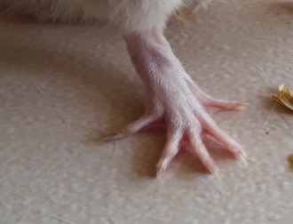 | 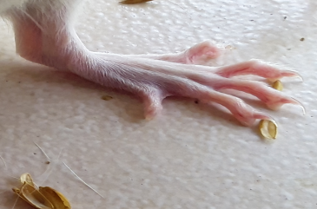 |  | 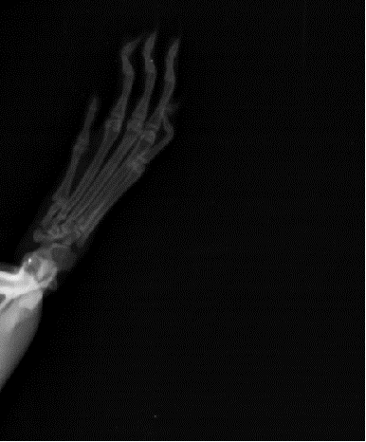 | 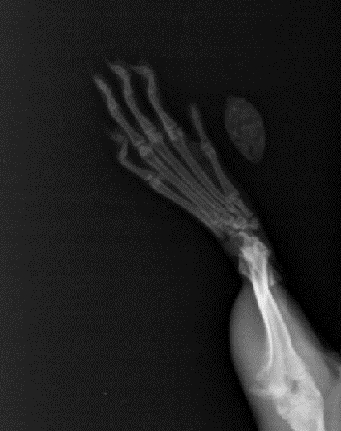
Disease control
II | 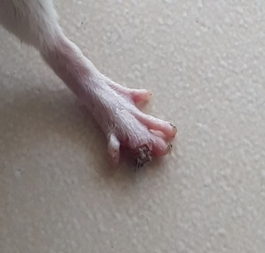 |  | 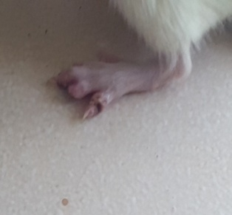 | 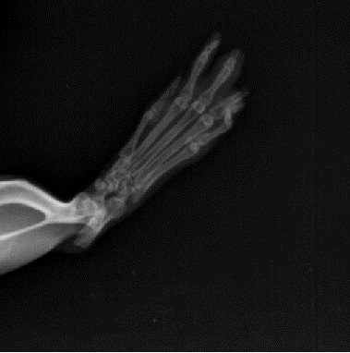 | 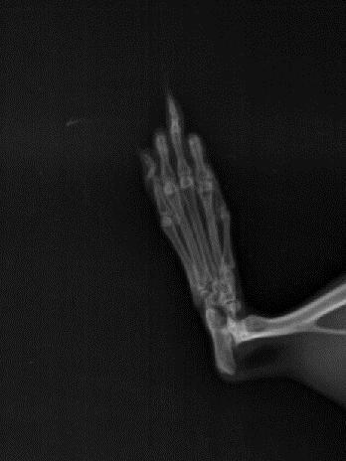
Induced and treated with standard
III | 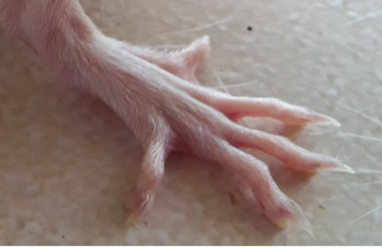 |  | 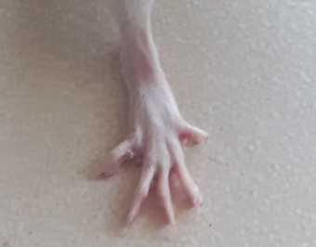 | 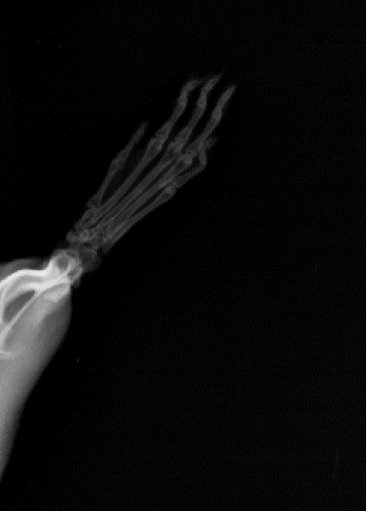 | 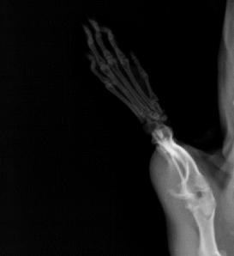
Induced andtreated with tenoxicam patch
IV | 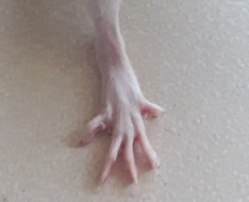 |  | 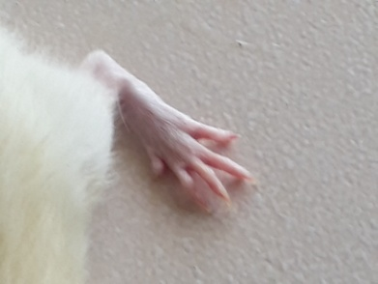 | 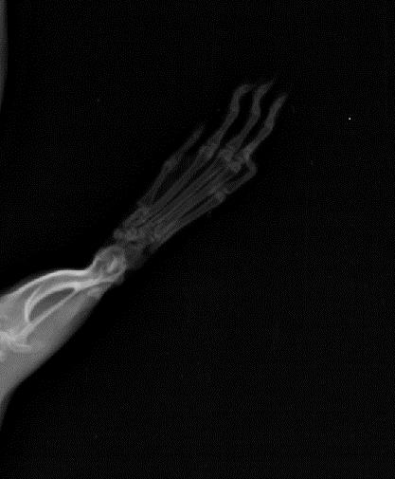 | 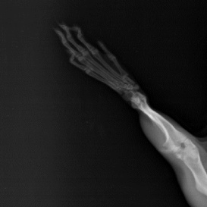

Recent Publications:
- JeevanaJyothi B., Guru Lakshmi.G(2014) In-vitro and In-vivo evaluation of transdermal prolonged release proniosomal gel formulations of Propranolol HCl” Int. Jl. of Drug development and research6(3);280-285.
- Jeevanajyothi B,Satya Sai Yogitha M (2016) Development and evaluation of prolonged release transdermal patches of losartan potassium, International research journal of Pharmacy 7(1);37-43
- Arun Prasad K, Narayanan N (2010) Preparation and evaluation of solid dispersion of terbinafine hydrochloride, International Journal of Pharmaceutical Sciences review and research 3(1), 130-134.
- Kunal N Patel, Hetal K Patel (2012) Formulation and characterization of drug in adhesive transdermal patches of diclofenac acid, International Journal of Pharmacy and Pharmaceutical Sciences 4(1), 296-299
- Yuxiu Zhang, DongmeiCun, Xin Kong (2014) Design and evaluation of a novel transdermal patch containing diclofenac and teriflunomide for rheumatoid arthritis therapy,Asian Journal of Pharmaceutical Sciences, 9(5);251–259.

Biography: Prof. B.JEEVANA JYOTHI completed B.Pharmacy and M.Pharmacy in Andhra University and Ph.D in Sri Padmavati Mahila Viswavidyalayam (Women’s university). She has teaching experience of 25 years. Expertise in development of nanotechnology based drug delivery systems and novel formulations of anticancer drugs. Her contribution towards the development of formulation of targeted drug delivery systems of curcumin and tenoxicam helps the present miserable and prevalent problem of rheumatoid arthritis. Published 19 research articles in Scopus indexed journals and one Book publication entitled “manual of Pharmaceutical Engineering” which is a prescribed book in INDIA and in use by all pharmacy students of INDIA. Served as Head of the Department of Pharmacy, Sri PadmavatiMahilaViswavidyalayam, during 2009 and 2012 and as BOS Chairperson during 2010 and 2013.

Contact number: +919705988430
Email Id: jeevanajyothi@yahoo.com
Category: Oral presentation (Poster)

