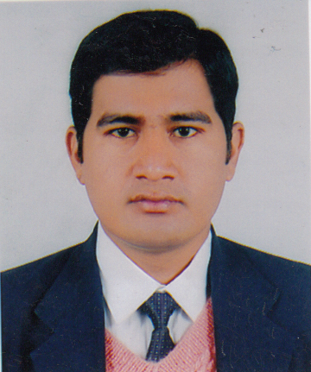

PRESCRIPTION AUDIT WITH SPECIAL EMPHASIS ON DRUG-DRUG INTERACTIONS STUDY IN A TERTIARY CARE TEACHING HOSPITAL

Name: Ajay Chandra

Norvic international hospital

Abstract
Drug–drug interactions (DDIs) may be defined as when two or more drugs interacting in such a manner that the effectiveness or toxicity of one or more drugs is altered. DDI in patients receiving multidrug therapy is a major concern. Although drug-drug interaction constitute only small portion of adverse drug reactions, they are often predictable and therefore avoidable or manageable. The aim of the present study was to assess the incidence and severity of DDIs in patients admitted in a tertiary care teaching hospital. A prospective, observational study was carried out for a period of 6 months (Jan–June 2013). During the study period, a total of 300 prescriptions were analyzed and was found that 242 prescriptions had DDI. The average number of drugs in each prescription was 8. Regarding the severity of clinical results, the interaction was classified as minor (114), moderate (447), major (40) from the 242 prescriptions. The 40 major DDI are reported from 32 prescriptions lead to increased hospitalisation and health care cost of the patients. Drug-drug interaction was identified by using micromedex, Stockley’s drug interaction book and other reputed journals. Many physicians were unaware of various drug-drug interactions. Hence education, computerised prescribing system and drug information along with collaborative drug selection and pharmaceutical care are strongly encouraged for physicians and pharmacists to avoid such incidences.
Keywords: Drug–drug interactions, hospitalized patients, prescription.

Biography
Ajay Chandra has completed his PharmD at the age of 27 years from Rajiv Gandhi University of Health Sciences. He is the Clinical Pharmacologist of Norvic International Hospital, a leading organization in health care centre of country. He has published a formulary for his hospital and has been serving as a DTC member also formulating antibiotic policy for the hospital.
Presenting author details
Full name: Dr Ajay Chandra
Contact number: +9779841103357
Session name/ number: 21 morning session
Category: ( Poster presentation)

