Non-communicable disease Co-morbidities and Treatment Outcomes among People Living with Human Immunodeficiency Virus on Highly Active Anti-retroviral Therapy at Jimma University Specialized Hospital, South West Ethiopia: Nested Case-Control Study
Tsegaye Melaku Kebede(MSc), Girma Mamo (MSc), Legese Chelkeba (PhD), Tesfahun Chanie (MSc): School of Pharmacy, Jimma University, , Jimma , Ethiopia
Abstract
Background: The life expectancy of people living with human immunodeficiency virus (HIV) has dramatically improved with the much increased access to antiretroviral therapy. Consequently, a larger number of people living with HIV are living longer and facing the increased burden of non-communicable diseases. Objective: To assess effect of chronic disease(s) co-morbidities and determinants of treatment outcomes among HIV infected patients on highly active anti-retroviral therapy at Jimma University Specialized Hospital.
Methods: A nested case–control study was conducted among people living with HIV at Jimma University Specialized Hospital from February 20 to August 20, 2016. Patient specific data was collected using structured data collection tool to identify relevant information and also patient reported outcome quality of life–HIV (PROQOL-HIV) scale was used to assess health related quality of life of patient. Data was analyzed using Statistical package for Social Science version 20.0. Logistic and linear regressions were done to identify factor associated to outcomes. Statistical significance was considered at p-value <0.05. Results: A total of 160 participants, 80 cases and 80 controls, were included in the analysis. Among cases hypertension accounts 13.8%, followed by diabetes (11.9%) and about 12.5% had multimorbidity. At baseline, the mean (±SD) age of cases was 42.32±10.69 years, whereas it was 38.41±8.23 years among controls. The median baseline CD4+ cell count was 184.50 cells/μL (IQR: 98.50 - 284.00 cells/μL) for cases and 177.0 cells/μL (IQR: 103.75 - 257.25 cells/μL) for controls. Post 6-months of highly active anti-retroviral therapy initiation, immunologic failure was 28.80% among cases and it was 16.25% among controls. An average increase of CD4+ cell count was 6.4 cells/μL per month among cases and 7.6 cells/μL per month among controls. The mean± SD score of health related quality of life among cases was 57.39 ±6.89, 73.52 ±13.22, 64.15±9.03, 81.37 ±8.31 and it was 71.74±21.64, 76.48±11.88, 67.25± 9.67, 81.53±8.08 among controls in physical health and symptoms, health concerns and mental distress, social and intimate relationships, treatment-related impact dimension respectively. Male sex [AOR, 3.51; 95% CI, 1.496 to 8.24; p=0.004], smoking history [AOR, 2.81; 95% CI, 1.072, to 7.342; p=0.036] and co-morbidity with non-communicable chronic disease(s) [AOR 3.99; 95% CI, 1.604 to 9.916; p=0.003)] are independent predictors of immunologic failure.
Conclusions and Recommendations: Chronic non-communicable disease(s) have negative effects on the kinetics of CD4+ cell count and also have negative impact on quality of life among HIV-infected patients who initiated antiretroviral therapy. So integration of chronic non-communicable disease-HIV collaborative activities will strengthen battle to control double burden of chronic illnesses.
Key words: Non-communicable disease, Co-morbidity, Human immunodeficiency virus, Treatment outcome, Health related quality of life

Image
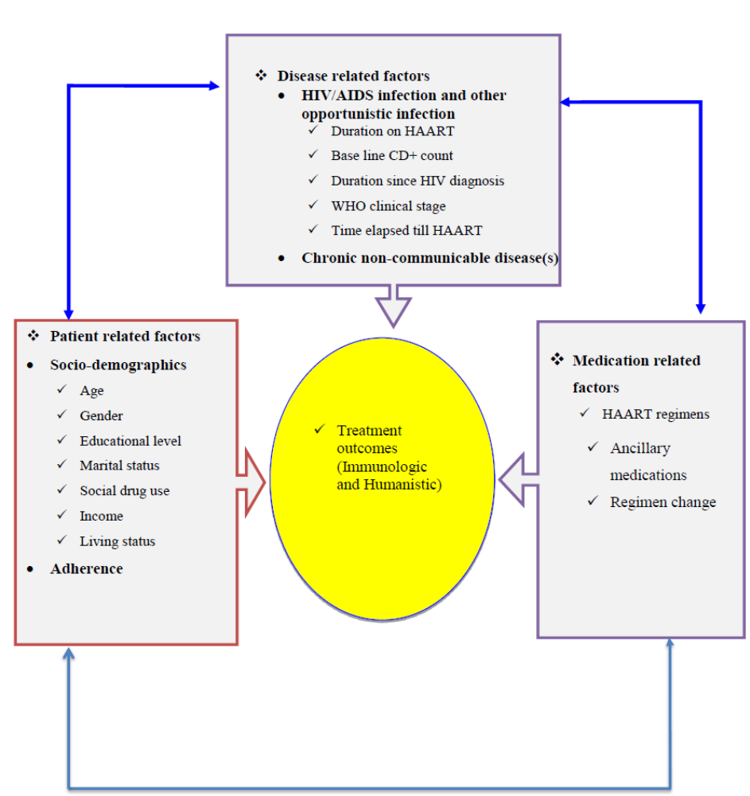 Conceptual frame work for treatment outcomes among HIV infected patients

Recent Publications
- Tsegaye Melaku et al, Assessment of Prescribers’ Adherence to the Basic Standards of Prescription Order writing in Jimma University Specialized Hospital, Southwest Ethiopia; The Experiment, 2014, 19(1), 1316-1329
- Gizat Molla, Tsegaye Melaku, Bogale Kebede; Knowledge, attitude, and practice of epileptic patients towards their illness and treatment in Jimma University specialized hospital, Southwest Ethiopia; North American Journal of Medical Sciences, 2014, 6,(8), 383-390
- Misganu Diriba, Tsegaye Melaku, Desta Assefa; Patients Adherence to Anti-tuberculosis Medicines and Associated Factors for Non-adherence at Tertiary Teaching Hospital, South West Ethiopia; Gaziantep Med J 2016;22(2):55-62
- Tadesse Sheleme, Belay Yimam, Tsegaye Melaku; Antibiotics Utilization Pattern in Pediatric Ward: The Case from Tertiary Teaching Hospital, South West Ethiopia; International Journal of Advanced Multidisciplinary Research (IJAMR) 2015, 2 (9); 54-61.

I am Lecturer and clinical pharmacist at School of pharmacy, Institute of health sciences, Jimma University. I am dedicated to upgrade both my knowledge and profession. I constantly strive for excellence and am committed to making my time as community problem solver and life-long learner as productive and beneficial as possible. my interests span across enhancing my capacity through continuing education and solving health care problems of my illiterate community, who make me literate. 'CREATE A PATH TO THE “good life,” NOT ONLY FOR MY-SELF BUT ALSO FOR OTHERS.'

