A Novel treatment for a Han patient with high risk of coronary obstruction underwent TAVI procedure using a novel second-generation device

DURAID HAMID NAJI AL-MIDFAI

Postdoctoral student, Henan provincial people’s Hospital; Fuwai Central China Cardiovascular Hospital, CHINA

Abstract
In this study the obstruction of coronary ostium (CO) is unusual but lethal complication under TAVI procedure it is not normally accepted that a range distance between the coronary ostium (CO) and the annulus lower than 10mm or in case of sinus of Valsalva diameter around 30mm, while the existing of bulky counted as a leaflet, this is also in case of the valve in valve implantation, in this situation consider as a risks for coronary occlusion (CO) as for TAVI methodology (1-2). In TAVAI device using J-Valve™ system is a brand new second-generation and TAVI device divided in to three U-shapes anatomically oriented devices such as “claspers” which could favour conjectural and “self-positioning” valve implantation (3). Furthermore, Due to the ability to enclosure and snaffle the main Major of leaflets in main time of valve implantation and in specific designed extra bear area located on the valve stent. The novelty of this valve is particular appropriate for the patient who is more in the risk for coronary ostium (CO) such as valve-in-valve implantation. In this study convey the patient of utilize J-Valve in therapy the case with an high risk of coronary ostium (CO) during TAVI procedure.

Keywords: TAVI; Coronary Ostium; Valve Implantation; J-Valve™.

Image
Figure 1 : J-Valve implantation in a patient with high risk of coronary obstruction. Upper Panel: Note both left coronary height was all less than 10mm with narrow aortic sinus (A-C).Lower Panel: CTA image after valve implantation. Valve was in good position with a patent coronary artery; the clasper of the J-Valve embraced and secured the native aortic valve leaflet then subsequently leaving the coronary ostia freely accessible from aortic leaflet (D-F).

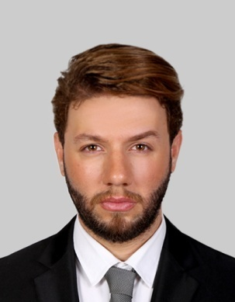
Dr. Duraid Al-Midfai considering the cardiovascular major for various reasons. Since I he was a child, he has been fascinated by the world around himself. When he traveled to China and Middle East, the conservation efforts of these two countries interested him and he knew that he wanted to do something related to the CAD disease in Genetics filed. He is currently a member of Fuwai Central China Cardiovascular Hospital As a post doctoral research in the cardio surgery department-in patient building as well as his work also collaborated with Henan Hospital in the Research Center building, which is a Big and famous hospital in central of china for cardiovascular disease treatment.
A long-term goal of him, his goals is to one day manage and discover a novel genes associated with various diseases in human genome. Moreover, he is also curious to learn more about any medical field that is somehow related to genetics research.

Email: duraidhamied@gmail.com
Notes/Comments:
- First of all I would love to receive an email about the acceptance of the abstract, as well as, I don’t like to share my article with others in case does not accept it or before the conference so please be more secure and tell me in advance.

