Urticarial Vasculitis in Childhood Onset Systemic Lupus Erythematosus
Ahmed Al Kamzari, Oman Medical Speciality Board
Fatma Al Kindi, Oman Medical Speciality Board
Safiya Al Abrawi, MD Royal Hospital
Buthaina Al Musalhi, Sultan Qaboos University Hospital
Ibraheem Al Zakwani, Sultan Qaboos University Hospital
Reem Abdwani, Sultan Qaboos University
Abstract
Urticarial Vasculitis (UV) is an uncommon disease presenting as cutaneous leukocytoclastic vasculitis with urticarial eruption in combination with various clinical and immunological features. UV commonly idiopathic, can rarely occur in association with childhood onset systemic lupus erythematosus (cSLE).
In this study, we aim to describe the frequency of UV in cSLE cohort of Arab ethnicity from Oman. We also aim to compare the epidemiological, clinical and laboratory characteristic of cSLE stratified by the presence of UV.

We conducted a retrospective cross sectional study among pediatric rheumatology centers over a 10 year period. We included all patients under the age of 13 years who fulfilled the Systemic Lupus International Collaborating Clinics classification criteria. While, the diagnosis of UV was based on the revised international Chapel Hill consensus.

A total of 148 cSLE patients, (n=44 males (30%), n=104 (70%) females), were included with a mean age at diagnosis 7.6±3.5 years and median disease duration 9.5 (5-13) years. UV in cSLE was diagnosed in 36% (n=53).

cSLE with UV were more likely to be males (57% vs 15%; p<0.001), with family history of SLE (53% vs 36%; p=0.044), younger in age (5.9 vs 8.5 years; p<0.001) and originating from Eastern region (62% vs 29%; p<0.001).

cSLE with UV, clinically, were more likely associated with conjunctivitis (32% vs 5.3%; p<0.001). However, they were less likely to be associated malar rash (5.7% vs 31%; p<0.001), CNS involvement (7.6% vs 20% p =0.045) and leukopenia (9.4% vs 24%; p=0.028).

The laboratory features of cSLE cohort with UV was more likely to be associated with low C3 (94% vs 66%; p<0.001) and C-ANCA (11% vs 0%; p=0.022). However, they were less likely to be associated with ANA (65% vs 83%; p=0.016), DsDNA (56% vs 72%; p=0.042) and P-ANCA (33% vs 55%; p=0.047).

In conclusion, we report a high occurrence of a rare disease in a cohort of cSLE of Arab ethnicity in which consanguineous marriage is prevalent presenting with unique features. Further studies are needed to evaluate the relationship of UV with SLE and to study the role of genetic, ethnic and environmental factors in disease expression.

Images:

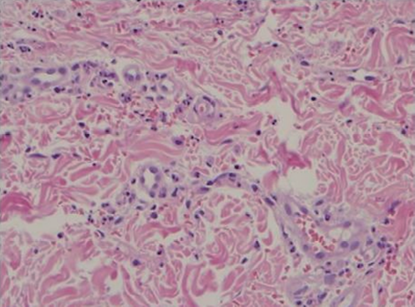
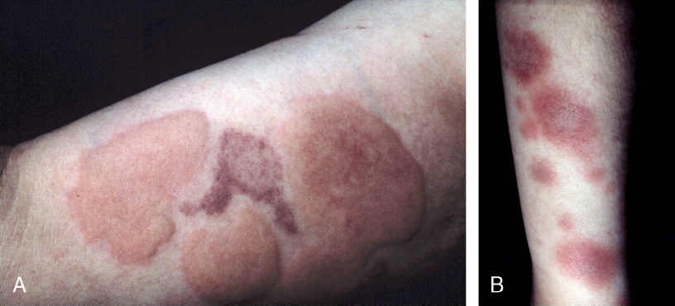
Fig.1 (A) urticarial lesions in a patient presenting with urticarial vasculitis, (B) high-power view highlights leukocytoclastic vasculitis in the dermal vasculature

Recent publication:
1- Al Rasbi A, Abdalla E, Sultan R, Abdullah N, Al Kaabi J, Al-Zakwani I, et al. Spectrum of systemic lupus erythematosus in Oman: from childhood to adulthood. Rheumatol Int. 2018 Sep;38(9):1691–8.
2- Abdwani R, Abdalla E, Al Abrawi S, Al-Zakwani I. Epidemiology of juvenile idiopathic arthritis in Oman. Pediatr Rheumatol Online J. 2015 Aug 1;13:33.
3- Al-Mayouf SM, Sunker A, Abdwani R, Abrawi SA, Almurshedi F, Alhashmi N, et al. Loss-of-function variant in DNASE1L3 causes a familial form of systemic lupus erythematosus. Nat Genet. 2011 Oct 23;43(12):1186–8
4- Abdwani R, Al-Abrawi S, Sharef SW, Al-Zakwani I. Geographical Clustering of Juvenile Onset Systemic Lupus Erythematosus within the Sultanate of Oman. Oman Med J. 2013 May;28(3):199–203.
5- Al-Saadi T, Kumzari AA, Hassan M. Relationship between Low Back Pain and Types of Office, Home and Car Seats in Sultan Qaboos University Staff. American Journal of Medical Sciences and Medicine. 2018 Jun 11;6(1):13–8.

Biography: Ahmed M. Al-kamzari.M.D
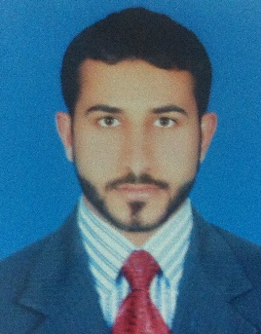
Ahmed Alkamzari is pediatric resident at Oman medical specialty board in Oman. He was graduated from college of medicine and health science at Sultan Qaboos University in June 2016. He joined the pediatric program residency immediately after his internship and currently his is on his 3rd year of residency. Throughout his undergraduate and post graduate years, he has been an active member of various pediatric societies with high passion for research and medical education.

