NTM PAROTITIS

Sadiya Zinjani
Senior Consultant Paediatrics, Max Hospital, Saket, Delhi, India
Abstract
The first impression on seeing this 5.6 yr girl with a Lt. parotid swelling was? Mumps, but it was only when antibiotics provided relief the possibility of a pyogenic infection was considered
In 2018 she made 2-3 visits with parotid swellings, but by October 2018 she had developed bilateral parotitis not responding to routine antibiotics
USG followed by CEMRI in Nov 2018 revealed bulky parotid glands, with multiple thick walled loculated abscesses & regional lymphadenopathy.
Both FNA & abscess debridement tissue microscopy revealed numerous epitheloid cell granulomas with multinucleated giant cells & some Langhans cells in a necrotic base
ZN stain for AFB was positive
Mycobacterium culture by MGIT & Genexpert MTB was negative
When the patient failed to respond to ATT, Clarithromycin was added & by 2 weeks the incision scar was all that was visible

Keywords; NTM, Parotitis, Langhans cells, granulomas, abscesses, ZN stain.AFB,MGI.

Discussion : Parotitis caused by NTM is an uncommon problem, commonly involving young children
Infections caused by NTM are now more frequently encountered -- perhaps due to a greater awareness & advanced diagnostics NTM are being recognized as causative agents in various symptomatic disease states. They are now being implicated in various disease manifestations in immuno competent hosts .In most cases of Parotitis, M. avium is the causative pathogen, other mycobacteria have also been reported as causative agents in some cases
In our case the histopathological picture augmented by the culture reports & failure to respond to ATT confirmed our diagnosis of NTM Parotitis
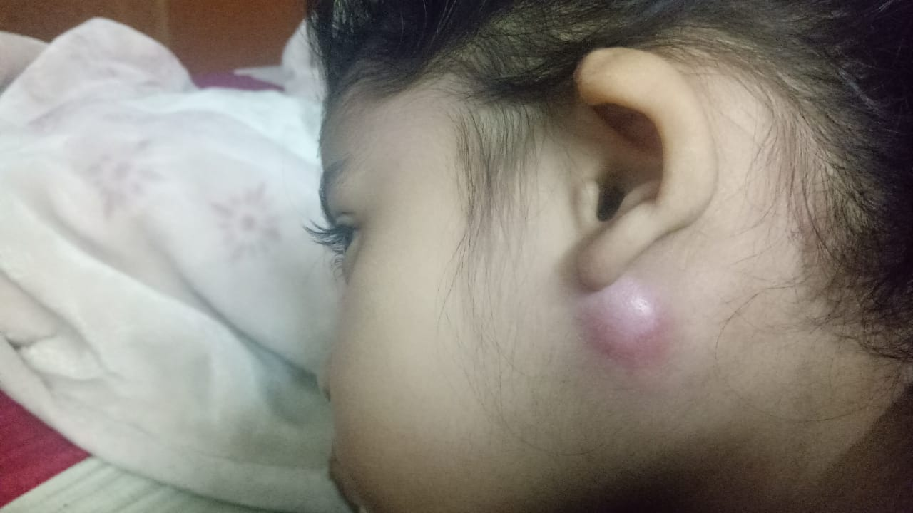
- Photograph of the child after 3 weeks of treatment with ATT & Clarithromycin

References

- Non tuberculous mycobacterial absccessus of the parotid gland - Arpan C. Shah, Umang Shah, Chandrakant Shah European Respiratory Journal 2016 48: PA2758; DOI: 10.1183/13993003.congress-2016.PA2758
- Non-tuberculous mycobacterial infection of the parotid gland in an immunosuppressed adult - F. S. Gittinger, 1, 2 A. Raible1 and V. A. J. Kempf3
- Bilateral parotitis caused by Mycobacterium chelonae in an immunocompetent child
Szu-Hung Chu1, 2, Shyh-Dar Shyur3, Yi-Lei Wu3, Kuo-Ming Chang4, Huei-Chung Lee5
- Medical Management for the Treatment of Nontuberculous Mycobacteria Infection of the Parotid Gland: Avoiding Surgery May Be Possible Emily Kay-Rivest, Sarah Bouhabel, Matthew Thomas Oughton, and Michael Peter Hier
- Mycobacterium simiae Infection of the Parotid Gland in an Immunocompetent Child - Journal of the Pediatric Infectious Diseases Society, Volume 2, Issue 4, December 2013, Pages 394–396

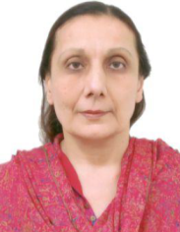
Biblography
Dr. Sadiya Zinjani graduated from the prestigious Armed Forces Medical College in the state of Maharashtra in India
She is a resident of Delhi, the capital city of India & has behind her several years of Pediatric & Neonatal practice.
She is attached to the Max Hospital, Saket, Delhi, as visiting consultant but her major focus is her private clinic at her residence in Delhi, where she consults, conducts well baby clinics, & does minor procedures
Her main interest is disease prevention, hence the immunization status of most of the regular attendees to her healthcare facility is something any Pediatrician would be proud of
Another area of her interest is nutrition, so on any normal day one finds Dr. Zinjani advising parents on the importance of breast feeding , the timely initiation of complementary feeding and balanced nutrition in toddlers & young children

