A rare case of popliteal aneurysm in a child.
Dr Krystal Dinh, Westmead Hospital
Dr Delfino Di Mascio, Westmead Hospital

Abstract

Popliteal arterial aneurysms are extremely rare in children with the most common causes being due to trauma. A 10 year female, who is otherwise fit and healthy, presented with a 6 day of left leg popliteal pain, mild odema and global bruising to the distal thigh. She is a regular dancer however reported no history of trauma, infection or connected tissue disorders. CT angio illustrated a thrombosed popliteal pseudo-aneurysm (19x19x17) with trickle flow, associated with soft tissue haematoma and collateralisation. She underwent a left great saphenous vein harvest, interposition bypass from mid SFA to above knee popliteal artery and embolectomy of SFA/popliteal artery. The girl had an uneventful post-operative recovery, her foot was warm and well perfused with palpable DP and PT pulses. Although, tissue grew staphylococcus epidermidis, tissue pathology illustrated nil acute inflammation; chronic inflammation was however reported. After extensive investigations by multiple sub specialties, no aetiology has been identified (negative vasculitis screen, negative thrombophilic screen, structurally and functionally normal heart, normal autoimmune and immunology screen, negative genetic screen for connective disorder). We attributed the popliteal aneurysm to be due to hyperextension of the knee.
Image
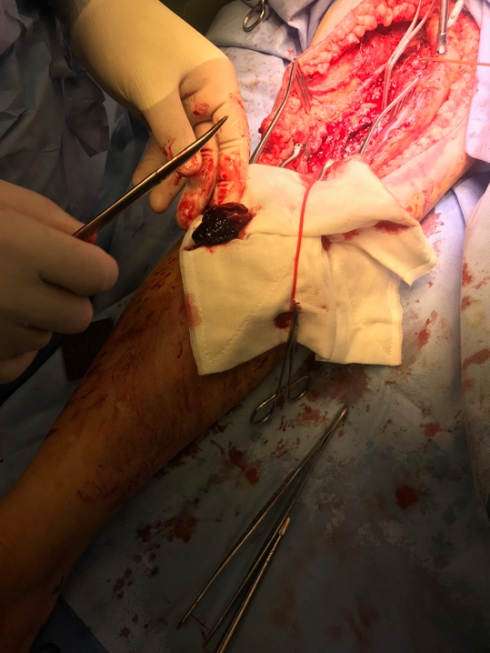

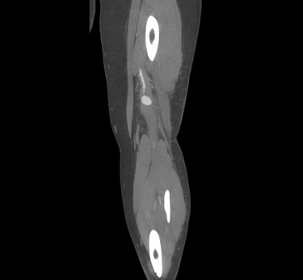


Biography
Dr Krystal Dinh is a doctor for Sydney, Australia. She has both and interest in vascular and trauma surgery.
Email: dinhkrystal9@gmail.com

