GARRE’S OSTEOMYELITIS
Author Dr Sadiya Zinjani
(Senior consultant –Paediatrics ,Max Hospital, Saket ,Delhi)

Also called periostitis ossificans ,proliferative periostitis and Garre’s sclerosing osteomyelitis
First described by Carl Garre in 1893 as an irritation induced focal thickening of the periosteum & cortical bone of the tibia
The first case of proliferative periostitis affecting the jaw bone was described by Berger in1948
Garre’s osteomyelitis mainly affects children & adolescents
Our case involved a 8yr girl who presented with a painful swelling Rt lower jaw, with difficulty in deglutition, there was no fever
Earlier the patient had been treated by Dentists & ENT Specialists with no relief
Relevant investigations were within normal limits
MDCT scan of the face/orbit showed cortical irregularity and erosions in the Rt hemi-mandible with a significant periosteal reaction & multiple irregular lytic areas in the marrow along with soft tissue changes suggestive of osteomyelitis
The OPG was normal
The significant periosteal reaction combined with osteomyelitis was suggestive of Garre’s osteomyelitis
No bone biopsies were considered due to the typical clinical & radiological features
With 4 weeks of antibiotic treatment the patient was completely relieved of her symptoms, with a major correction in the facial asymmetry.
Regular follow up demonstrated a remodeling of the mandible with normal results on bone scanning
Most cases of Garre’s osteomyelitis have followed an odontogenic infection
Our case had no evidence of any oral or dental infection , confirmed by a preadmission OPG & a post discharge CBCT, and thus responded well to conservative treatment.
She in all possibility developed this osteomyelitis secondary to an infection elsewhere in the body, which was controlled by the time she came to us
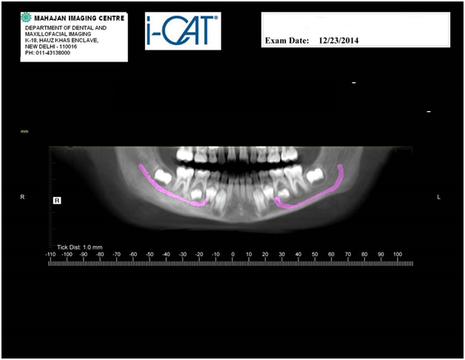

Panoramic reformated mandibular image 2 weeks post treatment

References

1)Chronic non-suppurative osteomyelitis with proliferative periostitis or ...
casereports.bmj.com › Archive
by KM Shah - ‎2013

2) Garre's sclerosing osteomyelitis. - NCBI
https://www.ncbi.nlm.nih.gov/pubmed/17921638
by R Suma - ‎2007 -

3) Garre's osteomyelitis: a case report - American Academy of Pediatric ...
www.aapd.org/assets/1/25/Schwartz-03-03.pdf
by S Schwartz

4) Chronic osteomyelitis with proliferative periostitis in the lower jaw ...
https://www.sciencedirect.com/science/article/pii/S1991790212001626
by YC Chang - ‎2015

5) Garré's Osteomyelitis at Right Mandible of a Nine-Year-Old Girl
www.hkjpaed.org/pdf/2016;21;291-293.pdf
2016
We are grateful to Dr.Anurag Singh maxilla facial surgeon, Max Hospital, Saket, for his inputs in this case

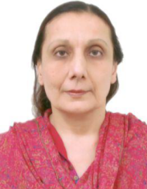
Biblography
Dr. Sadiya Zinjani graduated from the prestigious Armed Forces Medical College in the state of Maharashtra in India
She is a resident of Delhi, the capital city of India & has behind her several years of Pediatric & Neonatal practice.
She is attached to the Max Hospital, Saket, Delhi, as visiting consultant but her major focus is her private clinic at her residence in Delhi, where she consults, conducts well baby clinics, & does minor procedures
Her main interest is disease prevention, hence the immunization status of most of the regular attendees to her healthcare facility is something any Pediatrician would be proud of
Another area of her interest is nutrition, so on any normal day one finds Dr. Zinjani advising parents on the importance of breast feeding , the timely initiation of complementary feeding and balanced nutrition in toddlers & young children
Email: sadiazinjani@hotmail.com

