5th International Conference on Advances in Skin, Wound Care and Tissue Science
October 15-16, 2018 Rome, Italy

NovoSorb Biodegradable Temporising Matrix (BTM) - a paradigm shift in burn care
John Edward Greenwoodª*, Marcus James Dermott Wagstaff^{a,b}

ªAdult Burn Service, Royal Adelaide Hospital, Port Road, Adelaide 5000, South Australia, Australia
^{b}Department of Plastic and Reconstructive Surgery, Royal Adelaide Hospital, Port Road, Adelaide 5000, South Australia, Australia

Abstract
Introduction: NovoSorb BTM is a completely synthetic, bilayer ‘active’ temporizer. It buys time for patient and surgeon to allow recruitment of resources for definitive closure whilst improving the wound bed for definitive closure.
Methods/Results: We had noticed consistently improved surgical course and outcomes in burn patients treated with BTM and subsequent skin grafting. However, we had not fully appreciated the differences side to side until the 13th patient. In this 29 year old with 71% TBSA burns, initial complete debridement on Day 0 was followed by 1:2 meshed split skin graft to the chest and abdomen 3 days post burn. With insufficient donor sites, BTM was applied to his limbs at the same time. On Day 38 (5 weeks later), 1:2 meshed graft was applied to the integrated BTM on Day 38. At 9 months, markedly reduced mesh pattern and a softer, more supple result where BTM was implanted, even better by a year. This finding changed our practice. The next two big burn patients had similar courses. A 150Kg man with 70% TBSA full thickness burns injury to bilateral hands, forearms, arms, chest, abdomen, posterior trunk, thighs and circumferential left leg underwent tangential excision on Day 0. BTM was applied to all wounds on Day 3. Four serial grafting operations occurred between Day 42 to Day 72. He was discharged to inpatient rehabilitation at Day 91 and went home (converted to outpatient rehabilitation) three weeks later.
Conclusions: A better functional and cosmetic result with delayed grafting on BTM at 5 weeks compared to early grafting on fat made us question the traditional wisdom of early wound closure at all costs. Additionally, if a delay is desirable, definitive closure using autologous composite cultured skin becomes a viable option, raising the possibility of not needing skin grafts at all for closure!
Image
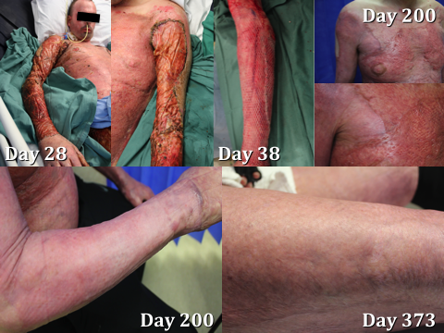
Figure - superior results with delayed graft/BTM than early graft/fat
Recent Publications
1. JE Greenwood, MJD Wagstaff. ‘The use of biodegradable polyurethane in the development of dermal scaffolds’ Chapter 22 In Cooper SL & Guan J (Eds) ‘Advances in Polyurethane Biomaterials’ 2016. Woodhead Publishing Series in Biomaterials, (Elsevier Inc.), Duxford, UK. ISBN:978-0-08-100614-6.
2. JE Greenwood. ‘Hybrid biomaterials for skin tissue engineering’ Chapter 9 In Albanna MZ & Holmes JH IV (Eds) ‘Skin Tissue Engineering and Regenerative Medicine’ 2016. Academic Press (Elsevier Inc.), London, UK. ISBN:978-0-12-801654-1.
3. JE Greenwood, BL Dearman ‘Split-skin graft application over an integrating, biodegradable temporising polymer matrix: Immediate and delayed’ Journal of Burn Care and Research Jan/Feb2012;33(1):7-19.
4. JE Greenwood, BL Dearman ‘Comparison of a sealed, polymer foam biodegradable temporising matrix against Integra™ dermal regeneration template in a porcine wound model’ Journal of Burn Care and Research Jan/Feb2012;33(1):163-173.
5. BL Dearman, K Stefani, A Li, JE Greenwood ‘Take’ Of A Polymer-Based Autologous Cultured Composite ‘Skin’ On An Integrated Temporising Dermal Matrix: Proof Of Concept’ Journal of Burn Care and Research 2013;34(1):151-160.
6. BL Dearman, A Li, JE Greenwood ‘Optimisation of a Polyurethane Dermal Matrix and Experience with a Polymer-based Cultured Composite Skin’ Journal of Burn Care and Research 2014;35(5):437-448.
11. JE Greenwood ‘The evolution of acute burn care - retiring the split skin graft (Hunterian Lecture)’ Annals of the Royal College of Surgeons of England 2017;99:432-438. Available at https://doi.org/10.1308/rcsann.2017.0110.
12. JE Greenwood, BJ Schmitt, MJ Wagstaff ‘Experience with a synthetic bilayer biodegradable temporizing matrix in significant burn injury’ Burns Open Jan 2018;2(1):17-34.

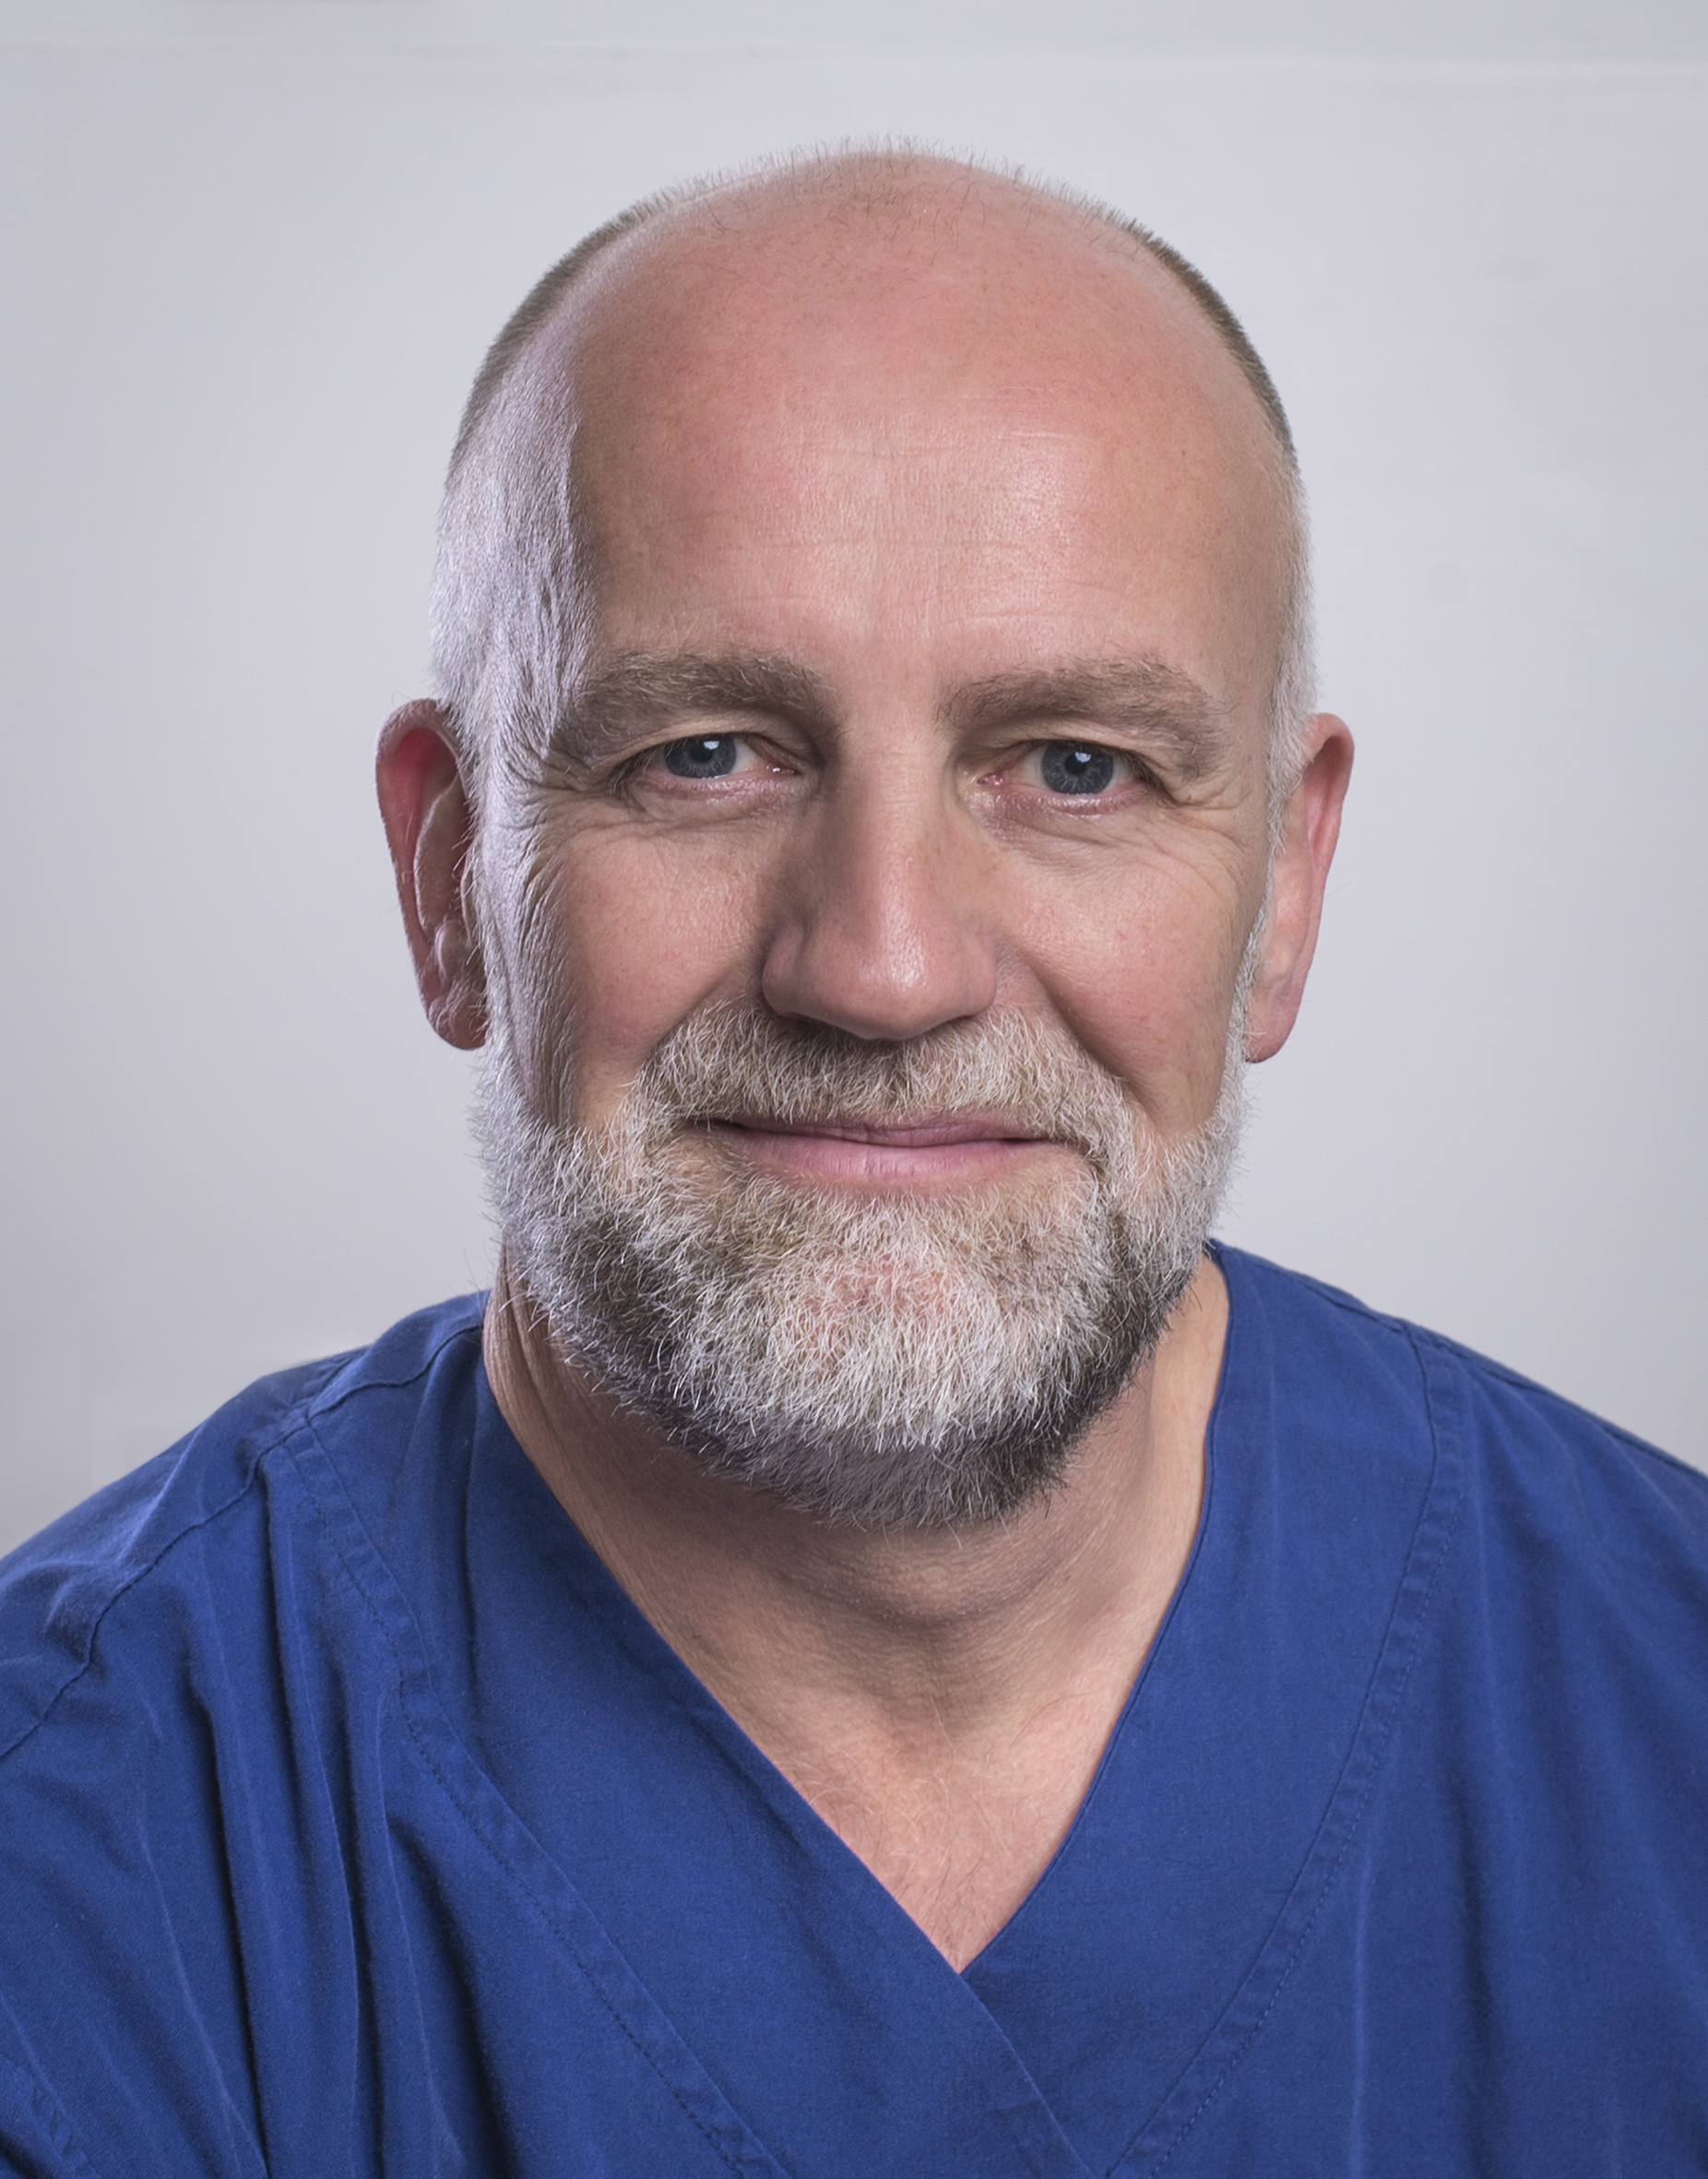
John Greenwood AM is an English-trained plastic surgeon who graduated from the University of Manchester in 1989 and now working full-time in burn care as the Medical Director of the Adult Burn Centre of the Royal Adelaide Hospital in Adelaide, South Australia. He has been developing skin replacement products, utilising the NovoSorb biodegradable polyurethane platform, since 2004. He was appointed Member of the Order of Australia (AM) following his work leading Australia’s only Burns Assessment Team after the carnage of the 2002 Bali Bombings which killed 202 civilians. He was the 2016 South Australian Australian of the Year.

Keywords: Outcomes;Burns;BTM;NovoSorb;Polyurethane;Dermal Matrix

Desired presentation: Oral

Topic: According to the list of topics provided on the web site

Corresponding Author Details: Professor Dr John Edward Greenwood AM
Email: john.greenwood@sa.gov.au
Adult Burn Service, Level 7, G Wing, Royal Adelaide Hospital, Port Road,
Adelaide, South Australia, Australia
Telephone: +61-422-000809

