5th International Conference on Advances in Skin, Wound Care and Tissue Science
October 15-16, 2018 Rome, Italy

NovoSorb Biodegradable Temporising Matrix (BTM) - use in significant burns
John Edward Greenwoodª*, Marcus James Dermott Wagstaff^{a,b}

ªAdult Burn Service, Royal Adelaide Hospital, Port Road, Adelaide 5000, South Australia, Australia
^{b}Department of Plastic and Reconstructive Surgery, Royal Adelaide Hospital, Port Road, Adelaide 5000, South Australia, Australia

Abstract
Introduction: The NovoSorb BTM is a completely synthetic bilayer material comprising a dermal component (2mm thick biodegradable polyurethane foam) bonded to a pseudoepidermis of non-biodegradable polyurethane film. Its primary function is to ‘temporise’ wounds, buying time for a definitive closure option to become available. Since the dermal foam becomes integrated and creates a neodermis, it is an ‘active’ temporiser, improving the wound bed for definitive closure.
Methods: To date, 18 patients with significant burns have been treated with BTM. Since the first, salient lessons regarding the application (contouring, cutting and fixing), dressing, monitoring, timing of delamination and grafting have presented themselves. , The initial 5 patients were part of a pilot trial, the following two (involved in the Pinery Bushfire Disaster) and the subsequent 11 have been permitted by the Therapeutic Goods Administration (TGA) either under Special Access or Authorised Prescriber Schemes. In all cases a photographic (and sometimes video) record has been taken at every procedure and review and several cases will be discussed.
Results/Conclusions: The matrix integrated completely in almost all cases and graft take over integrated BTM was uniformly excellent. Several episodes of localized infection were treated by local manoeuvres, dressings and systemic antibiotics without removal or loss of the BTM. Some BTM required removal and replacement. The split skin grafts applied over integrated BTM varied from sheet graft to 1:3 mesh. Graft loss was rare and in all cases, mesh pattern faded, becoming invisible in some by 12 months. Functional and cosmetic outcomes (measured by POSAS and MAPS) have been significantly better than historical cases. Reconstruction within BTM areas has been limited to web space releases and simple flap release of unusual contracture bands. BTM is now our treatment of choice and has led to a recent paradigm shift in burn care at our institution.

Image
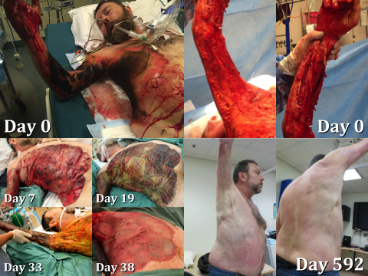
Figure - BTM result from 4th degree burn injury
Recent Publications
1. JE Greenwood, MJD Wagstaff. ‘The use of biodegradable polyurethane in the development of dermal scaffolds’ Chapter 22 In Cooper SL & Guan J (Eds) ‘Advances in Polyurethane Biomaterials’ 2016. Woodhead Publishing Series in Biomaterials, (Elsevier Inc.), Duxford, UK. ISBN:978-0-08-100614-6.
2. JE Greenwood. ‘Hybrid biomaterials for skin tissue engineering’ Chapter 9 In Albanna MZ & Holmes JH IV (Eds) ‘Skin Tissue Engineering and Regenerative Medicine’ 2016. Academic Press (Elsevier Inc.), London, UK. ISBN:978-0-12-801654-1.
3. JE Greenwood, BL Dearman ‘Split-skin graft application over an integrating, biodegradable temporising polymer matrix: Immediate and delayed’ Journal of Burn Care and Research Jan/Feb2012;33(1):7-19.
4. JE Greenwood, BL Dearman ‘Comparison of a sealed, polymer foam biodegradable temporising matrix against Integra™ dermal regeneration template in a porcine wound model’ Journal of Burn Care and Research Jan/Feb2012;33(1):163-173.
5. BL Dearman, K Stefani, A Li, JE Greenwood ‘Take’ Of A Polymer-Based Autologous Cultured Composite ‘Skin’ On An Integrated Temporising Dermal Matrix: Proof Of Concept’ Journal of Burn Care and Research 2013;34(1):151-160.
6. BL Dearman, A Li, JE Greenwood ‘Optimisation of a Polyurethane Dermal Matrix and Experience with a Polymer-based Cultured Composite Skin’ Journal of Burn Care and Research 2014;35(5):437-448.
11. JE Greenwood ‘The evolution of acute burn care - retiring the split skin graft (Hunterian Lecture)’ Annals of the Royal College of Surgeons of England 2017;99:432-438. Available at https://doi.org/10.1308/rcsann.2017.0110.
12. JE Greenwood, BJ Schmitt, MJ Wagstaff ‘Experience with a synthetic bilayer biodegradable temporizing matrix in significant burn injury’ Burns Open Jan 2018;2(1):17-34.

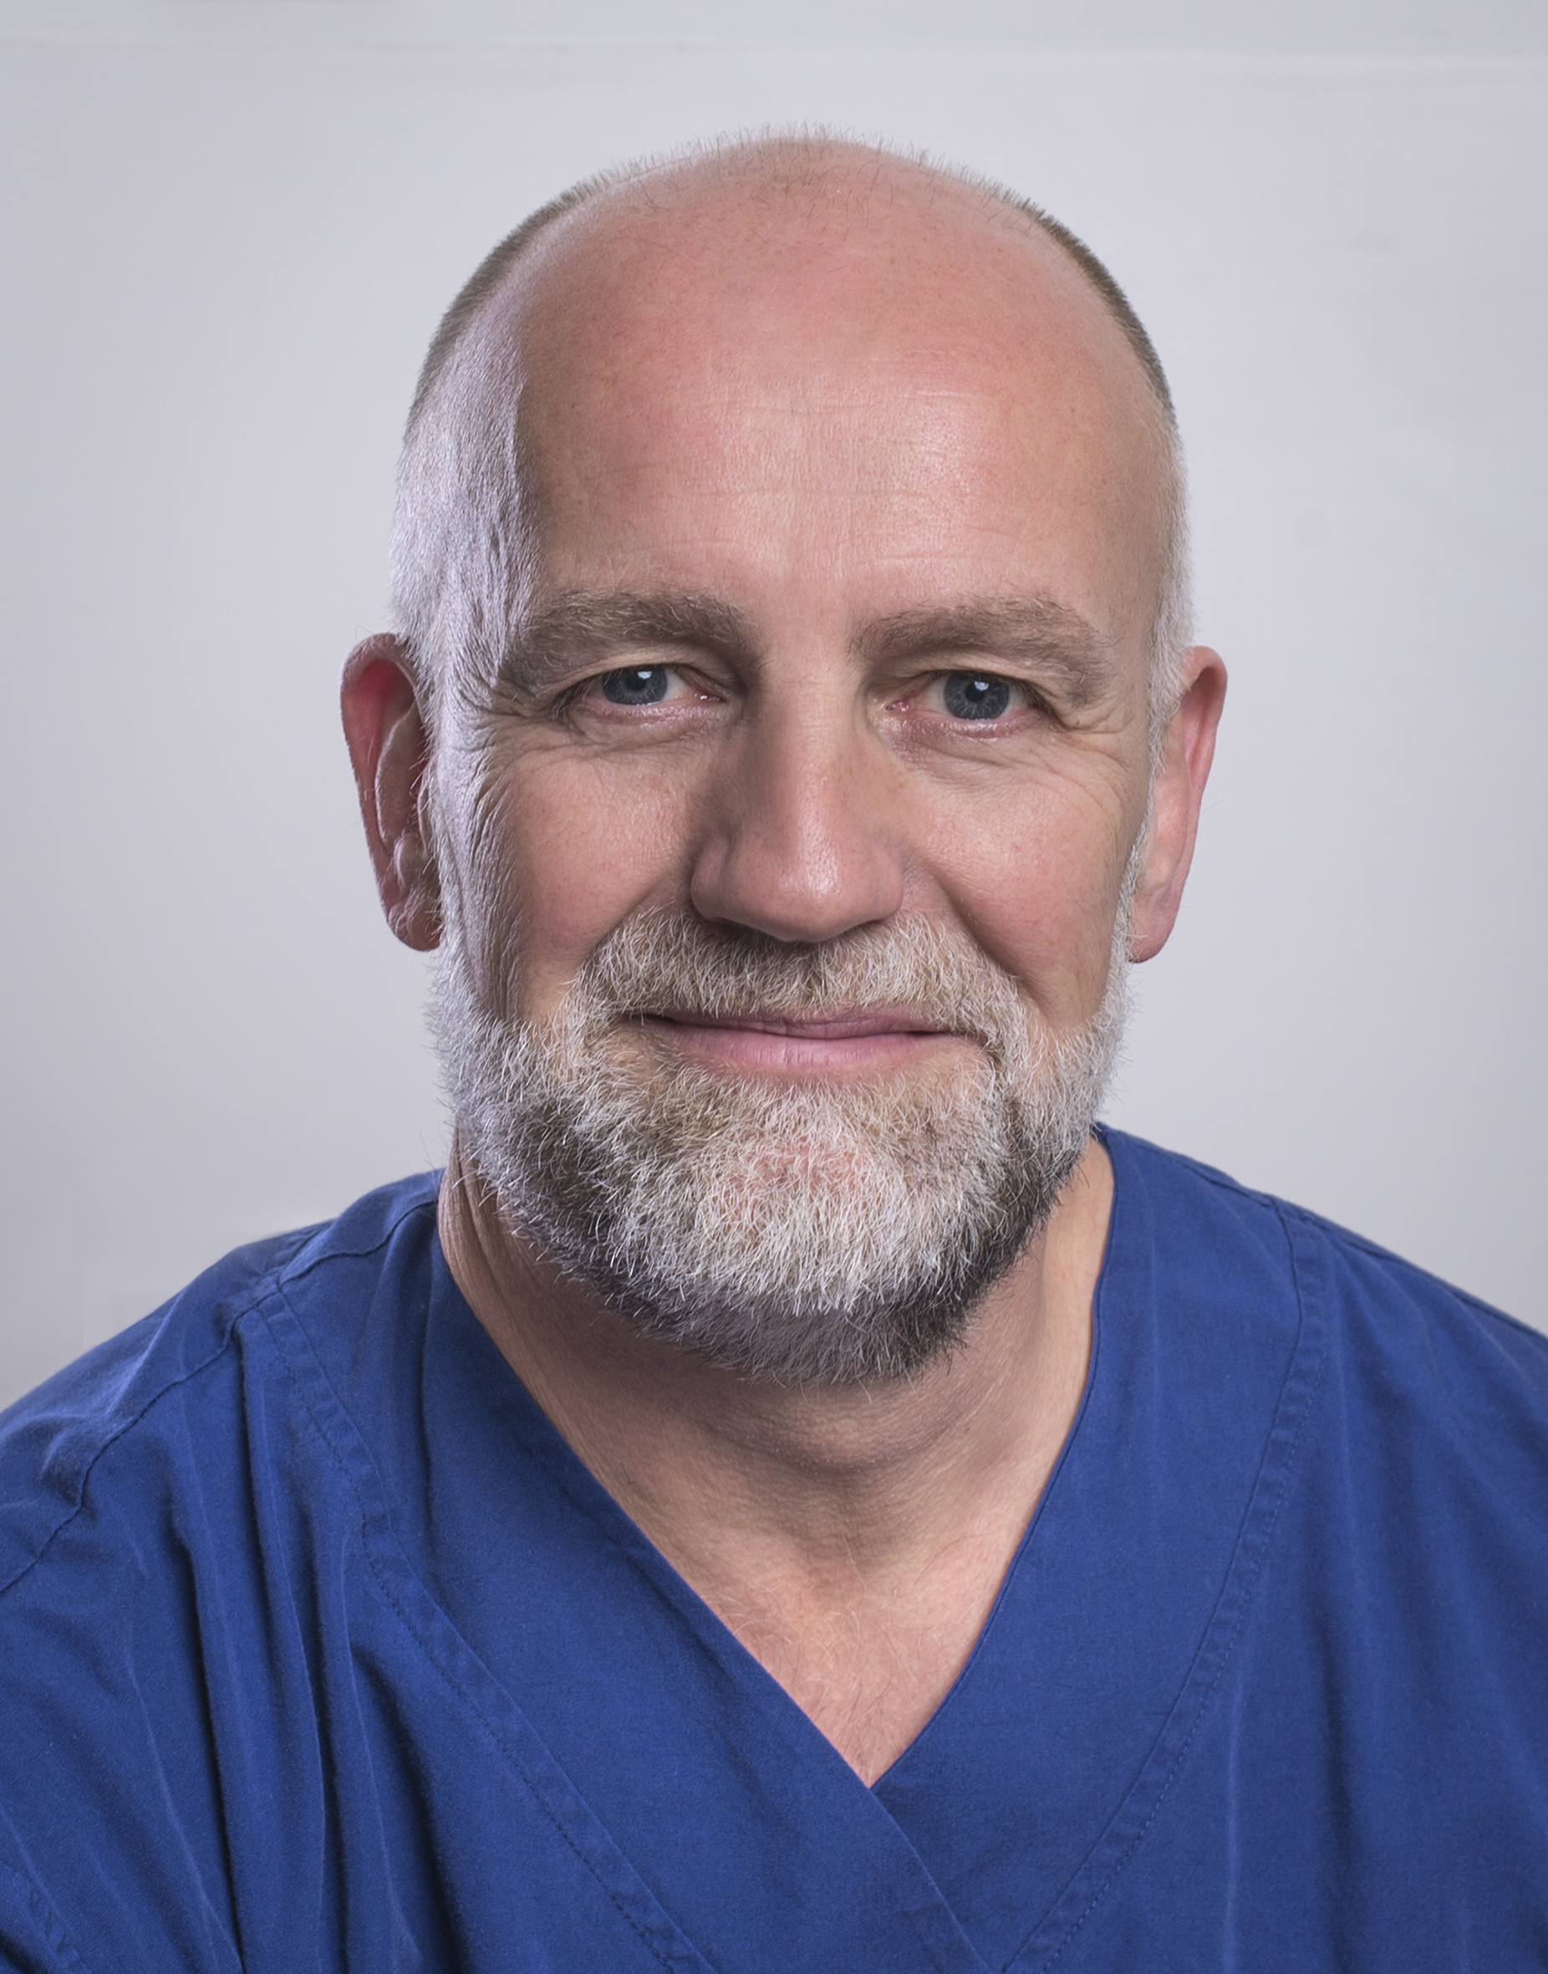
John Greenwood AM is an English-trained plastic surgeon who graduated from the University of Manchester in 1989 and now working full-time in burn care as the Medical Director of the Adult Burn Centre of the Royal Adelaide Hospital in Adelaide, South Australia. He has been developing skin replacement products, utilising the NovoSorb biodegradable polyurethane platform, since 2004. He was appointed Member of the Order of Australia (AM) following his work leading Australia’s only Burns Assessment Team after the carnage of the 2002 Bali Bombings which killed 202 civilians. He was the 2016 South Australian Australian of the Year.

Keywords: Burns;BTM;NovoSorb;Polyurethane;Dermal Matrix

Desired presentation: Oral

Topic: According to the list of topics provided on the web site

Corresponding Author Details: Professor Dr John Edward Greenwood AM
Email: john.greenwood@sa.gov.au
Adult Burn Service, Level 7, G Wing, Royal Adelaide Hospital, Port Road,
Adelaide, South Australia, Australia
Telephone: +61-422-000809

