5th International Conference on Advances in Skin, Wound Care and Tissue Science
October 15-16, 2018 Rome, Italy

NovoSorb Biodegradable Temporising Matrix (BTM) - use in complex wounds
John Edward Greenwoodª*, Marcus James Dermott Wagstaff^{a,b}

ªAdult Burn Service, Royal Adelaide Hospital, Port Road, Adelaide 5000, South Australia, Australia
^{b}Department of Plastic and Reconstructive Surgery, Royal Adelaide Hospital, Port Road, Adelaide 5000, South Australia, Australia

Abstract
Introduction: The NovoSorb BTM is a completely synthetic bilayer material comprising a dermal component (2mm thick biodegradable polyurethane foam) bonded to a pseudoepidermis of non-biodegradable polyurethane film. Its primary function is to ‘temporise’ wounds, buying time for a definitive closure option to become available. Since the dermal foam becomes integrated and creates a neodermis, it is an ‘active’ temporiser, improving the wound bed for definitive closure.
Methods: BTM has become a solution for complex wound surgical reconstruction, both acutely and long-term. The first four patients were post-necrotising fasciitits. The first (neck) had serial debridement, which left the muscular structures of the neck and the left submandibular gland exposed. The second required upper limb amputation through the shoulder and had extensive flank wounds with exposed ribs. The third had a large lower limb wound down to muscle. The fourth was an elderly dialysis patient with an open axilla, flank wound and exposed ribs. The fifth in the series was the degloved dorsum of foot (figure). The sixth has a carcinoma resection over radiotherapy-treated calvarium on which a graft repair failed. The seventh was a very extensive post-necrotising fasciitis wound involving neck and chest. The eighth and ninth were reconstructions for poor function in adults who had been burned as children. Since the BTM is not yet regulated in Australia, these were treated under the Therapeutic Goods Administration (TGA) Authorised Prescriber Scheme. In all cases a photographic (and sometimes video) record has been taken at every procedure and review and each case will be discussed.
Results/Conclusions: The matrix integrated completely in all cases and graft take was uniformly excellent. There was no incidence of loss or problems with infection. Using BTM the matrix avoided major flap reconstructions in some patients, and yielded a far better result than graft alone in others.

Image
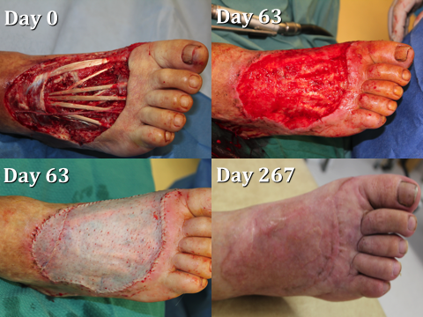
Figure - complex foot wound reconstruction in Patient 5.
Recent Publications
1. JE Greenwood, MJD Wagstaff. ‘The use of biodegradable polyurethane in the development of dermal scaffolds’ Chapter 22 In Cooper SL & Guan J (Eds) ‘Advances in Polyurethane Biomaterials’ 2016. Woodhead Publishing Series in Biomaterials, (Elsevier Inc.), Duxford, UK. ISBN:978-0-08-100614-6.
2. JE Greenwood. ‘Hybrid biomaterials for skin tissue engineering’ Chapter 9 In Albanna MZ & Holmes JH IV (Eds) ‘Skin Tissue Engineering and Regenerative Medicine’ 2016. Academic Press (Elsevier Inc.), London, UK. ISBN:978-0-12-801654-1.
3. MJD Wagstaff, BJ Schmitt, P Coghlan, JP Finkemeyer, Y Caplash, JE Greenwood ‘A biodegradable polyurethane dermal matrix in reconstruction of free flap donor sites: A pilot study’ ePlasty 2015;15:102-118.
4. MJD Wagstaff, BJ Schmitt, Y Caplash, JE Greenwood ‘Free flap donor site reconstruction: A prospective case series using an optimized polyurethane temporizing matrix’ ePlasty 2015;15:231-248.
5. JE Greenwood, MJD Wagstaff, M Rooke, Y Caplash ‘Reconstruction of extensive calvarial exposure after major burn injury in two stages using a biodegradable polyurethane matrix’ ePlasty 2016;16:151-160.
6. MJD Wagstaff, Y Caplash, JE Greenwood ‘Reconstruction of an anterior cervical necrotizing fasciitis defect using a biodegradable dermal substitute’ ePlasty 2017;17:

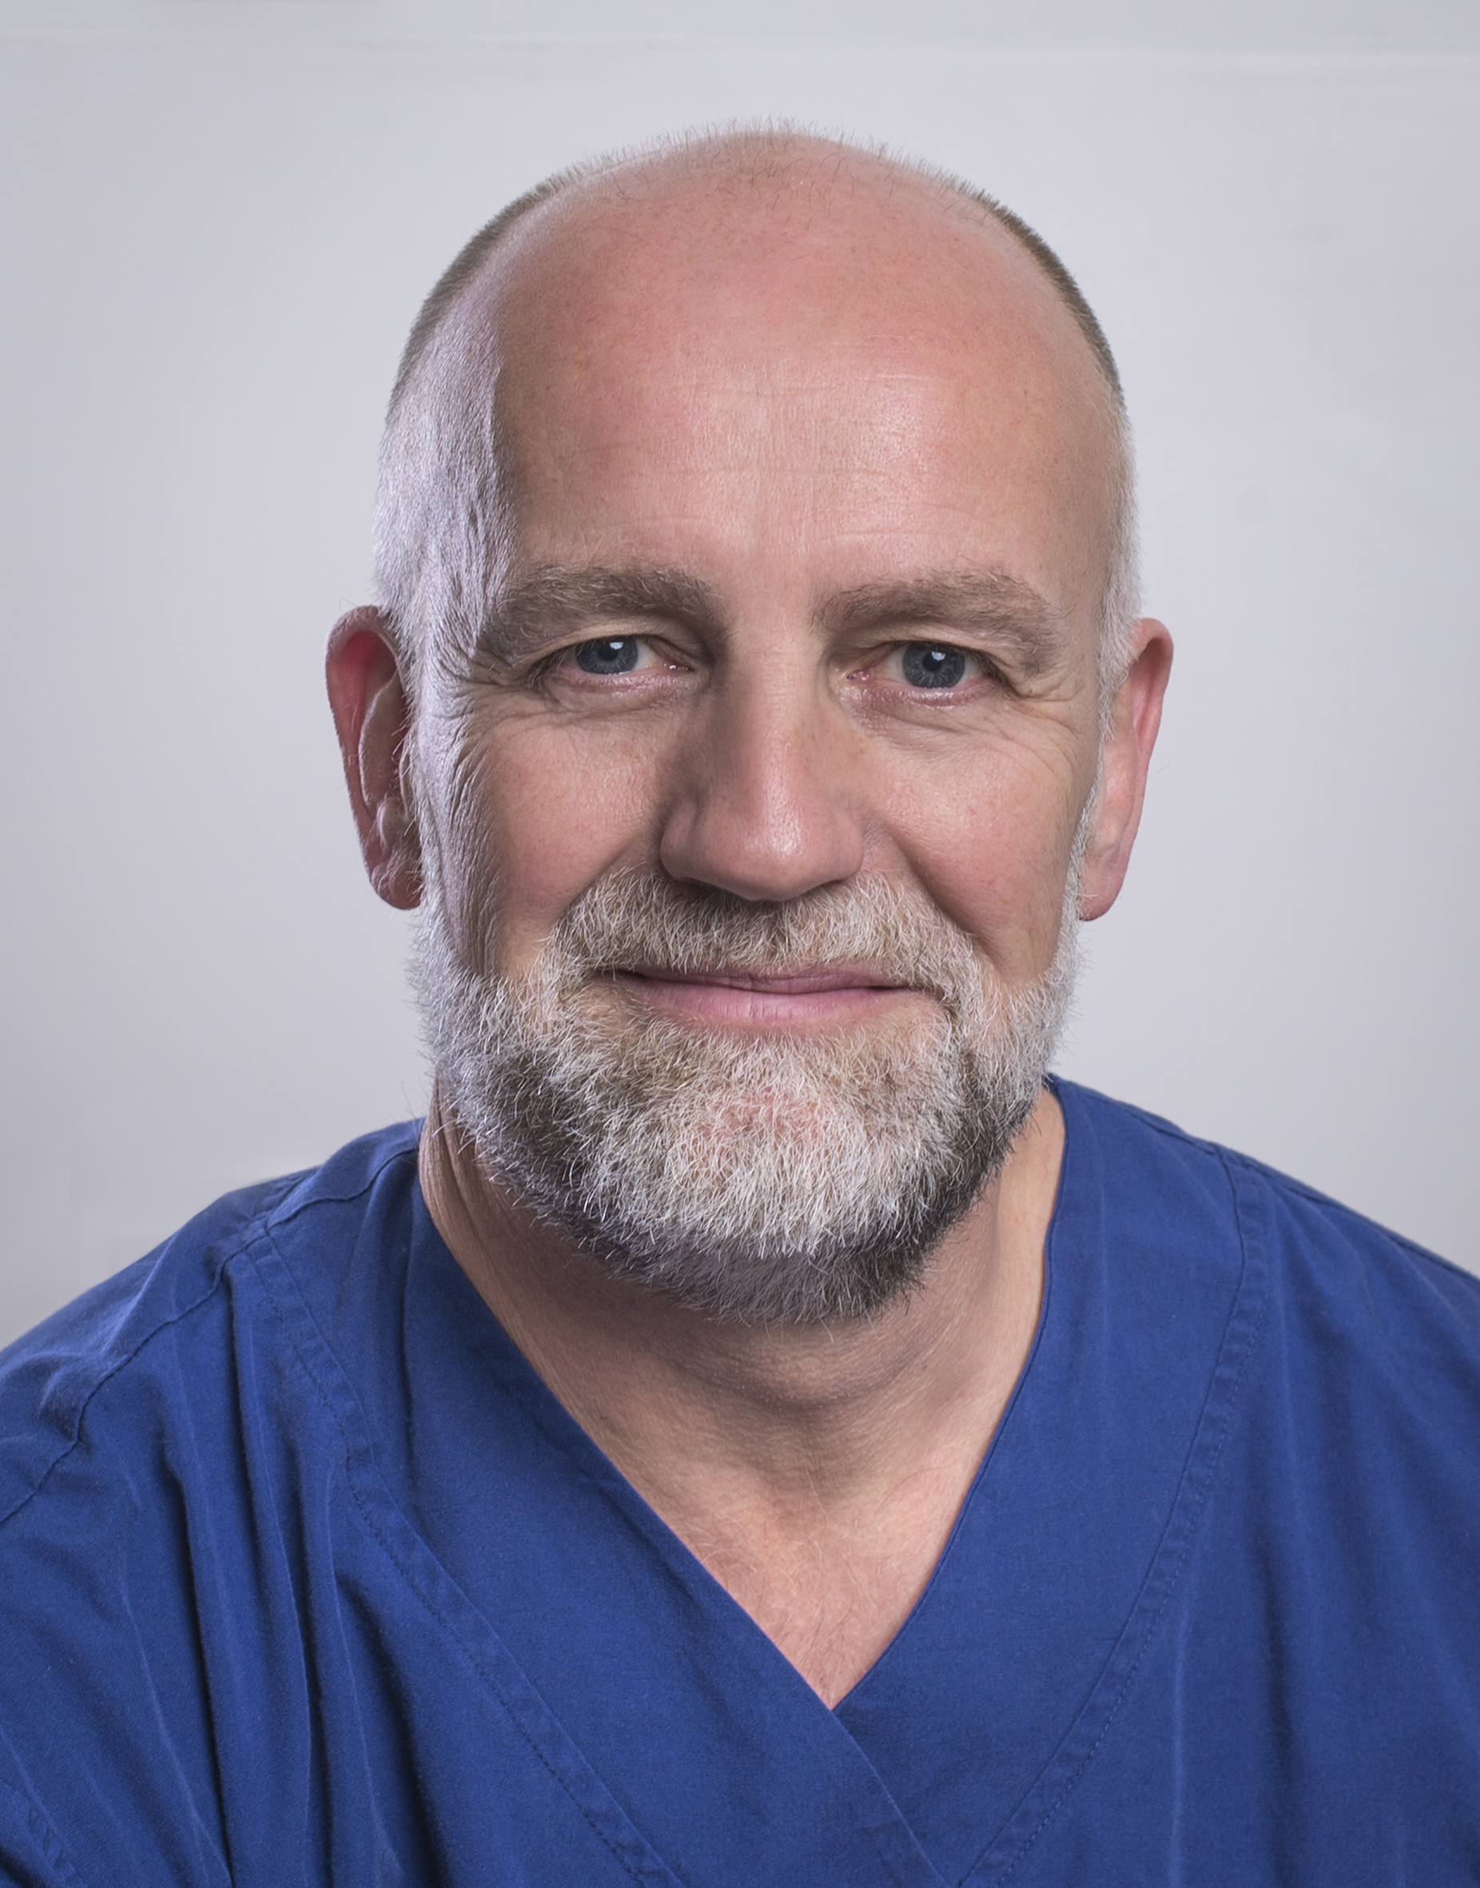
John Greenwood AM is an English-trained plastic surgeon who graduated from the University of Manchester in 1989 and now working full-time in burn care as the Medical Director of the Adult Burn Centre of the Royal Adelaide Hospital in Adelaide, South Australia. He has been developing skin replacement products, utilising the NovoSorb biodegradable polyurethane platform, since 2004. He was appointed Member of the Order of Australia (AM) following his work leading Australia’s only Burns Assessment Team after the carnage of the 2002 Bali Bombings which killed 202 civilians. He was the 2016 South Australian Australian of the Year.

Keywords: complex wounds;BTM;NovoSorb;polyurethane;dermal matrix

Desired presentation: Oral

Topic: According to the list of topics provided on the web site

Corresponding Author Details: Professor Dr John Edward Greenwood AM
Email: john.greenwood@sa.gov.au
Adult Burn Service, Level 7, G Wing, Royal Adelaide Hospital, Port Road,
Adelaide, South Australia, Australia
Telephone: +61-422-000809

