5th International Conference on Advances in Skin, Wound Care and Tissue Science
October 15-16, 2018 Rome, Italy

NovoSorb Biodegradable Temporising Matrix (BTM) - use in complex burn wounds
John Edward Greenwoodª*, Marcus James Dermott Wagstaff^{a,b}

ªAdult Burn Service, Royal Adelaide Hospital, Port Road, Adelaide 5000, South Australia, Australia
^{b}Department of Plastic and Reconstructive Surgery, Royal Adelaide Hospital, Port Road, Adelaide 5000, South Australia, Australia

Abstract
Introduction: The NovoSorb BTM is a completely synthetic bilayer material comprising a dermal component (2mm thick biodegradable polyurethane foam) bonded to a pseudoepidermis of non-biodegradable polyurethane film. Its primary function is to ‘temporise’ wounds, buying time for a definitive closure option to become available. Since the dermal foam becomes integrated and creates a neodermis, it is an ‘active’ temporiser, improving the wound bed for definitive closure.
Methods: During a pilot trial of BTM in 5 significant burn injured patients, and in 13 patients subsequently, several complex problems emerged. With careful planning and meticulous surgical technique, BTM has been used to overcome these problem wounds. Where bone has been exposed, denuded of periosteum or paracranium, two strategies have allowed BTM use, integration and successful closure with split skin grafts. Either the cortex has been drilled to allow granulation from the medulla within) or dermabraded off (exposing medulla, or calvarial diploie). BTM has also been used to reconstruct amputation stumps, where the extent of the burn has left poor coverage (allowing more distal amputation) and providing a significantly better and more robust stump for prosthesis application. Additionally, in several patients, part of, or the whole back, have been treated by BTM application, integrating despite allowing the patient to lie on them continually. Since the BTM is not yet regulated in Australia, these were treated under the Therapeutic Goods Administration (TGA) Authorised Prescriber Scheme. In all cases a photographic (and sometimes video) record has been taken at every procedure and review and each case will be discussed.
Results/Conclusions: The matrix integrated completely in all cases and graft take was uniformly excellent. There was no incidence of loss or problems with infection. Using BTM the matrix avoided major flap reconstructions in some patients, and yielded a far better result than graft alone in others.

Image
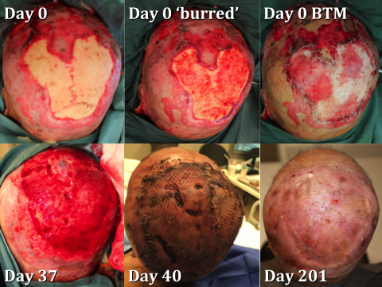
Figure - post-burn exposed calvarial reconstruction in a 96yr old man.
Recent Publications
1. JE Greenwood, MJD Wagstaff. ‘The use of biodegradable polyurethane in the development of dermal scaffolds’ Chapter 22 In Cooper SL & Guan J (Eds) ‘Advances in Polyurethane Biomaterials’ 2016. Woodhead Publishing Series in Biomaterials, (Elsevier Inc.), Duxford, UK. ISBN:978-0-08-100614-6.
2. JE Greenwood. ‘Hybrid biomaterials for skin tissue engineering’ Chapter 9 In Albanna MZ & Holmes JH IV (Eds) ‘Skin Tissue Engineering and Regenerative Medicine’ 2016. Academic Press (Elsevier Inc.), London, UK. ISBN:978-0-12-801654-1.
3. JE Greenwood, BL Dearman ‘Split-skin graft application over an integrating, biodegradable temporising polymer matrix: Immediate and delayed’ Journal of Burn Care and Research Jan/Feb2012;33(1):7-19.
4. JE Greenwood, BL Dearman ‘Comparison of a sealed, polymer foam biodegradable temporising matrix against Integra™ dermal regeneration template in a porcine wound model’ Journal of Burn Care and Research Jan/Feb2012;33(1):163-173.
5. BL Dearman, A Li, JE Greenwood ‘Optimisation of a Polyurethane Dermal Matrix and Experience with a Polymer-based Cultured Composite Skin’ Journal of Burn Care and Research 2014;35(5):437-448.
6. JE Greenwood, MJD Wagstaff, M Rooke, Y Caplash ‘Reconstruction of extensive calvarial exposure after major burn injury in two stages using a biodegradable polyurethane matrix’ ePlasty 2016;16:151-160.
7. JE Greenwood ‘The evolution of acute burn care - retiring the split skin graft (Hunterian Lecture)’ Annals of the Royal College of Surgeons of England 2017;99:432-438. Available at https://doi.org/10.1308/rcsann.2017.0110.

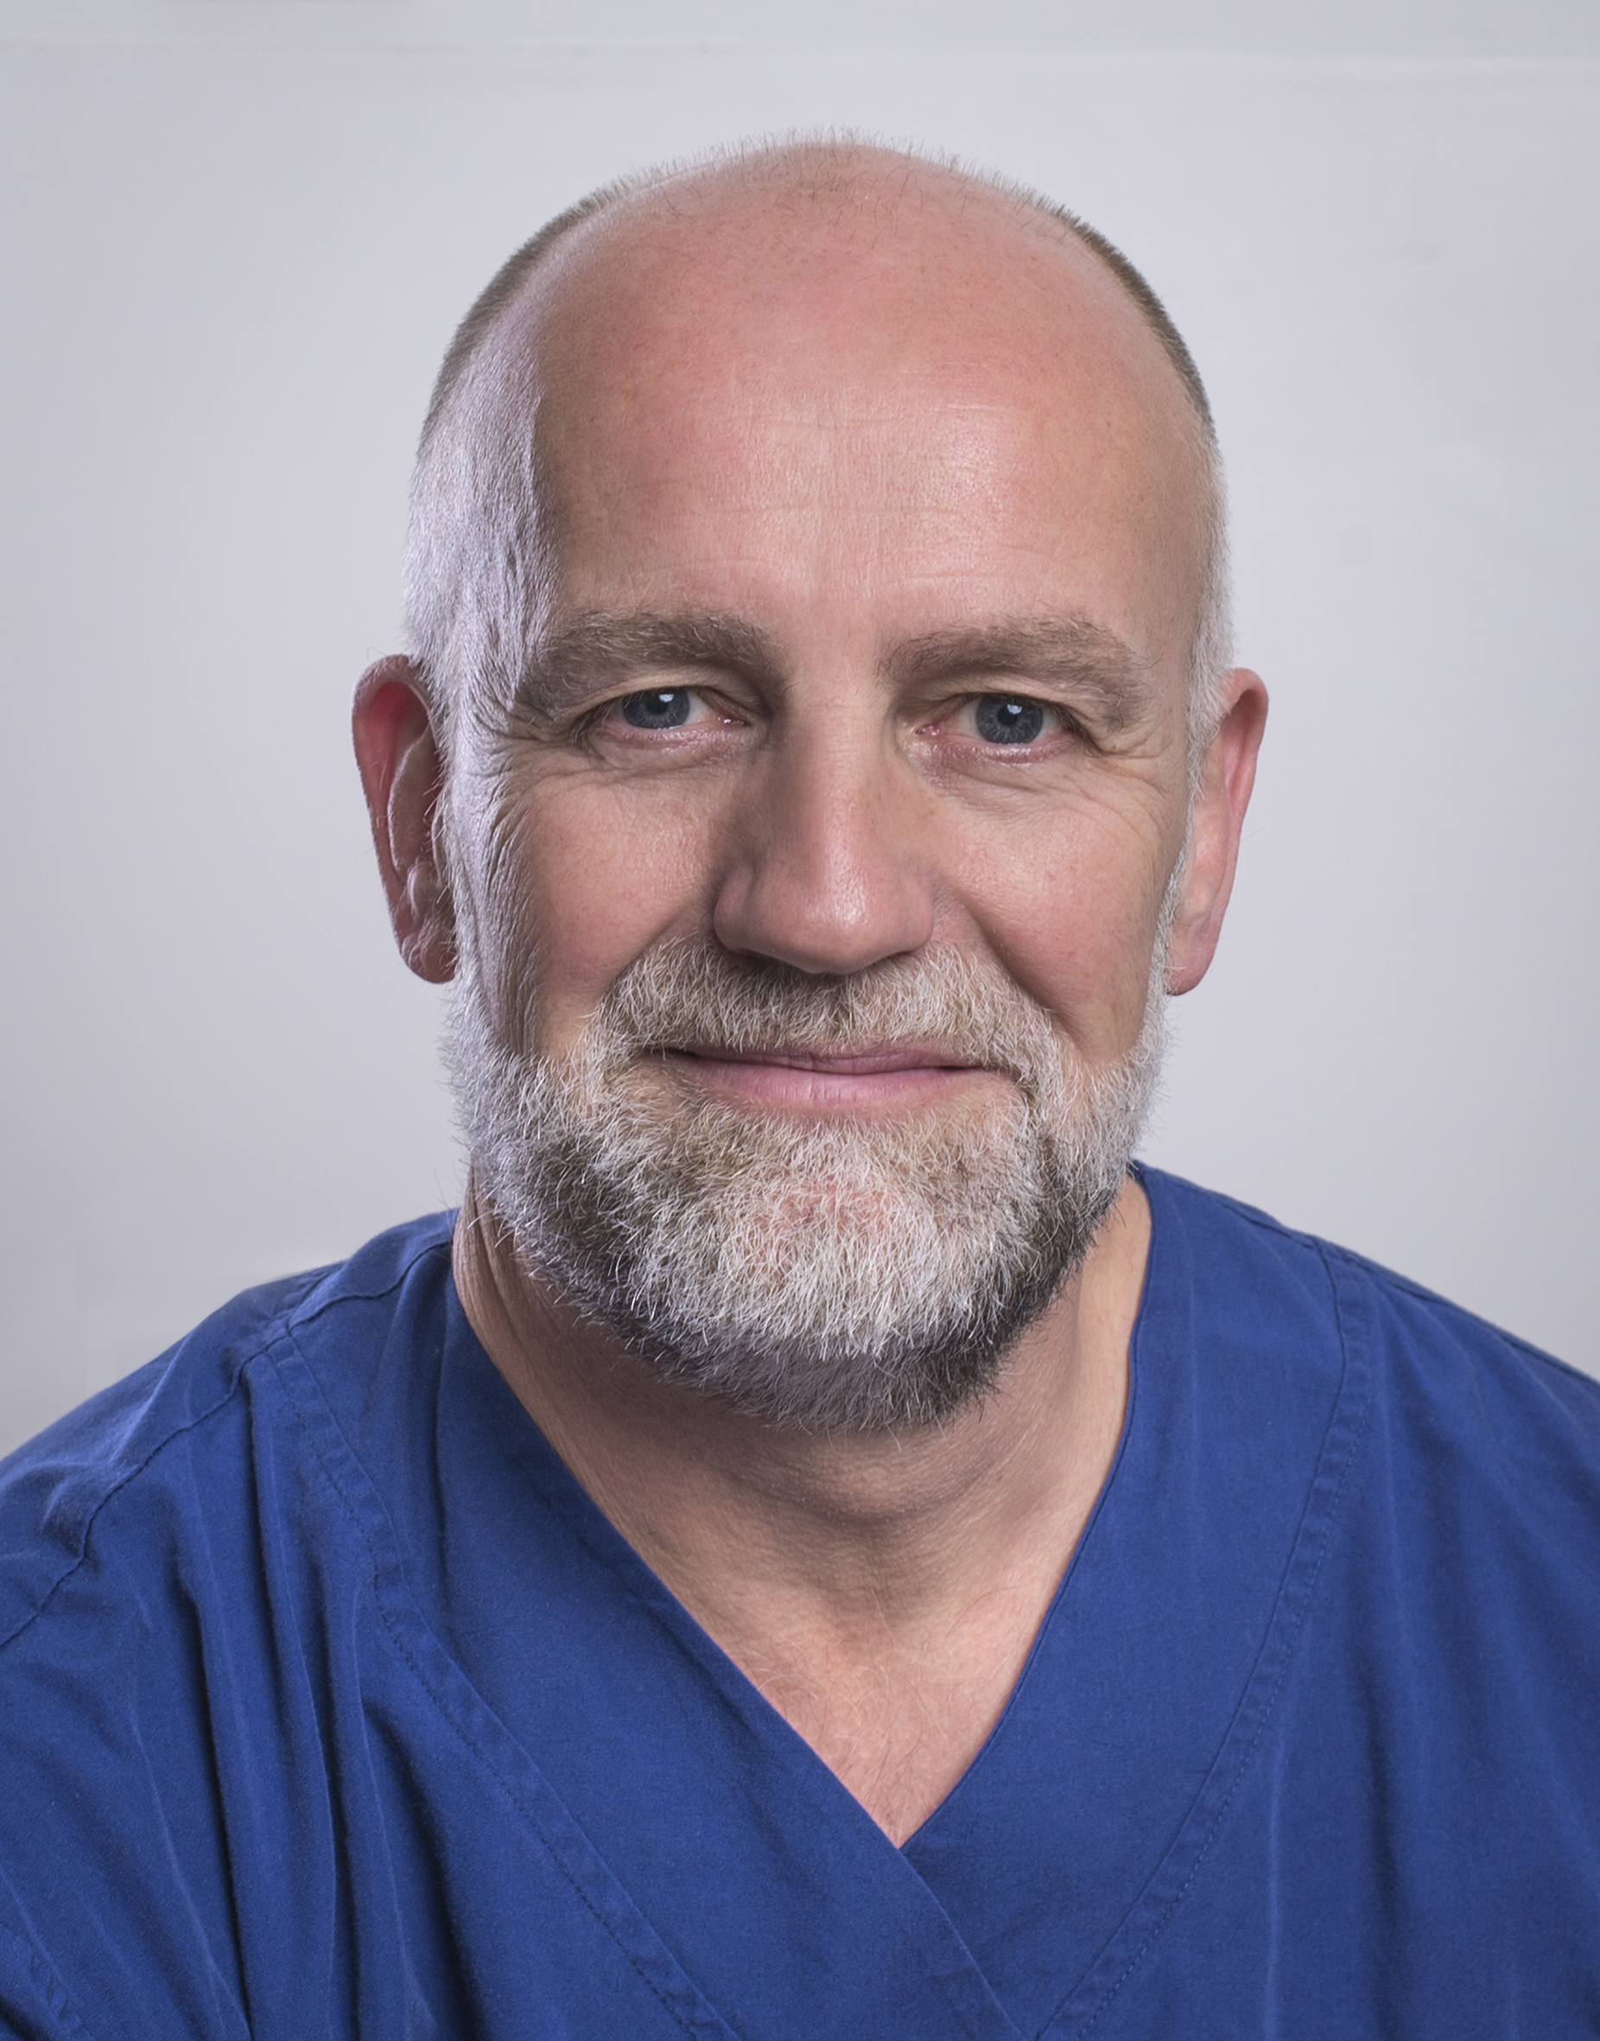
John Greenwood AM is an English-trained plastic surgeon who graduated from the University of Manchester in 1989 and now working full-time in burn care as the Medical Director of the Adult Burn Centre of the Royal Adelaide Hospital in Adelaide, South Australia. He has been developing skin replacement products, utilising the NovoSorb biodegradable polyurethane platform, since 2004. He was appointed Member of the Order of Australia (AM) following his work leading Australia’s only Burns Assessment Team after the carnage of the 2002 Bali Bombings which killed 202 civilians. He was the 2016 South Australian Australian of the Year.

Keywords: complex burn wounds;BTM;NovoSorb;polyurethane;dermal matrix

Desired presentation: Oral

Topic: According to the list of topics provided on the web site

Corresponding Author Details: Professor Dr John Edward Greenwood AM
Email: john.greenwood@sa.gov.au
Adult Burn Service, Level 7, G Wing, Royal Adelaide Hospital, Port Road,
Adelaide, South Australia, Australia
Telephone: +61-422-000809

