7th International Conference on Advances in Skin, Wound Care and Tissue Science
September 25-26, 2019 Copenhagen, Denmark

Study on wound healing after cutaneous lesion and reconstructed Autologous Pigmented Skin Dressing (APSD) in nude mice: GLP-study
J.C. Lepivert^{a,b}, E. Desnouveaub², V. Casoli ^{a,b}, M. Cario^{a, c}
ª INSERM 1035, University Bordeaux, 146 rue Leo Saignat, Bordeaux, France, 33076
^{b} Department of Plastic & reconstructive surgery, University Hospital, Place Amélie Rabat Léon Bordeaux, France;, 33 000
^{c} National Reference Center for Rare Skin Disease, Department of Dermatology, University Hospital, 1 rue Jean Burguet Bordeaux, France, 33 000

Abstract
Authors develop a biological dressing designed for patients presenting chronical wound, burn injury or congenital melanocytic naevus. The reconstructed skin is produced under Good Laboratory Practices (GLP). Subsequently, application of Autologous Pigmented Skin Dressing (APSD) on immunodeficient mouse model demonstrates its harmlessness and functionality with the required safety controls. Keratinocytes, melanocytes and fibroblasts were extracted from a patient’s biopsy and multiplied.
On top of the collagen matrix, fibroblasts were seeded to remodel collagen and secondly, keratinocytes and melanocytes were seeded to produce the epidermal layer. APSD was produced in 3 to 5 weeks. From July 2018 to July 2019, 4 groups of 7 mice were implanted. For each group, 6 mice were treated with Test Item and one mouse with collagen matrix alone as control. Defects of 6 cm² on dorsum of mice were done and covered with APSD or matrix alone. Wound healing, clinical behavior, adverse events, tumor development and mortality signs were checked every day. Groups 1, 3 and 4 healed well. Follow up demonstrated a good integration of APSD with minor retraction and a diffuse pigmentation. Group 2 had skin retraction that increased during weeks. In the control group, wounds did not heal and a complete skin retraction was present.
Bioengineered APSD demonstrated enthusiastic results regarding wound healing. It can be easily handled and shipped.
APSD groups healed well except one group for which the quality of cells was initially worse as compared to cells for the 3 other groups. A clinical trial is planned by mid-2020.

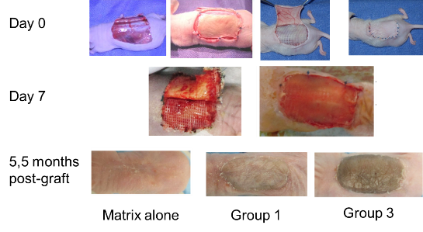
Image

Figure 1 : Procedure of graft of APSD on nude mice and macroscopic observation of APSD
Recent Publications
- Alet JM, Michot A, Desnouveaux E, Fleury M, Téot L, Fluieraru S, Casoli V (2019) .Collagen regeneration template in the management of full-thickness wounds: a prospective multicentre study. J Wound Care. 2019
- Cario M, Taieb A (2019) Isolation and Culture of Epidermal Melanocytes. Methods Mol Biol. 2019;1993:33-46.
- Leclère FM, Desnouveaux E, Choughri H, Casoli V (2018) Acellular dermal matrix: New applications for free flap pedicle coverage - A prospective study in 10 patients.J Cosmet Laser Ther. 2018.
- Salducci M, André N, Guéré C, Martin M, Fitoussi R, Vié K, Cario-André M (2014) Factors secreted by irradiated aged fibroblasts induce solar lentigo in pigmented reconstructed epidermis. Pigment Cell Melanoma Res.
- Cario-André M, Pain C, Gauthier Y, Casoli V, Taieb A (2006) In vivo and in vitro evidence of dermal fibroblasts influence on human epidermal pigmentation. Pigment Cell Res.
- Casoli V, Cario-André M, Costet P, Pain C, Taïeb A (2004) Comparison of long-term survival of pigmented epidermal reconstructs cultured in vitro vs. xenografted on nude mice. Pigment Cell Res. Feb;17(1):87-92.

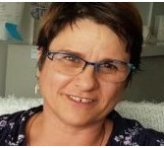
Biography Dr. Cario has been Graduated from University of Bordeaux in 2000 as Physician Doctor in Biological and Medical sciences, with the specialties including cellular biology, molecular biology histopathology and dermatology. Later on, she obtained her diploma in Methods in clinical research and her HDR entitled Physiopathology of pigmentation in 2017 from University of Bordeaux. Presently she is the team leader of the "Physiopathology of pigmentation and tissue engineering group" of INSERM 1035 and the co-manager of Aquiderm a technology transfer unit specialized especially in skin engineering and evaluation of efficacy of cosmetic Products

Keywords:, fibroblasts, keratinocytes, skin engineering, pigmentation

Desired presentation: _ Oral / _ Poster / _ either

Topic : Advances in skin &wound care

Corresponding Author Details: Muriel Cario , PhD
INSERM 1035
National Reference Center for Rare Skin Diseases
Aquiderm
University Bordeaux
146 rue Leo Saignat,
33076 Bordeaux cedex
France
T : 33557571432
e-mail : muriel.cario-andre@u-bordeaux.fr

