7th International Conference on Advances in Skin, Wound Care and Tissue Science

September 25-26, 2019 Copenhagen, Denmark

Fabrication of Pomegranate /Honey Nanofibers for Use as Antibacterial Wound Dressings
Sara S. Abou Zekry ¹, Ahmed Abdellatif ^{2, *}, Hassan M. E. Azzazy ^{3, *}
¹ Biotechnology program, ² Department of Biology, ³ Department of Chemistry, School of Sciences and Engineering, American university in Cairo, New Cairo, 11835, Egypt.
Recent Publications
1- Diana G. Sami, Hana H. Heiba, Ahmed Abdellatif (2019) Wound healing models: A systematic review of animal and non-animal models. Wound Medicine 24 (2019), 8-17.
2- Balbaa, A. O., El-Fattah, A. A., Awad, N. M., & Abdellatif, A. (2019). Effects of nanoscale electric fields on the histology of liver cell dysplasia. Nanomedicine, 8(1), 515-528.‏

3-Wessam A Sarhan & Hassan ME Azzazy (2017) Apitherapeutics and phage-loaded nanofibers as wound dressings with enhanced wound healing and antibacterial activity. Nanomedicine, 12(17), 2055-2067.
4-Wessam A. Sarhan, Hassan M. E. Azzazy, and Ibrahim M. El-Sherbiny (2016) Honey/Chitosan Nanofiber Wound Dressing Enriched with Allium sativum and Cleome droserifolia: Enhanced Antimicrobial and Wound Healing Activity. ACS Applied Materials & Interfaces 8 (10), 6379-6390.

5- Sarhan, W. A., Azzazy, H. M., & El-Sherbiny, I. M. (2016). The effect of increasing honey concentration on the properties of the honey/polyvinyl alcohol/chitosan nanofibers. Materials Science and Engineering: C, 67, 276-284.‏

6-Sara S, Abou Zekry, Ahmed Abdellatif, Hassan Azzazy Fabrication of Pomegranate/Honey Nano-fibers for Use as Antibacterial Wound Dressings (in press).
7- Histological and clinical evaluation of wound healing in a Novel Animal Model of Pressure Ulcer.
Diana G. Sami, Ahmed Abdellatif (in press).

Image
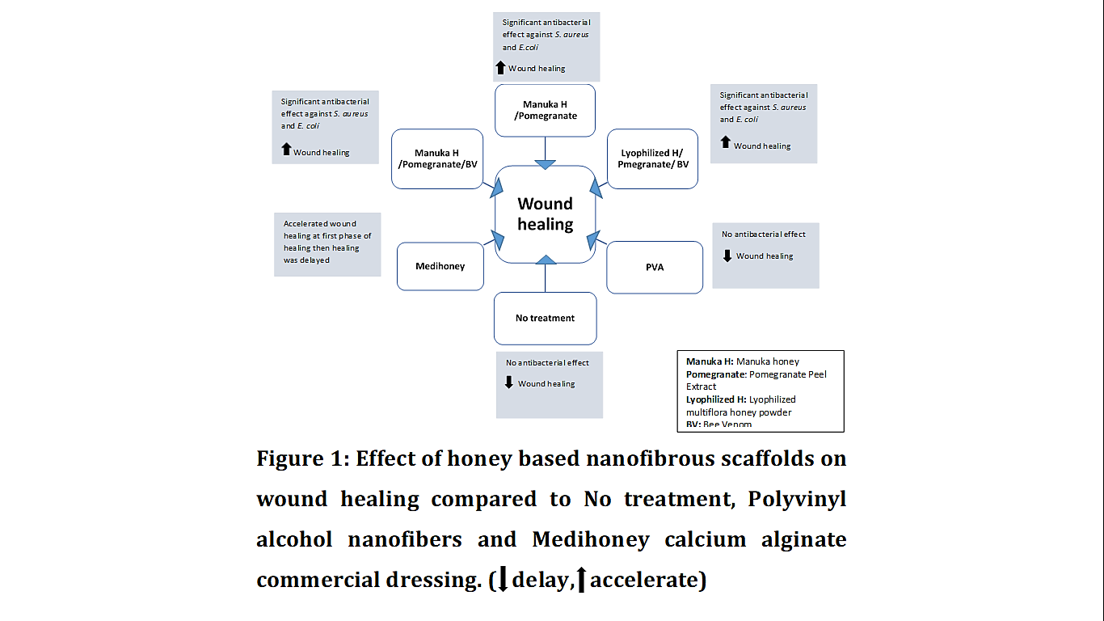

Abstract
Honey, pomegranate peel extract (PPP) and bee venom (BV), were used in combination with polyvinyl alcohol (PVA) to develop a novel nanofibrous wound dressing. Methanolic PPP was prepared and mixed with either manuka honey (MH) or lyophilized multiflora honey powder (LH) together with BV to have a total of three formulas: MH/PPP, MH/PPP/BV and LH/PPP/BV. The formulas were tested for their antibacterial activity, cytotoxicity, and wound healing activity in an excisional wound rat model. Scanning electron microscopy showed that LH fibers had smaller and more uniform diameter than MH fibers. Moderate swelling and higher weight loss capacities were detected when compared to PVA mats. Antibacterial tests showed significant antibacterial activity against S. aureus and E. coli compared to negative controls (P < 0.0001). No cytotoxicity was observed. In vivo wound healing study showed that all treatment groups enhanced wound healing as shown by increased wound closure percentages compared to negative control groups at days 3,5 and 10 (P < 0.0001), and histological examination. In comparison to treatment groups, Medihoney® calcium alginate dressing significantly enhanced healing compared to negative controls at days 3 and 5. However, healing was delayed afterwards. These results indicate that MH/PPP/BV nanofibers are promising for wound healing.



Biography

Sara S. Abouzekry earned B.Sc. in Pharmacy from Ain Shams University, Cairo, Egypt in 2007. Later on, she obtained her Master of Science degree in Biotechnology from The American University in Cairo, Egypt early this year. Sara is interested in biomedical applications of nanofibers in wound healing. In her thesis project, multiple natural products known for their antibacterial and anti-inflammatory properties were electrospun into nanofibers in order to test their wound healing activity. Currently she is working on developing new formulas for wound healing while working as a research assistant in the biology department in the American University in Cairo.

Desired presentation: X Oral / _ Poster / _ either

Topic : Skin and Wound Dressings
Corresponding Author Details: Ahmed Abdellatif & Hassan M. E. Azzazy
School of Sciences and Engineering
American University in Cairo
AUC Avenue, P.O. Box 74
New Cairo 11835 Egypt

