Topic: The impact of appropriate assessment of pressure ulcer among clinicians.
Author name: Abdulaziz Binkanan

According to the study of Tayyib, Coyer and Lewis (2016), the rate of pressure ulcers (PU) in hospitalized patients has increased. Therefore, the appropriate assessment of pressure ulcer plays a crucial rule and has a huge impact on variety of aspects such as the evaluation, treatment plan and level of risk (Manganese et al., 2017). Engles et al. (2016) stated that appropriate assessment of wounds in pressure ulcer is the key factor that helps in limiting the further growth of pressure ulcer. Moreover, Early assessment practices help in understanding different patterns of the patient life such as nutrition, mental status, mobility and physical activity of a person. Thus, proper or appropriate assessment help clinicians to understand patient needs by which they understand the factors which has caused pressure ulcer.

According to Eva (2016), the assessment is the fundamental tool which impacts on diagnostic practices of clinicians in an efficient way (Eva et al., 2016).
By taking appropriate assessment of patient with pressure ulcer, healthcare professionals evaluate that to which extent patient needs treatment and prevention of pressure ulcer. On the other hand, by taking assessment of pressure ulcer, clinicians undertake the prolonged course of treatment so as to fully heal the wounds. In addition, Appropriate assessment help clinicians to diagnose that how a person gained an ulcer, for example, the study of Park, Lee and Kwon (2016), examined that clinicians diagnose the reasons which cause skin tissues damage as a result at such part or area of damage skin the supply of blood is reduced, and due to the lack of blood supply, a person could diagnosed with pressure ulcer. (EPUAP and NPUAP guidelines).

According to the study of Lee, and Kim (2016), healthcare practitioners were involved in an assessment process with the intention to determine the prevalence of pressure ulcer cases in the England. They found 24,674 patients with adverse PU condition. Proper assessment has provided assistance to clinicians to perceive the information of patients’ urinary incontinence, smoking, dry skin, terminal illness and chronic systemic condition; these are all the major symptoms which originates PU in old people. The study of Guy (2019), comprehends that clinicians who do not perform assessment cannot diagnose reasons that what activities the patient needs to stop. Therefore, diagnosis and assessment empower clinicians to consider different ways that can allow patient to prevent skin from damaging.

Areas which help clinicians to determine the risk of developing pressure Ulcer by Braden Scale, Table-1
Sensory
Perception
Moisture
Activity
Nutrition
friction and shear

Table 1: Areas which help clinicians to determine the risk of developing pressure ulcer based on
Braden Scale

Assessment also allows management to perceive the parameters like length, width and depth of pressure ulcer. According to the management guidelines of the National Patient Safety Agency (NPSA) assessment plays a critical role in determining solution to the problems such as pressure ulcer disease in patients (Boyko, Longaker and Yang, 2018). Moreover, assessment practice is the golden standard in diagnosing, treatment and management of PU.

Appendix:

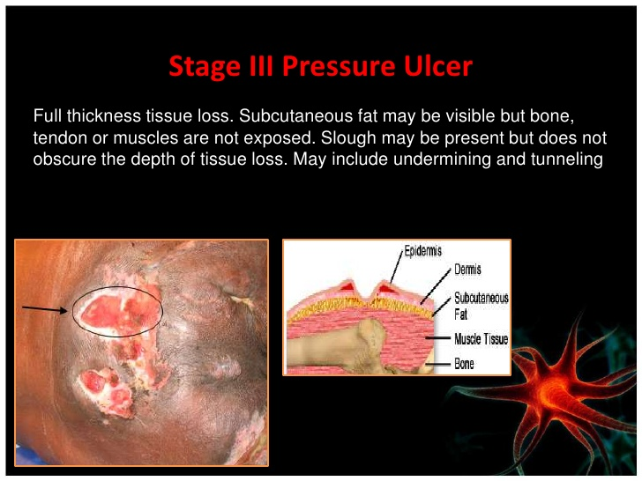
Figure 1: Pressure ulcer assessment and management. Source: https://www.slideshare.net/FurqanKhan1/pressure-ulcer-assessment-and-management

References
Andrade, C.C.D., Almeida, C.F.D.S.C., Pereira, W.E., Alemão, M.M., Brandão, C.M.R. and Borges, E.L., 2016. Costs of topical treatment of pressure ulcer patients. Revista da Escola de Enfermagem da USP, 50(2), pp.295-301.
Bae, J.M., 2015. Value-based medicine: concepts and application. Epidemiology and health, 37.
Baugh, C.M., Kroshus, E., Stamm, J.M., Daneshvar, D.H., Pepin, M.J. and Meehan III, W.P., 2016. Clinical practices in collegiate concussion management. The American journal of sports medicine, 44(6), pp.1391-1399.
Benbow, M., 2012. Management of pressure ulcers. [online] Available at: https://www.nursinginpractice.com/article/management-pressure-ulcers
Benbow, M., 2016. Best practice in wound assessment. Nursing Standard (2014+), 30(27), p.40.
Boyko, T.V., Longaker, M.T. and Yang, G.P., 2018. Review of the current management of pressure ulcers. Advances in wound care, 7(2), pp.57-67.
Choi, E.P., Chin, W.Y., Wan, E.Y. and Lam, C.L., 2016. Evaluation of the internal and external responsiveness of the Pressure Ulcer Scale for Healing (PUSH) tool for assessing acute and chronic wounds. Journal of advanced nursing, 72(5), pp.1134-1143.
Cook, J.R., Hausman, E.M., Jensen-Doss, A. and Hawley, K.M., 2017. Assessment practices of child clinicians: Results from a national survey. Assessment, 24(2), pp.210-221.
Engels, D., Austin, M., McNichol, L., Fencl, J., Gupta, S. and Kazi, H., 2016. Pressure ulcers: factors contributing to their development in the OR. AORN journal, 103(3), pp.271-281.
Eva, K.W., Bordage, G., Campbell, C., Galbraith, R., Ginsburg, S., Holmboe, E. and Regehr, G., 2016. Towards a program of assessment for health professionals: from training into practice. Advances in Health Sciences Education, 21(4), pp.897-913.
Fabbruzzo-Cota, C., Frecea, M., Kozell, K., Pere, K., Thompson, T., Thomas, J.T. and Wong, A., 2016. A clinical nurse specialist–led interprofessional quality improvement project to reduce hospital-acquired pressure ulcers. Clinical Nurse Specialist, 30(2), pp.110-116.
Greenwood, C. and McGinnis, E., 2016. A retrospective analysis of the findings of pressure ulcer investigations in an acute trust in the UK. Journal of tissue viability, 25(2), pp.91-97.
Guy, H., 2019. Best practice: pressure ulcer risk assessment and grading. Learning disabilities, 4, p.00.
Han, G. and Ceilley, R., 2017. Chronic wound healing: a review of current management and treatments. Advances in therapy, 34(3), pp.599-610.
Kennedy-Malone, L., Martin-Plank, L. and Duffy, E., 2018. Advanced practice nursing in the care of older adults. FA Davis.
Lee, Y.J., Kim, J.Y. and Korean Association of Wound Ostomy Continence Nurses, 2016. Effects of pressure ulcer classification system education programme on knowledge and visual differential diagnostic ability of pressure ulcer classification and incontinence‐associated dermatitis for clinical nurses in Korea. International wound journal, 13, pp.26-32.
Manganese, D., Medina, J., Collazos, D. and Simpson, T., 2017. Complete Offloading Cushion for Wheelchair Bound Patients.
Mishu, M.C. and Schroeder, J.W., 2015, July. Modelling of pressure ulcer (PU) risk prediction system. In 2015 Science and Information Conference (SAI) (pp. 650-656). IEEE.
Park, S.H., Lee, Y.S. and Kwon, Y.M., 2016. Predictive validity of pressure ulcer risk assessment tools for elderly: a meta-analysis. Western Journal of Nursing Research, 38(4), pp.459-483.
Payne, D., 2016. Strategies to support prevention, identification and management of pressure ulcers in the community. British journal of community nursing, 21(Sup6), pp.S10-S18.
Richardson, A., Peart, J., Wright, S.E. and McCullagh, I.J., 2017. Reducing the incidence of pressure ulcers in critical care units: a 4-year quality improvement. International Journal for Quality in Health Care, pp.1-7.
Smith, I.L., Nixon, J., Brown, S., Wilson, L. and Coleman, S., 2016. Pressure ulcer and wounds reporting in NHS hospitals in England part 1: audit of monitoring systems. Journal of tissue viability, 25(1), pp.3-15.
Tayyib, N., Coyer, F. and Lewis, P.A., 2016. Implementing a pressure ulcer prevention bundle in an adult intensive care. Intensive and Critical Care Nursing, 37, pp.27-36.
Vélez-Díaz-Pallarés, M., Lozano-Montoya, I., Correa-Pérez, A., Abraha, I., Cherubini, A., Soiza, R.L., O’Mahony, D., Montero-Errasquin, B. and Cruz-Jentoft, A.J., 2016. Non-pharmacological interventions to prevent or treat pressure ulcers in older patients: Clinical practice recommendations. The SENATOR-ONTOP series. European Geriatric Medicine, 7(2), pp.142-148.

Biography:
Mr. Abdulaziz Binkanan graduated from King Saud University in Saudi Arabia as Nursing Specialist. Then he started working in King Saud Medical City. Later on, he obtained his master’s degree from De Montfort University in United Kingdom and he’s still working at King Saud Medical City in the capital of Saudi Arabia.

