7th International Conference on Advances in Skin, Wound Care and Tissue Science
September 25-26, 2019 Copenhagen, Denmark

Diverse Biological Functions of Thrombomodulin in Cells and Wound Healing
Hua-Lin Wu^{1,2,3,*}, Guey-Yueh Shi^{1,2}, and Yi-Kai Hong^{1,2,3}
¹The Institute of Basic Medical Sciences, College of Medicine, National Cheng Kung University, Tainan, Taiwan.
²Department of Biochemistry and Molecular Biology, College of Medicine, National Cheng Kung University, Tainan, Taiwan.
³International Center of Wound Repair and Regeneration, College of Medicine, National Cheng Kung University, Tainan, Taiwan.

Abstract
Thrombomodulin (TM) is a type I transmembrane glycoprotein that was formerly identified as an anticoagulant factor in endothelial cells (ECs) in 1982. It can form a complex with thrombin to facilitate the activation of protein C in the blood circulation. The activated protein C will catalyze the cleavage and inactivation of coagulation factors to constrain the blood coagulation cascade. However, TM was also identified in various cell types which do not have direct contact with blood circulation, indicating that TM may have distinct biological functions in different cell types and contexts.
In our studies we demonstrated that TM was highly concentrated at the cell-cell contact region in ECs and keratinocytes, where it functions as an adhesion protein, in conjunction with cadherin/occludin, to stabilize cell-cell junctions. Moreover, we also demonstrated that lectin domain of TM is essential for cell-cell adhesion and LeY oligo-saccharide is the ligand of the lectin domain. The cytoplasmic domain of TM can be anchored to F-actin through actin linker protein ezrin. In addition, TM expression is involved in the epithelial/mesenchymal transition in cancer cells.
On the other hands, we demonstrated that TM functions as a novel plasminogen (Plg) receptor in migrating cells. The dissociation constant of Plg and TM is about 10⁻⁷M as determined by Biacore plasma resonance system. TM, plg and urokinase Plg activator was colocalized at the leading edges in the migrating ECs. It is possible that TM expression can promote Plg activation to facilitate the pericellular proteilysis in front of migrating ECs to facilitate cell migration, invasion and angiogenesis.

Image

Recent Publications
- Hong Y.-K, Lee Y.-C, Cheng T.-L, Lai C.-H, Hsu C.-K, Kuo C.-H, Hsu Y.-Y, Li J.-T, Chang B.-I, Ma C.-Y, Lin S.-W, Wang K.-C, Shi G.-Y, and Wu H.-L. (2019) Tumor endothelial marker 1 (TEM1/endosialin/CD248) enhances wound healing by interacting with platelet-derived growth factor receptors. J Invest Dermatol. DOI:10.1016/j.jid.2019.03.1149.
- Cheng T.-L., Chen P.-K., Huang W.-K., Kuo C.-H., Cho .-F.,
Wang K.-C., Shi G.-Y., Wu H.-L., Lai C.-H.. (2018) Plasminogen/thrombomodulin signaling enhances VEGF expression to promote cutaneous wound healing. Journal of Molecular Medicine, DOI : 10.1007/s00109-018-1702-1.
- Lai, C.-H., Wang, K.-C., Kuo, C.-H., Lee, F.-T., Cheng, C.-L., Chang, B.-I., Yang, Y.-J., Shi, G.-Y., Wu, H.-L. (2017) Recombinant adeno-associated virus vector carrying the thrombomodulin lectin-like domain for the treatment of abdominal aortic aneurysm. Atherosclerosis, 262 ,62-70.
- Lin, W.-L., Chen, C.-C., Shi, G.-Y., Ma, C.-Y., Chang, C.-F. and Wu, H.-L. (2017). Monocytic thrombomodulin promotes cell adhesion through interacting with its ligand, Lewis Y. Immunology and Cell Biology, 95: 372–379.
- Cheng, T.-L., Lai, C.-H., Shieh, S.-J., Jou, Y.-B., Yeh, J.-L., Yang, A.-L., Wang, Y.-H., Wang, C.-Z., Chen, C.-H., Shi, G.-Y., Ho, M.-L., Wu, H.-L. (2016). Myeloid thrombomodulin lectin-like domain inhibits osteoclastogenesis and inflammatory bone loss. Sci Rep, 6:28340.

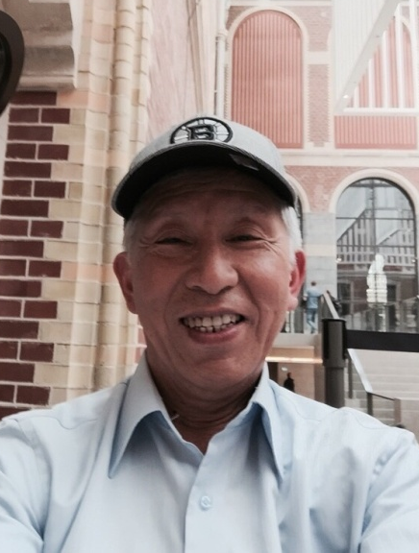

Biography

Cardiovascular disease is still an important global health problem. Vascular Biology is the major research interest in my lab. Thrombomodulin is a transmembrane protein in vascular endothelial cells and keratinocytes. It can regulate blood coagulation by activating protein C, which in turn inhibits blood coagulation by inactivation of factors Va and VIIIa. Thrombomodulin plays an important role in cell-cell adhesion. It can regulate the distribution of plasminogen and migration of endothelial cells. Recently we also demonstrated that it can regulate inflammation responses by association with CD14 and monocyte adhesion to inflammatory endothelial cells. We also interested in the role of thrombomodulin in wound healing and in vascular diseases including atherosclerosis and aortic aneurysm using tissue specific gene knockout mice and recombinant proteins.

Keywords: Thrombomodulin, cell-cell adhesion, angiogenesis, inflammation, vascular disease, and wound healing

Desired presentation: Oral

Topic: Skin and Wound Healing, Wound Healing and Tissue Repair

Corresponding Author Details:
Author Name: Hua-Lin Wu
e-mail Address: halnwu@mail.ncku.edu.tw
Organization/University: Department of Biochemistry and Molecular Biology, College of Medicine, National Cheng Kung University
City, State, Country: Tainan 701, Taiwan, ROC.
Telephone Number, Fax Number: +886-6-2353535, Ext. 5541

