7th International Conference on Advances in Skin, Wound Care and Tissue Science
September 25-26, 2019 Copenhagen, Denmark

The Synergistic Effect of Tumor Endothelial Marker 1 and Platelet-Derived Growth Factor in Wound Healing
Yi-Kai Hong^{1,2,3}, Guey-Yueh Shi^{1,2}, and Hua-Lin Wu^{1,2,3,*}
¹The Institute of Basic Medical Sciences, College of Medicine, National Cheng Kung University, Tainan, Taiwan.
²Department of Biochemistry and Molecular Biology, College of Medicine, National Cheng Kung University, Tainan, Taiwan.
³International Center of Wound Repair and Regeneration, College of Medicine, National Cheng Kung University, Tainan, Taiwan.

Abstract
Tumor endothelial marker 1 (TEM1), also known as endosialin or CD248, is a type I transmembrane glycoprotein containing a C-type lectin-like domain. It is specifically expressed in smooth muscle cells, pericytes, and fibroblasts. Dermal fibroblasts play a pivotal role in during cutaneous wound healing, especially in the proliferative and remodeling phases. However, the mechanism by which TEM1 physiologically regulate wound healing remains to be unexplored. In the process of wound healing, both TEM1 and platelet-derived growth factor (PDGF) receptor α (PDGFRα) expressions were significantly up-regulated in myofibroblasts in the granulation tissues. A delayed wound healing was observed in TEM1 deficiency mice. Fibroblast activation, collagen deposition, and proliferation of fibroblasts were decreased in granulation tissues in the wounds of TEM1-deleted mice. The migration, adhesion, and proliferation activities in NIH3T3 cells were attenuated when TEM1 expression was knockdown by short hairpin RNA. The signal transduction, mitogenic, and chemoattractive effects induced by PDGF-BB were inhibited by TEM1 silencing. Furthermore, TEM1 and PDGFRα were co-localized in sub-cellular organelles in dermal fibroblasts. The association of TEM1 and PDGFRα was also demonstrated by co-immunoprecipitation. In conclusion, we demonstrated that TEM1, in cooperation with PDGFRα, plays a critical role in wound healing by enhancing the mitogenic and chemoattractive effects of PDGF-BB and collagen deposition in myofibroblasts.

Image
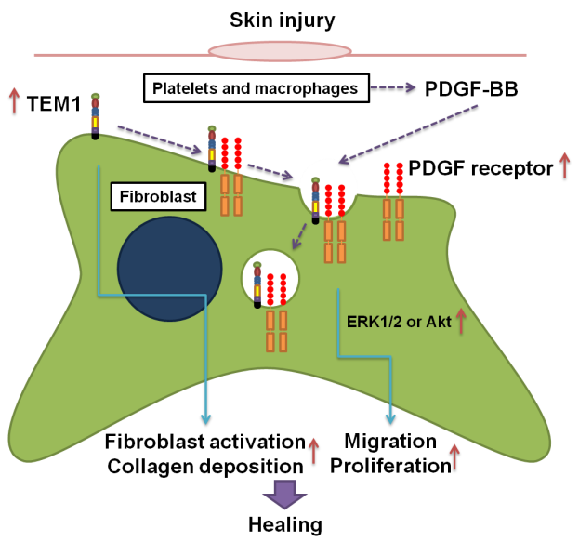
Wounding induces the protein expression of TEM1 and PDGF receptor. TEM1 interacts with PDGF receptor in the activated fibroblasts to regulate PDGF-BB-mediated migration and proliferation in fibroblasts via ERK and Akt signaling pathways. TEM1 also governs the expression of α-SMA and collagen production. In conclusion, TEM1expression in fibroblasts plays a critical role in wound healing process by enhancing the biological responses to FDGF-BB and collagen deposition in fibroblasts.

Recent Publications
- Hong YK, Lee YC, et al. Tumor Endothelial Marker 1 (TEM1/endosialin/CD248) Enhances Wound Healing by Interacting with Platelet-Derived Growth Factor Receptors. J Invest Dermatol. 2019 Apr 12. pii: S0022-202X(19)31480-0.

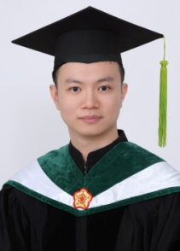
Biography

I’m Yi-Kai Hong, a Ph.D. candidate in Institution of Basic Medical Sciences of National Cheng Kung University in Taiwan. My research project is to investigate the biological function of tumor endothelial marker 1 (TEM1), which is also known as endosialin, in skin fibroblasts. TEM1 is a type I trans-membrane glycoprotein, which belongs to the same family as thrombomodulin. We demonstrated that TEM1 was up-regulated in the wound. However, the effects of TEM1 on wound healing are still unknown. Wound healing in TEM1 knockout mice was significantly slowed in comparison to controls. Moreover, the proliferation, migration, and activation in fibroblasts in the wound were also significantly down regulated. We further demonstrated that TEM1 may play a critical role in platelet-derived growth factor induced signaling pathways and cell functions. More importantly, we demonstrated that TEM1 was a mediator of platelet-derived growth factor receptor α.

Keywords: Tumor endothelial marker 1, cutaneous wound healing

Desired presentation: Oral/Poster

Topic: Skin and Wound Healing, Wound Healing and Tissue Repair

Corresponding Author Details:
Author Name: Hua-Lin Wu
e-mail Address: halnwu@mail.ncku.edu.tw
Organization/University: Department of Biochemistry and Molecular Biology, College of Medicine, National Cheng Kung University
City, State, Country: Tainan 701, Taiwan, ROC.
Telephone Number, Fax Number: +886-6-2353535, Ext. 5541

