THE EFFECT OF EDUCATIONAL PROGRAM ON NURSES’ KNOWLEDGE ABOUT PRESSURE ULCER
ABDULAZIZ BINKANAN
KING SAUD MEDICAL CITY

Pressure ulcer is a global issue and lack of knowledge about pressure ulcer among nurses been found. Therefore, the aim of this study is to determine the effectiveness of an educational program on nurses’ knowledge related to pressure ulcer. Moreover, if they have lack of knowledge related to pressure ulcer or the prevention and care of the pressure ulcer, then the lack of knowledge can be eliminated by the educational program or not.
52 registered nurses work in a medical city participated in this study and deal with pressure ulcer on daily basis. quasi- experimental design in which the study has two parts (Quantitative). A pre-test and post-test design used. A questionnaire distributed to the nurses to assess their knowledge before conducting the educational program. Then the educational program delivered to them. After that, the same questionnaire given to them for comparison. After the collection of data, the ratio of the correct answers of the pre-test and post-test were compared. Statistical Package for Social Science used.
After implementing the educational program majority of nurses provided the correct answers to the same questionnaire and the lack of knowledge can be eliminated by the educational program. Moreover, around 25% correct answers of the questionnaire while in the post-test, the nurses gave approximately 97% correct answers.

Table 1 to show the Tests of Normality
 | Kolmogorov-Smirnova |  |  | Shapiro-Wilk
 | Statistic | df | Sig. | Statistic | df | Sig.
Score before Education  Score after Education | .100  .232 | 52  52 | .200  .000 | .970  .644 | 52  52 | .202  .000

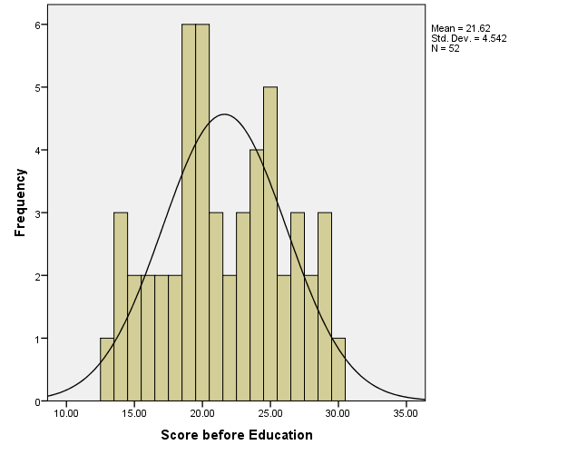

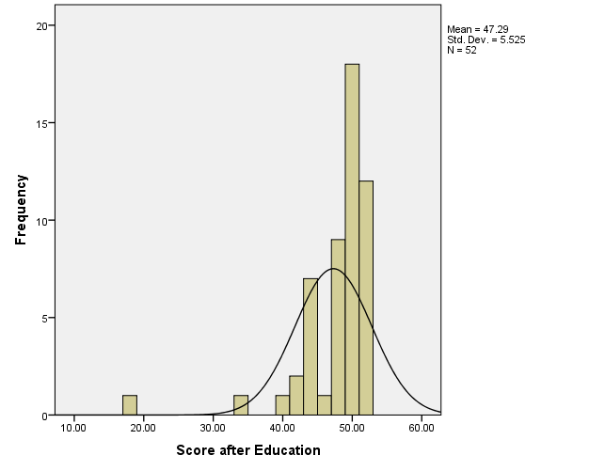

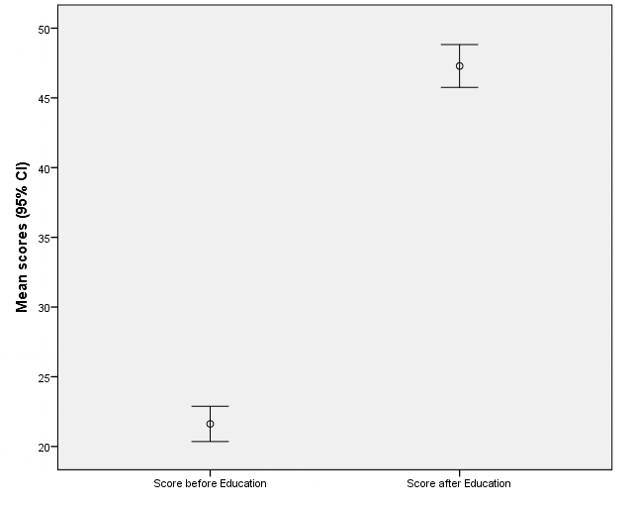

Among several studies, many of the studies are considered in this study to provide a clear perception that the educational and training program can enhance the knowledge of nurses related to the pressure ulcer (Bergman et al., 2015; Qaddumi, J. and Khawaldeh, 2016, p. 6; Monami et al., 2015). Moreover, the study and results show that there is a need of associational and a professional training program in this field.

References:
Aqoulah, E.A.A., Ismail, S., Juni, M.H., Shahar, H.K. and Tubaishat, A., 2018. EFFECT OF EDUCATIONAL INTERVENTION ON PRESSURE ULCER DOCUMENTATION AMONG NURSES IN JORDAN MINISTRY OF HEALTH TERTIARY HOSPITALS: A QUASI-EXPERIMENTAL RESEARCH APPROACH.
Beeckman, D., Defloor, T., Schoonhoven, L. and Vanderwee, K., 2011. Knowledge and attitudes of nurses on pressure ulcer prevention: a cross‐sectional multicenter study in Belgian hospitals. Worldviews on Evidence‐Based Nursing, 8(3), pp.166-176.
Bos, B.S., Wangen, T.M., Elbing Jr, C.E., Rowekamp, D.J., Kruggel, H.A., Conlon, P.M., Scroggins, L.M., Schad, S.P., Neumann, J.A., Barth, M.M. and Grubbs, P.L., 2016. Pressure Ulcer Prevention: Where Practice and Education Meet. Journal for nurses in professional development, 32(2), pp.94-98.
Claudia, G., Diane, M., Daphney, S.G. and Danièle, D., 2010. Prevention and treatment of pressure ulcers in a university hospital centre: a correlational study examining nurses' knowledge and best practice. International journal of nursing practice, 16(2), pp.183-187.
El Enein, N.Y.A. and Zaghloul, A.A., 2011. Nurses' knowledge of prevention and management of pressure ulcer at a Health Insurance Hospital in Alexandria. International journal of nursing practice, 17(3), pp.262-268.
Hulsenboom, M.A., Bours, G.J. and Halfens, R.J., 2007. Knowledge of pressure ulcer prevention: a cross-sectional and comparative study among nurses. BMC nursing, 6(1), p.2.
Källman, U. and Suserud, B.O., 2009. Knowledge, attitudes and practice among nursing staff concerning pressure ulcer prevention and treatment–a survey in a Swedish healthcare setting. Scandinavian journal of caring sciences, 23(2), pp.334-341.
Köse, I. and Öztunç, G., 2016. Knowledge of Nurses Working in Intensive Care Units in Relation to Preventive Interventions for Pressure Ulcer. International Journal of Caring Sciences, 9(2), p.677.
Maylor, M. and Torrance, C., 1999. Pressure sore survey Part 2: nurses' knowledge. Journal of Wound Care, 8(2), pp.49-52.
Mohamed, S.A. and Weheida, S.M., 2014. Effects of implementing educational program about pressure ulcer control on nurses' knowledge and safety of immobilized patients. Journal of Nursing Education and Practice, 5(3), p.12. (Mohamed et al., 2014, p. 12)
Moore, Z. and Price, P., 2004. Nurses’ attitudes, behaviours and perceived barriers towards pressure ulcer prevention. Journal of clinical nursing, 13(8), pp.942-951
Qaddumi, J. and Khawaldeh, A., 2014. Pressure ulcer prevention knowledge among Jordanian nurses: a cross-sectional study. BMC nursing, 13(1), p.6.
Sendelbach, S., Zink, M. and Peterson, J., 2011. Decreasing pressure ulcers across a healthcare system: moving beneath the tip of the iceberg. Journal of Nursing Administration, 41(2), pp.84-89.
Smith, D. and Waugh, S., 2009. Research study: an assessment of registered nurses' knowledge of pressure ulcers prevention and treatment. Kansas Nurse, 84(1), p.3.
Swafford, K., Culpepper, R. and Dunn, C., 2016. Use of a comprehensive program to reduce the incidence of hospital-acquired pressure ulcers in an intensive care unit. American Journal of Critical Care, 25(2), pp.152-155.
Zulkowski, K., Ayello, E.A. and Wexler, S., 2007. Certification and education: do they affect pressure ulcer knowledge in nursing. Advances in skin & wound care, 20(1), pp.34-38.

