7th International Conference on Advances in Skin, Wound Care and Tissue Science
September 25-26, 2019 Copenhagen, Denmark

Analysis of drug release kinetics from electrospun-based nanofibrous wound dressings.
Nikifor Asatianiª*, Petr Mikešª

ª Department of Chemistry, Faculty of Science, Humanities and Education, Technical University of Liberec, Studentská 1402/2, Liberec, Czech Republic, 46117

Abstract
Wound healing often requires use of antibiotics, which might produce negative side effects like trouble sleeping, headache, diarrheas, etc. Thus, there is heightened interest of local delivery of a drug to a wound. Accordingly, electrospinning is a versatile method to produce biologically functional nanofibrous wound dressings for further applications in tissue engineering as local drug delivery systems. However, kinetics of drug release from such systems are still poorly understood. The purpose of this study is to develop nanofibrous wound dressing materials modified with incorporation of drugs. Moreover, the aim is to investigate drug release kinetics from the obtained wound dressings considering different drug loadings. Additionally, cell interactions and cytotoxicity of the fabricated mats was investigated. Finally, an attempt to establish a mathematical model for prediction of release kinetics of examined drug delivery system, proceeding from experimentally obtained data and on the basis of the solution of the diffusion equation, has been made. The fabricated nanofibrous mats in this study had biphasic kinetics of drug release. The mat with lower concentration was able to release the drug in a sustained manner for at least 7 days. Increment of the drug loading supported cells proliferation. None of tested drug loading were found cytotoxic. The characterization of the process of drug release from nanofibers and the development of a mathematical model for the calculation of drug concentration will facilitate the design and preparation of nanofibrous wound dressings. The main impact of this study is therefore mainly in tissue engineering and regenerative medicine. Furthermore, in the pharmaceutical industry, due to the perspective to avoid adverse effects and reduction of the required dosages. The importance of such research is proofed by the growing interest of leading pharmaceutical companies in this field.
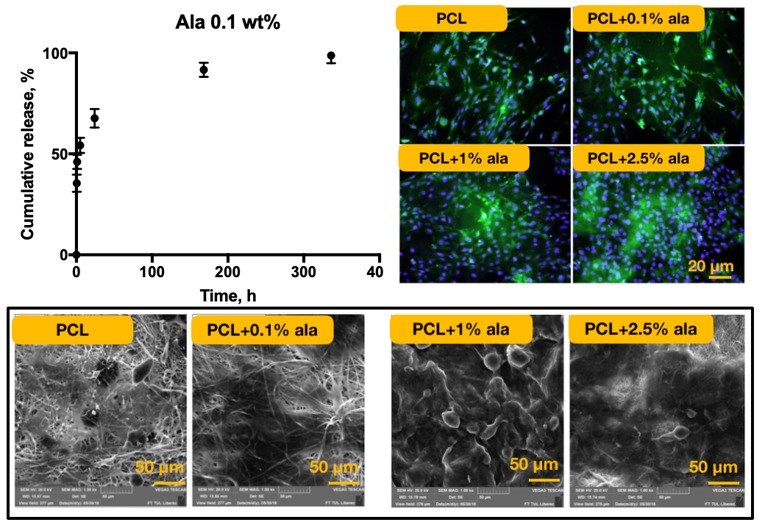

Figure 1: Cumulative release profile of a short peptide Alaptide from polycaprolactone nanofibrous mat (left), images from fluorescent microscope showing increased number of cells on the mats after 14 days of incubation (right), SEM images demonstrating proliferation of cells on nanofibrous mats with different drug loadings (bottom).

Recent Publications
- K. Kataria et al., “In vivo wound healing performance of drug loaded electrospun composite nano fi bers transdermal patch,” Int. J. Pharm., vol. 469, no. 1, pp. 102–110, 2014.
- L. Preem et al., “Interactions between chloramphenicol, carrier polymers and bacteria – implications for designing electrospun drug delivery systems countering wound infection,” 2017.
- Z. Huo et al., “Electrospinning Preparation of Timosaponin B-II-Loaded PLLA Nanofibers and Their Antitumor Recurrence Activities In Vivo,” vol. 2015, 2015.
- Z. Sklenář, et al., “Formulation and release of alaptide from cellulose-based hydrogels,” Acta Vet. Brno, vol. 81, no. 3, pp. 301–306, 2012.
- D. Press, “Advances in drug delivery via electrospun and electrosprayed nanomaterials,” pp. 2997–3017, 2013.


Biography
Eng. Nikifor Asatiani has been Graduated from Technical University of Liberec (Czech Republic), in 2018 with the specialties including Nonwoven materials, Tissue Engineering and Nanomaterials. Later on, he continued his research in development of electrospun-based wound dressings and then he applied for post-graduate study in 2018. Presently he has been working at the Technical University and the Institute for Nanomaterials, Advanced Technology and Innovation at the Liberec City.
Keywords: wound dressings, drug release kinetics, short peptides, electrospinning.

Desired presentation: Poster

Topic : Track 05: Tissue Science and Regenerative Medicine

Corresponding Author Details: Nikifor Asatiani
nikifor.asatiani@tul.cz
Technical University of Liberec
Liberec, Czech Republic
(+420)777176544

