Research Plan

The role of adipocyte-derived extracellular vesicles in vimentin mediated fibrosis

1. Applicant

Sepideh Parvanian

2. Research environment

This project will be carried out at professor Fang Cheng's research group at Åbo Akademi University.
3. Background

Fibrosis, the accumulation of aberrant myofibroblast and extracellular matrix molecules that make up scar tissue, is a common feature of chronic tissue injury. Progressive fibrosis of major organs is a devastating and fatal process, contributing to almost 50% of mortalities in the developed world[1]. Currently, there are no anti-fibrotic agents that can halt progressive organ fibrosis and cure patients, and organ transplantation is the only treatment for end state organ failure. As in fibrosis of other organs, myofibroblasts are the cells responsible for cardiac fibrosis and scar buildup in the heart and have been reported to originate from resident fibroblasts, epithelial cells, endothelial cells, pericytes, monocytes, and circulating fibrocytes[2].
Vimentin has been shown to be involved in wound healing, but its functional contribution to this process is not clear. Previous studies show that loss of vimentin led to a severe deficiency in fibroblast growth and vimentin can orchestrate the healing by controlling fibroblast proliferation, TGF-β1–Slug signaling, collagen accumulation, and EMT processing, all of which in turn govern the required keratinocyte activation[3].
Extracellular vesicles (EVs) as emerging intercellular communicasomes have the potential to target a range of molecular processes and recipient cells and a promising delivery vehicle for improving wound healing. The various studies demonstrate the ability of EVs to target physiological processes and intracellular pathways involved in the haemostatic, inflammatory, proliferative and remodelling phases of wound healing.[4]

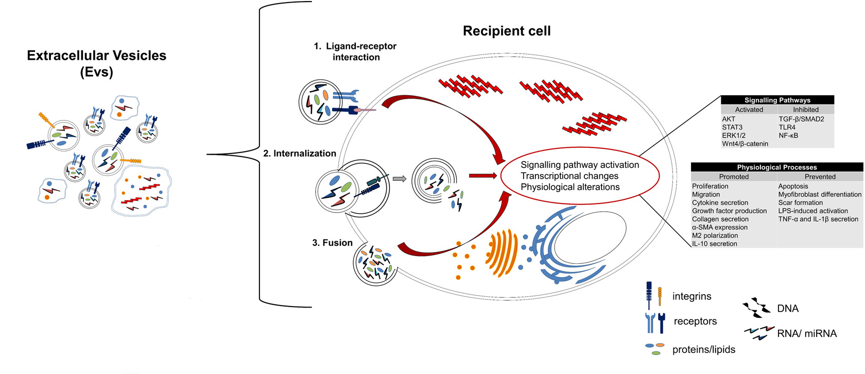
Fig. 1.The interaction between Extracellular vesicles and recipient cells. Although there is overlap among the different EV subtypes, some molecules express more than others across the major EV subtypes, which can be used as candidate markers for the identification of EV subtypes. EV interact with recipient cells by 1) ligand-receptor interaction; 2) internalization; and 3) direct fusion with the plasma membrane which culminate with the transfer of the biochemically-active EV cargo to the recipient cells leads to the regulation of signalling pathway activation and modulation of physiological processes such as proliferation, migration and differentiation. Abbreviations: AKT - attenuation of protein kinase B; Alix - programmed cell death 6 interacting protein; CD – cluster of differentiation; ERK - extracellular signal-regulated kinase; HSP70 - heat shock protein 70; IL – interleukin; LPS – lipopolysaccharide; NF-κB - nuclear factor kappa-light-chain-enhancer of activated B-cells; SMA - smooth muscle actin; SMAD - Sma and Mad related protein; STAT - signal transducer and activator of transcription; TGF-β - transforming growth factor β; TLR - Toll-like receptor; TNF - tumor necrosis factor; TSG101 - tumor susceptibility gene 101; Wnt4 - wingless-type MMTV integration site family, member 4. [4]
4. Research Aims

Investigating the adipocyte-derived extracellular vesicle (EV) subtypes is a promising strategy for developing novel anti-fibrotic treatments since their specific composition has the potential to target a range of molecular processes on recipient cells. Scientifically, the project is expected to contribute to novel fundamental insights on the role of fibrotic-derived extracellular vesicles in myofibroblasts heterogeneity and mechanism of fibrosis. By systematically characterizing EVs during injury and fibrosis, we will understand the contribution of the Extracellular vesicles toward tissue regeneration and myofibrotic remodeling after injury. Exploration of the causative proteins with functional and mechanistic assays will allow us to achieve a deep mechanistic understanding and potentially development of strategies to prevent, diagnose, and treatment of fibrosis. It may also provide a new paradigm on how developmental signaling pathways are co-opted in different ways to promote or inhibit tissue regeneration.
The groundbreaking nature of this work paves the way for (1) better understanding of vimentin’s role in wound healing processes (2) providing the new information to clarify the regulation of EVs during the wound healing process.
The overall goal of the proposed research is to study the function of EV subtypes based on the characterization of adipocyte-derived EV populations as a novel modulators in tissue repair and regeneration (skin and heart fibrosis as the model systems), in order to mechanistically understand how their specific composition may cause distinct metabolic responses in recipient cells and tissues.
Specifically, we aim at:

1) Using knock-out Vimentin 3T3-LT1 cells to clarify the role of vimentin in fibrotic signalling pathway
2) Characterization of extracellular vesicle subtypes during wound healing processes in mouse heart and skin fibrosis model
3) Unravelling molecular markers and mechanisms of fibrosis by using 3D organoid systems

5. Research Questions

- Do VIM^{-/-} 3T3LT1-derived EVs secrete vimentin during wound healing process?
- Do Vimentin regulate the composition of EVs derived from Adipose-derived Stem Cells (ASCs) in tissue regeneration and fibrosis development?
- What signaling activities affecting fibroblast activation and ECM production during tissue regeneration and fibrosis?

6. Research Methods

6.1 Developing extracellular vesicle isolation and characterization approaches.

Differential centrifugation is the most common method used for the isolation of EV(Fig. 2) [5]. Furthermore, density gradient ultracentrifugation, ultrafiltration, size-exclusion chromatography, precipitation and microfluidics have been reported as efficient methods.[6]
Electron microscopy, Western blot, flow cytometry will use as detection methods and protein purification and nanoparticle tracking analysis will perform to quantification of EV in supernatants.

6.2 Using 3D organoid model of heart and skin fibrosis.

Organoid systems have been developed to model many diseases as the efficient method compare with traditional models. In this research, we will provide a perspective on the potential for organoids to serve as models for fibrosis and describe how current organoid techniques could be applied to heart and skin wound healing research.

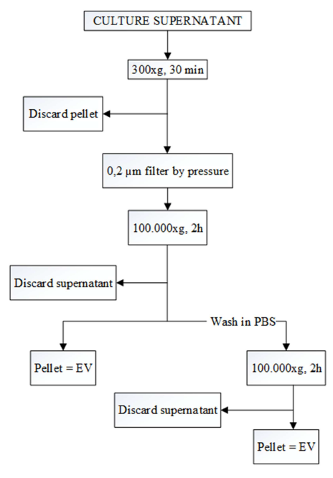
Fig. 2. EV isolation procedure based on differential ultracentrifugation.[5]

6.3 High-throughput screen in 3D organoid systems to unravel molecular markers and mechanisms of fibrosis.

Based on the results of single cell transcriptomics in mouse heart and skin fibrosis model, we will perform functional perturbation in targeted cells to identify which proteins and signaling pathways are crucial for regeneration and fibrosis.

7. Estimated timetable for the research and studies
Sub-project | Month/Year
- Literature review,  - Developing extracellular vesicle isolation and characterization approaches | 6/18 – 10/18
- Study the effect of adipocyte-derived extracellular vesicles on Myofibroblast Differentiation and Collagen Synthesis | 11/18 – 4/19
- Study the effects of different types of extracellular vesicles on Myofibroblast Differentiation and Collagen Synthesis  - First manuscript writing and sending for publication | 5/19 – 12/19
- Study the role of adipocyte-derived extracellular vesicles in vimentin mediated fibrosis | 12/19 – 6/20
- High-throughput fluorescence imaging approaches for anti-fibrotic drugs compare extracellular vesicle in skin fibrosis using in vitro  - Second manuscript writing and sending for publication | 7/20 – 12/20
- In vitro 3D organoid system and stem cell culture  - Arrayscan high-content analysis and screening systems | 1/21 – 12/21
- Studying Molecular markers in fibrosis mechanisms  - Third manuscript writing and sending for publication. | 1/22 – 6/22

8. Bibliography
A.
[1] S. L. Friedman, D. Sheppard, J. S. Duffield, and S. Violette, “Therapy for fibrotic diseases: Nearing the starting line,” Sci. Transl. Med., vol. 5, no. 167, 2013.
[2] E. El Agha et al., “Mesenchymal Stem Cells in Fibrotic Disease,” Cell Stem Cell, vol. 21, no. 2, pp. 166–177, 2017.
[3] F. Cheng et al., “Vimentin coordinates fibroblast proliferation and keratinocyte differentiation in wound healing via TGF-β–Slug signaling,” Proc. Natl. Acad. Sci., vol. 113, no. 30, pp. E4320–E4327, 2016.
[4] J. Cabral, A. E. Ryan, M. D. Griffin, and T. Ritter, “Extracellular vesicles as modulators of wound healing,” Adv. Drug Deliv. Rev., vol. 129, pp. 394–406, 2018.
[5] M. Franquesa et al., “Update on controls for isolation and quantification methodology of extracellular vesicles derived from adipose tissue mesenchymal stem cells,” Front. Immunol., vol. 5, no. OCT, 2014.
[6] M. Y. Konoshenko, E. A. Lekchnov, A. V. Vlassov, and P. P. Laktionov, “Isolation of Extracellular Vesicles: General Methodologies and Latest Trends,” Biomed Res. Int., vol. 2018, 2018.

