7th International Conference on Advances in Skin, Wound Care and Tissue Science
September 25-26, 2019 Copenhagen, Denmark

Mechanically Resistant, Biodegradable PVA/CA Dressings Functionalized with LL37 Peptide Reduce Microbial Burden
Helena P. Felgueiras*, Marta A. Teixeira, Tânia D. Tavares and M. Teresa P. Amorim

Centre for Textile Science and Technology (2C2T), University of Minho, Campus de Azurém, 4800-058 Guimarães, Portugal

Abstract
Statement of the Problem: Typically, acute wound healing is a well-organized process that evolves in a predictable amount of time. Chronic wounds (CW) result from gradual tissue degradation, and are characterized by defective cell matrix, high bacteria counts, prolonged inflammation and moisture imbalance. Antimicrobial dressings, that combine dressing and antibiotics, have been suggested as potential strategies to treat CW. However, the rising of antibiotic-resistant pathogens has turned these systems obsolete, revealing antimicrobial-peptides (AMPs), which display a broad spectrum of activity against pathogens and act rapidly at multiple sites within microbial cells, as viable alternatives.
Methodology: In this work, poly(vinyl alcohol) (PVA) and cellulose-acetate (CA) were prepared via casting/phase-inversion method in the form of films. Different PVA/CA ratios were tested. Their mechanical, thermal and biodegradation profiles were followed. The films' capacity to absorb exudates was also determined. Films were functionalized with LL37 peptide. This AMP is endowed with immunoregulatory abilities, with great potential for wound healing, and important antimicrobial features.
Findings: Results revealed the homogeneity of the fashioned dressings, their thermal stability and mechanical resistance above skin, namely tensile strength. As the content of CA increased, the films absorbancy decreased. Dressings degradation was more important at basic pHs (i.e. simulated body fluid at pH 9). LL37 was more efficient against Gram positive bacteria (i.e. Staphylococcus epidermidis) than Gram negative. In vitro, clotting time was significantly accelerated by this AMP presence in the dressings. Overall, the PVA/CA functionalized films demonstrated their potential for applications in wound healing.

Image
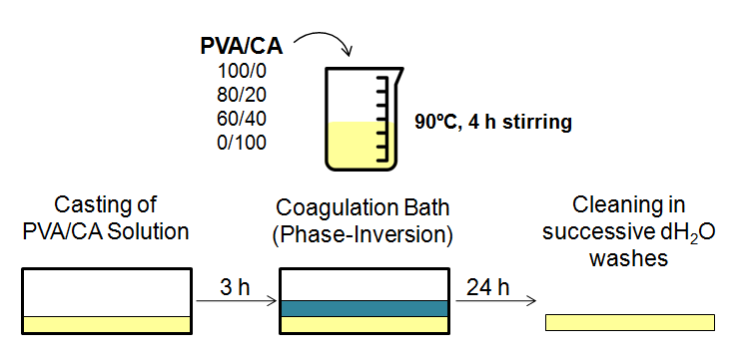
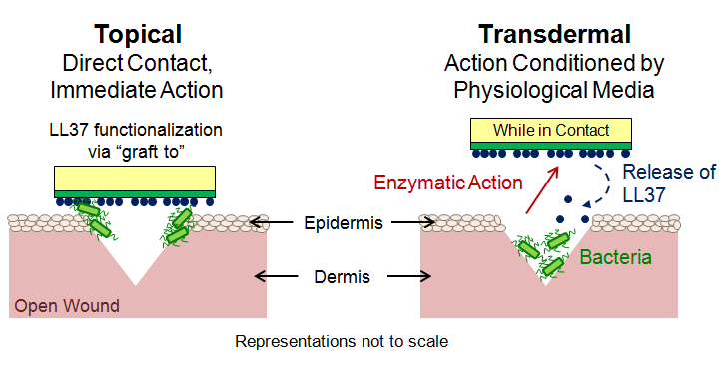
Figure 1: (top) PVA/CA films production methodology. (bottom) Representation of the LL37 action mode, topical and transdermal, while functionalized onto PVA/CA films.

Recent Publications
- Querido MM (2018) Cecropin–Melittin functionalized polyurethane surfaces prevent Staphylococcus epidermidis adhesion without inducing platelet adhesion and activation. Adv Mater Interfaces 5: 1801390.
- Felgueiras HP (2017) Functionalization of electrospun polymeric wound dressings with antimicrobial peptides. Colloids Surf B Biointerfaces 156:133-148.
- Felgueiras HP (2017) Electrospun polymeric dressings functionalized with antimicrobial peptides and collagen type I for enhanced wound healing. IOP Mater Sci Eng 254:062004.
- Coelho D (2017) Antibacterial electrospun poly(vinyl alcohol)/enzymatic synthesized poly(catechol) nanofibrous midlayer membrane for ultrafiltration. ACS Appl Mater Interfaces 9:33107-33118.
- Felgueiras HP (2017) Octadecyl chains immobilized onto hyaluronic acid coatings by thiol-ene “Click Chemistry” increase the surface antimicrobial properties and prevent platelet adhesion and activation to polyurethane. ACS Appl Mater Interfaces 9:7979-7989.
- Felgueiras HP (2015) Contributions of adhesive proteins to the cellular and bacterial response to surfaces treated with bioactive polymers: case of poly(sodium styrene sulfonate) grafted titanium surfaces. J Mater Sci Mater Med 26:261.


Dr. Helena P. Felgueiras is graduated in Biomedical Engineering from University of Minho (Portugal). In 2014, she completed her PhD studies also in Biomedical Engineering (specialization in biomaterials) at Université Paris 13 (France). Presently, she has been working at the Centre for Textile Science and Technology (2C2T) as a Junior Researcher, developing medical textiles.
Keywords: antimicrobial peptides, biodegradable films, thermal and mechanical stability, exudates absorbancy, antimicrobial action, accelerated clotting time, wound-healing applications.

Desired presentation: Oral

Topic : Skin and Wound Healing (day 1, 11h50-12h30)

Corresponding Author Details: Helena P. Felgueiras
helena.felgueiras@2c2t.uminho.pt
Centre for Textile Science and Technology, University of Minho
Guimarães, Portugal
+351 253 510 283

