Systemic Drug Related İntertriginous and Flexural Exanthem (SDRIFE) Due to Diclofenac: Case Report

Didem Mullaaziz, Serap Maden

Near East University Faculty of Medicine, Dermatology and Venereology Department, Cyprus
Abstract: Systemic Drug Related İntertriginous and Flexural Exanthem (SDRIFE) is an unusual drug reaction which is occurring after exposure to systemic drugs. We present a case of a 37-year-old woman with SDRIFE due to diclofenac tablets.
Introductıon: SDRIFE defined by 5 clinical diagnostic criteria; 1) To be exposed to systemic drug at first or repeated dose (contact allergens excluded) 2) Sharply demarcated erythema of the gluteal/perianal area and/or V-shaped erythema of thighs 3) Involvement of at least one other flexural fold 4) Symmetry of affected areas 5) Absence of systemic symptoms and signs.
Case Report: A 37-year-old female patient was admitted to our policlinic due to itchy and erythematous changes of her axillary and femoral region. One week prior to the onset of the lesions, she had been prescribed diclofenac for thoracic outlet syndrome. On dermatological examination she had an sharply demarcated erythematous scaly plaques on her bilateral axillary and medial aspects of femoral region with symmetrically. She had no systemic symptoms and signs. Routine biochemical and haematological analysis were within normal limits. The histopatologic examination was compatible with the clinical diagnosis of drug-induced exanthema of the SDRIFE. The diclofenac treatment was discontinued and systemic methylprednisolone was started with topical steroid. The eruption resolved within 2 weeks.
Discussion: SDRIFE has been reported with multiple medications including antibiotics, antifungals, antihypertensives, radiocontrast mediators, chemotherapeutic agents, biologics and others. In this report, we describe a case induced by diclofenac, a drug which has not been previously reported to cause SDRIFE. The latency time between drug intake and onset of eruption ranges from a few hours to a few days as our patient.
Conclusion
SDRIFE is an uncommon drug reaction should be considered on the differential diagnosis of intertriginous eruptions, especially in atypical cases. The relation between skin eruption and drug exposure may easily be overlooked or misdiagnosed. It is important to diagnose SDRIFE because lesions will regress rapidly by cutting off the defined causative agent. To the best of our knowledge, this is the first report of SDRIFE induced by diclofenac.

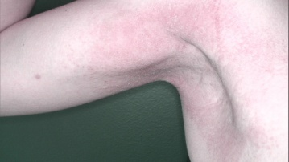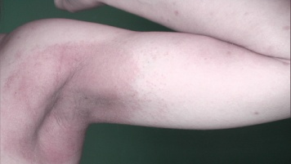
Figure 1: Sharply demarcated erythematous scaly plaques on bilateral axillary area
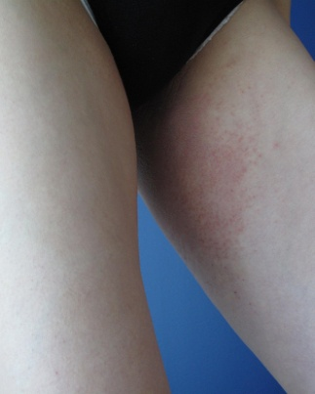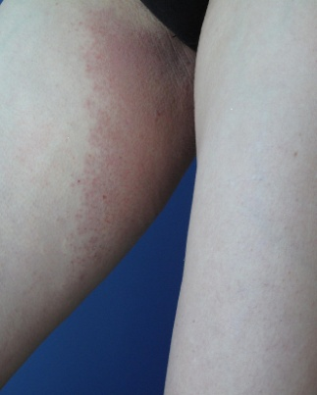
Figure 2: V-shaped erythema on medial aspects of femoral region
References
- Winnicki M1, Shear NH (2011) A systematic approach to systemic contact dermatitis and symmetric drug-related intertriginous and flexural exanthema (SDRIFE): a closer look at these conditions and an approach to intertriginous eruptions. Am J Clin Dermatol. 12:171-80
- Lugović-Mihić L1, Duvančić T, Vučić M, Situm M, Kolić M, Mihić J (2013) SDRIFE (baboon syndrome) due to paracetamol: case report. Acta Dermatovenerol Croat. 21: 113-7
- Binitha MP, Sasidharanpillai S, John R, Sherjeena PV (2014) Symmetrical drug-related intertriginous and flexural exanthema due to ranitidine. Indian J Pharmacol. 46(5): 551-2
- Şikar Aktürk A, Bayramgürler D, Salman S, Yıldız KD, Odyakmaz Demirsoy E (2014) Symmetrical drug-related intertriginous and flexural exanthema (SDRIFE) induced by oral metronidazole. Cutan Ocul Toxicol. 33(4): 337-8.
- Dogru M, Ozmen S, Ginis T, Duman H, Bostanci I (2012) Symmetrical drug-related intertriginous and flexural exanthema (baboon syndrome) induced by amoxicillin-clavulanate. Pediatr Dermatol. 29(6): 770-1

Biography
I was born in Cyprus, 1983. I graduated in 2006 from the Medical School of Trakya University Turkey. In 2012 I completed my residency at Suleyman Demırel University, faculty of Medicine on Dermatology. I have been working as a Assist. Prof. in the Dermatology and Venereology Department of Medical Faculty, Near East University since January 2013.
E-mail: didem_mullaaziz@yahoo.com

