Silver alginates for treatment of chronic wounds: Bactericidal effect and in vitro tissue compatibility

Claudia Eder, Orthopaedic Hospital Speising, Austria Martina Stangl, University of Applied Sciences, Austria
Peter Landowski, Krankenhaus Göttlicher Heiland, Austria
Sabrina Schildboeck,,Orthopaedic Hospital Speising, Austria
Michael Ogon, Orthopaedic Hospital Speising, Austria
Peter Metzger, Krankenhaus Göttlicher Heiland, Austria

Abstract
Introduction:
Due to the increase of antibiotic resistant bacteria strains, silver alginates are increasingly applied for treatment of chronic wounds. As silver ions released from the dressing may be absorbed by surrounding fibroblasts, an influence on wound healing cannot be excluded.. Aim of the presented study is to investigate the antimicrobial effect of silver ions on patient derived wound swabs as well as their biological effect on fibroblast cell cultures in vitro.
Methods:
A commercially available silver alginate paste (Calgitrol®) was used for the experiments.
Antimicrobial efficacy was evaluated on Staph. aureus, Staph. epidermidis and P. aeruginosa by measuring optical density of the culture medium at 600 nm and evaluating the number of colony forming units.
The NIH 3T3 fibroblast cell line was used for assessment of biological effects: Growth curves were applied to study the effect on cell proliferation. Cell viability was analyzed via Trypan Blue dye exclusion test. A non-radioactive proliferation assay (EZ4U) was applied to study cytotoxic effects. The influence on wound healing was observed via 2-D-scratch test. All experiments were performed in triplicates and data were analyzed using a student’s TTest at a 0,05 level of significance.
Results:
Calgitrol® was able to completely suppress bacterial proliferation, but demonstrated a detrimental effect on eukaryotic cell proliferation and viability: 24 hours after addition of Calgitrol® conditioned medium, cell counts had significantly decreased and no viable cells were detected. Collagen concentration decreased from 110µg/ml (+/-14) to 56 µg/ml (+/-4,5, p<0,015). While in vitro wound scratches were closed after 48 hours in the control group, no healing tendency was observed after Calgitrol® application.
Discussion:
The activation of fibroblasts and their immigration into the wound bed is a crucial step in wound healing. Silver alginates demonstrated an excellent bactericidal effect, but strongly suppressed fibroblast proliferation, migration and collagen synthesis in vitro. Despite their excellent bactericidal properties, they should not be used uncritically in the treatment of chronic wounds.

Image

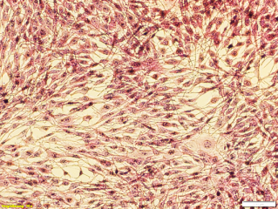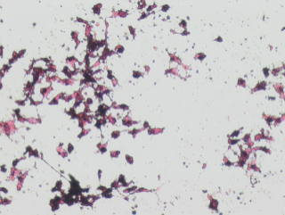
a)
b)
Fig 1.: H/E staining of NIH-3T3 fibroblast cell cultures 24 hours after treatment with Calgitrol conditioned medium (a) and the corresponding control (b) in standard medium

Fig 2.: Calgitrol is able to completely suppress the proliferation of Staph aureus in vitro.


Biography
The cell culture laboratory at the Orthopaedic Hospital Speising is located at the cutting edge of basic science and clinical research. The main interest of the multidisciplinary research group is Tissue Engineering of bone and cartilaginous tissues, the prevention of surgical site infection and the advancement of wound healing.

Email: claudia.eder@oss.at

