Development of a metal ion containing Alginate hydrogel for wound tissue repair
Gulsan AS Kazi, BDS, PhD, Yamagata University, Japan

Abstract
A problem increasing day by day is that millions of people suffer from wounds including skin wounds, surgical or traumatic disruption. Although, suture is still the main device to close the wounds, it has some disadvantages such as granuloma formation, inflammatory reactions and scar formation, which is some times aesthetically difficult to accept. Therefore, tissue adhesives have been good alternatives as supporting materials. This fact is based on their attractive properties including reduction of surgery time, mitigation of infection, preventing leakages, easy application, no removal requirements, less pain and great cosmetic results. Surgical adhesives can be made from natural polymers includes chitin, chitosan, gelatin, collagen, alginate. Among the natural polymers, sodium alginate is a natural linear polysaccharide and has biocompatibility, non-toxicity, non-immunogenicity, biodegradability, antimicrobial activity, and can be simply gelled with divalent cations. Also it has been used in a number of biomedical applications and drug delivery. In recent years essential nutrient metal element get a huge interest in the field of regenerative medicine. Chromium (Cr) is an essential trace element. Trivalent oxidation state of the chromium (Cr3+) is the most stable form in biological systems and beneficial effects of Cr3+ ion is widely studied that it regulates the IGF-1and collagen synthesis. However, weather the Cr3+ has function on wound healing is still unclear. In this study, chromium ion induced alginate hydrogel base bio adhesives were designed for surgical wound close. We prepared 0.3% (W/V) alginate hydrogel using the trivalent chromium solution and animal experiment was carried out. Different size surgical wound along with bleeding was made on mouse ventral and dorsal surface and then closed the wound using either alginate-Cr solution or traditional suture materials. After 1 week and 2 weeks a protruding tissue at the wound closure area can be seen in control group, which was not looks nice aesthetically, whereas it was very difficult to find out the wound region in experimental sample confirmed its aesthetical property. This pilot study suggests that this new materials have a great potential as wound closing materials particularly where aesthetical appearance is more important.

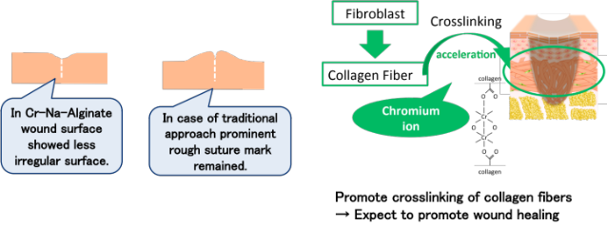
Recent Publications (minimum 5)
- Mohandas A (2015) Exploration of alginate hydrogel/nano zinc oxide composite bandages for infected wounds. Int J Nanomedicine 1:53-66.
- Frederick U (2015) Development and functional characterization of alginate dressing as potential protein delivery system for wound healing. International Journal of Biological Macromolecules, 81:137-150.
- Doloff JC (2017) Colony stimulating factor-1 receptor is a central component of the foreign body response to biomaterial implants in rodents and non-human primates. Nat Mater. 16:671-680.
- Gayatri R (2001) Chromium(III)-induced structural changes and self-assembly of collagen. Biochem Biophys Res Commun 283:229-35.
- Sinan I (2000) Modeling chromium sulfate complexes in relation to chromium tannage in leather technology: a computational study. Applied Organometallic Chemistry 14: 660-669.
- Yamamoto A (1998) Cytotoxicity evaluation of 43 metal salts using murine fibroblasts and osteoblastic cells. Journal of Biomedical Materials Research, 39:331-340.


Biography
Gulsan Ara Sathi has her expertise in tissue regeneration and passion in improving the disease control and treatment facility (Sasaki & Sathi 2017). Her new idea provides new findings in developmental biology (Sathi GA, 2017). She also works as a part of different creative biomimetic materials evaluation study (Taketa 2015, Farahat 2017). She has built up her such view in regenerative field after years of experience in research, evaluation, teaching and both in hospital and education institutions.
Email: sathiga@yz.yamagata-u.ac.jp

Notes/Comments:

