Orthotics Dynamic System Splint for Wound Care in Diabetic Foot
Atefeh Aboutorabi, PhD, USWR, Iran
Email: aboutorabito11@yahoo.com
Monireh Ahmadi bani, PhD, USWR, Iran
Mokhtar Arazpour, PHD, USWR, Iran

Abstract (300 word limit)
Introduction: A diabetic foot ulcer is an open wound or sore that develops on the skin. These types of ulcers are a common complication of peripheral neuropathy that is caused by diabetes (diabetic polyneuropathy). New wound care devices are designed to wounds healing therapy. The orthotics dynamic system (ODS) splint was developed with feature of total contact and allows therapist and also patients for wound daily inspection and regular cleaning or dressing of wounds. The plastozote sleeve is custom molded to patient’s foot to follow plantar surface with ¼ inch of length added beyond toes. Stockinetts is placed on the leg after that insert is position. Another stockinette is applied to hold insert in place. A padded total contact cast is applied using fiberglass. The cast is bivalved and Straps are added. At the end insert removed and relieve to offload area of wound. Patient can ambulate with a rocker bottom cast shoe under splint. So ODS can help to healing of wound processing. (1-5)

Image
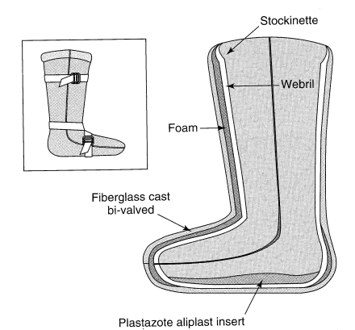
Recent Publications (minimum 5)
1. Armstrong DG, Nguyen HC, Lavery LA, Van Schie CH, Boulton AJ, Harkless LB. Off-loading the diabetic foot wound. Diabetes care. 2001;24(6):1019-22.
2. Baranoski S, Ayello EA. Wound care essentials: Practice principles: Lippincott Williams & Wilkins; 2008.
3. Elftman N. Management of the neuropathic foot. JPO: Journal of Prosthetics and Orthotics. 2005;17(2):S4-S27.
4. Hsu JD, Michael J, Fisk J. AAOS atlas of orthoses and assistive devices: Elsevier Health Sciences; 2008.
5. Sussman C, Bates-Jensen BM. Wound care: a collaborative practice manual: Lippincott Williams & Wilkins; 2007.

