Wound and burn healing activity of some Iranian medicinal herbs
Abdollah Ghasemi Pirbalouti, PhD, Shahrekord Branch, Islamic Azad ‎University, Iran;
Lyle Craker, PhD, College of Natural Science, Massachusetts University, Amherst, MA, USA
Abed Koohpayeh, DVM, Shahrekord Branch, Islamic Azad ‎University, Iran;
S. Mohammad Alavi-Samani, Shahrekord Branch, Islamic Azad ‎University, Iran;

Abstract
More than 80% of the world’s population depends upon traditional medicines for various skin diseases and skin care. The traditional use of medicinal herbs for wound and burn healing has received attention by the scientific community. Approximately one-third of all traditional medicine in use is for the treatment of wounds and skin disorders, compared to only 1-3% of modern drugs. Results of investigations indicate that the medicinal herbs affecting various phases of the healing process, such as coagulation, inflammation, fibroplasia, epithelization, collagenation and wound contraction are abundant in the scientific literature.
In this study, the effect of some Iranian medicinal herbs, as traditional healing for burn and cut wounds, on wound and burn healing in animal model was investigated.
Creams of this experimental contain the ethanolic extracts from the aerial parts of Ephedra procera (Ephedraceae) and Thymus daenensis (Lamiaceae); the flowers of Punica garnatum (Punicaceae) and Malva sylvestris (Malavaceae); and the leaves of Amygdalus communis (Rosaceae). During the wound and burn healing periods, the measurement of wound and burn area and histopathological properties of the wounds was done on days 6, 12, 18, and 24 in all groups.
There were significant differences in surface area and the periods of wound healing between the groups. Histopathological results obtained indicated that some Iranian medicinal herbs are much more powerful herbal drug as compared to the others treatments, especially synthetic drugs in that formation of collagen fibers and re-epithelization of the wound area was prominent. Experimental results indicate the extracts from the Iranian herbs could be important sources of phenolic compounds with high antioxidant capacity. Antioxidants may help to control burn and wound oxidative stress and thereby accelerate wound healing.
In conclusion, the results of the present study have proved that some Iranian herbs possess remarkable burn and wound healing activity supporting the folkloric assertion of the plant in Iranian folk medicine.

Image
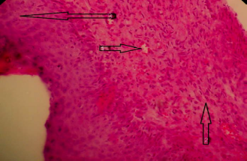
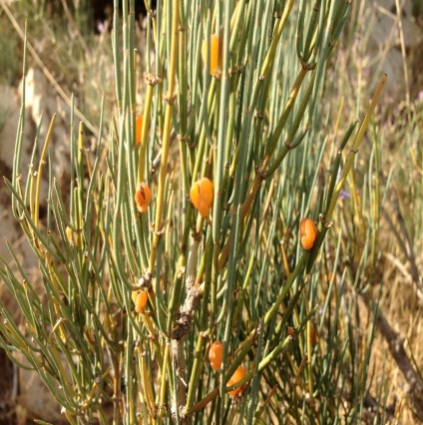
Ephedra procera cream (H&E40X).
1: Angiogenesis;
2: Collagenfibers and fibrous tissue;
3: Epithelization tissue.
Recent Publications
- Annan K, Houghton PJ (2007) Antibacterial, antioxidant and fibroblast growth stimulation of aqueous extracts of Ficus asperifolia Miq. and Gossypium arboreum L., wound-healing plants of Ghana. Journal of Ethnopharmacology 119:141-144.
- Mantle D, Gok MA, Lennard TWJ (2001) Adverse and beneficial effects of plant extracts on skin and skin disorders. Adverse Drug Reaction and Toxicological Reviews, 20:89-103.
- Nayak BS, Godwin I, Davis EM, Pillai GK (2007) The evidence based wound healing activity of Lawsonia inermis Linn. Phytotherapy Research 21:827-831.
- Shanmuga Priya KS, Gnanamani A, Radhakrishnan N, Babu M (2002) Healing potential of Datura alba on burn wounds in albino rats. Journal of Ethnopharmacology 83:193-199.
- Babaeizadeh S, Heydarnejhad S, Ghasemi Pirbalouti A, Khamesipoor F, Moghtadaei-Khorasgani E, Heydari-Soureshjani P (2016) Wound healing activity of extract from Thymus daenensis in burn wound model: an experimental animal study. Acta Poloniae Pharmaceutica 73:1615-1622.
- Ghasemi Pirbalouti A, Azizi S, Koohpayeh A, Hamedi B (2010) Wound healing activity of Malva sylvestris and Punica granatum in alloxan-induced diabetic rats. Acta Poloniae Pharmaceutica 67:511-516.

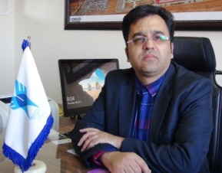
Biography
Abdollah Ghasemi Pirbalouti is professor at Medicinal Plants Depertment, Islamic Azad University, Shahrekord Branch, Iran. He has spent the past 15 years working with medicinal and aromatic plants, and considerable experience plant production and biology, botany, phytochemistry, and pharmacognosy. He is familiar with medicinal and aromatic plants production, and quality control for the development of new products. His experience also includes laboratory extraction and essential oil constituent analysis using gas chromatography, mass spectrometry, and HPLC. In addition, He is chief in editor of Journal of Herbal Drugs, International Journal of Medicinal Herbs (www.jhd.iaushk.ac.ir). During 2012-2013, he worked as a Research Scholar in the Medicinal Plant Program at the University of Massachusetts, Amherst, Massachusetts, USA. After 2015, He is head of the Islamic Azad University, Shahrekord Branch, and Chaharmahal va Bakhtiari Province, Iran
Email: ghasemi955@yahoo.com

Notes/Comments:

