Physico-mechanical properties and in vitro biological performance of keratin/bacterial cellulous nanofibrous composites for wound healing applications

Amir Azarniya, MSc, Sharif University of Technology, Iran
Elnaz Tamjid, PhD, Tarbiat Modares University, Iran
Niloofar Eslahi, PhD, Science and Research Branch, Islamic Azad University, Iran
Abdolreza Simchi, PhD, Sharif University of Technology, Iran

Abstract
Statement of the Problem: A miscellaneous assortment of synthetic or natural biopolymers have been used for fabrication of nanofibrous scaffolds to meets the ever increasing demands in the field of tissue regeneration, wound healing, and drug delivery. Nowadays, utilization of natural polymers regenerated from natural resources such as cellulose and keratin have attracted great attention for tissue engineering. Nevertheless, keratin-based nanofibrous mats have insufficient physicomechanical properties and need to be strengthened. Bacterial cellulose nanofibrils (BCNFs), as a nontoxic biocompatible polysaccharide, are the advantageous candidates to enhance the physicomechanical properties along with the cell response of electrospun keratin nanofibers. In this work, we have prepared nanofibrous composites based on keratin and bacterial cellulous and studied their physico-mechanical properties and in vitro biocompatibility. Methodology & Theoretical Orientation: An electrospinning apparatus was employed to collect keratin-based nanofibers containing different amounts of BCNFs (0, 1, 3, and 5 wt. %). Tensile test, water contact-angle measurement, MTT analysis, and cell attachment and cell growth assay were carried out to evaluate the physicomechanical and biological performance of the nanofibrous scaffolds. Findings: In this study, keratin/BCNF nanofibrous mats were obtained by electrospinning. FESEM observations revealed that the addition of 1 wt. % BCNFs to the electrospinning solution leads to a significant decrease in the fibers diameter. Incorporation of 1 wt. % BCNFs into the keratin-based hydrophobic mats (water contact angle (θ)=126°) significantly improved hydrophilicity (water contact angle (θ)=83°). The nanofibrous composite had mechanical strength close to the natural skin and mediated acceptable cell viability and proliferation. Conclusion & Significance: The electrospun BCNFs-reinforced keratin nanofibrous scaffolds mats with enhanced physico-mechanical and biological performance were prepared. The developed nanofibrous composites are potentially useful for wound healing and skin tissue engineering applications.

Image
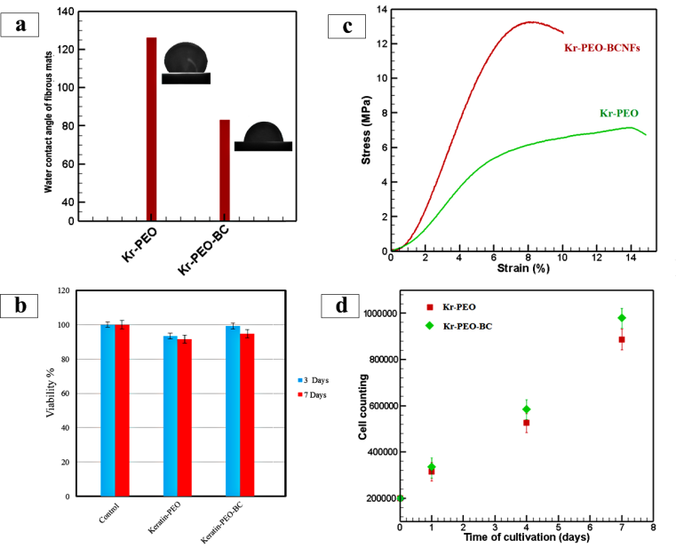
Recent Publications
- Thompson ZS, Rijal NP, Jarvis D, Edwards A, Bhattarai N (2016) Synthesis of keratin-based nanofiber for biomedical engineering. Journal of Visualized Experiments 108:53381.
- Yen KC, Chen CY, Huang JY, Kuo WT, Lin FH (2016) Fabrication of keratin/fibroin membranes by electrospinning for vascular tissue engineering. Journal of Materials Chemistry B 4:237-244.
- Yong L, Jia L, Jie F, Meng W (2014) Preparation and characterization of electrospun human hair keratin/poly (ethylene oxide) composite nanofibers. Matéria (Rio de Janeiro) 19:382-388.
- Martínez‐Sanz M, Olsson RT, Lopez‐Rubio A, Lagaron JM (2012) Development of bacterial cellulose nanowhiskers reinforced EVOH composites by electrospinning. Journal of Applied Polymer Science 124:1398-1408.
5. Wan YZ, Luo H, He F, Liang H, Huang Y, Li XL (2009) Mechanical, moisture absorption, and biodegradation behaviours of bacterial cellulose fibre-reinforced starch biocomposites. Composites Science and Technology 69:1212-1217.

 Biography
Elnaz Tamjid has her expertise in Nanobiotechnology and Biomedical Engineering. Her research interest is the development of novel biocompatible nanomaterials for tissue engineering, cell tracking and bioimaging using rapid prototyping techniques including 3D-printing and electrospinning. In this field she focuses on stem cell- and scaffold-based tissue engineering approaches to soft/hard regenerative medicine. She has designated this strategy after years of experience in research, evaluation, teaching and administration in Materials Science and Engineering, and Biological Sciences educational institutions.

Email: tamjid@modares.ac.ir

Notes/Comments:

