5th International Conference on Advances in Skin, Wound Care and Tissue Science
October 15-16, 2018 Rome, Italy

Characteristics, Properties, and Functionality of Fetal Membranes: An Overlooked Area in the Field of Parturition

Laura Martinª*, Lauren Richardson ^{b} and Ramkumar Menon ^{b}

ª São Paulo State University (UNESP), São Paulo, Brazil
^{b} The University of Texas Medical Branch at Galveston, Galveston, TX, United States

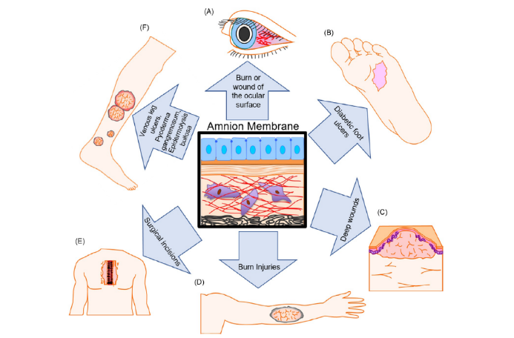

Abstract
Human fetal membranes (or amniochorion membranes) are the innermost lining of the intrauterine cavity. Membranes are fetal tissue in origin, start developing when fetal growth begins and are constituted by amnion and chorion connected by collagen rich extracellular matrix forming the innermost layers of the intraamniotic cavity. Extracellular matrix (ECM) made of fibrous proteins embedded in a polysaccharide gel and various collagen types provide the architectural and structural framework of the fetal membranes respectively. From the point of conception, pluripotent stem cells that surround the fetus forming the amniochorion membranes are vital to fetal survival. The amniochorion membranes are composed of multiple cellular and stromal layers containing epithelial and mesenchymal stem cells.
Since the early 19th century, physicians and researchers alike have been using either amniochorion or intact fetal membranes for wound repair, as cell-based wound dressings can be beneficial in many settings. These cells are used in a variety of fields, forming organs in vitro, and improving wound healing in clinics. There are many different forms of commercially available fetal membranes that are both cryopreserved and dehydrated which are useful in various clinical situations due to the abundance of different stimulating factors. In obstetrics, the usefulness of fetal membrane ECM is restricted to filling gaps in the membrane to avoid premature rupture of membranes arising from fetal surgery. This lack of application is partly due to the poor understanding of the properties of amnion epithelial cells and other cells in their extracellular matrix. By understanding where these cells come from and what their uses are in other areas, we can get a better idea of how they will act in vivo.

Image

Figure 1: Amnion membrane uses in wound healing. (A) In the ophthalmology field, amnion membranes are used to treat conjunctivitis scarring, acute burns, and persistent cornea defects. This cell-based dressing was chosen because of its transparent nature and its Type IV collagen basement membrane that promotes the expansion, migration, and invasion of epithelial progenitor cells. (B) In the endocrinology field, amnion membranes are used for diabetic foot ulcers as well as foot and ankle injuries such as chronic wounds, fasciitis, and tendonitis. Amnion membranes are used in these fields because they promote faster ulcer closure and help the healing of chronic wounds due to secreted factors. (C) and (D) In dermatology, amnion membranes are used for burns and deep wounds because they reduce pain, infection, increase mobility, and promote re-epithelization. (E) In the field of surgery, amnion membranes are used to help seal surgical incisions and close dehiscence due to their ability to promote closer healing of hard-to-heal wounds. (F) Venous leg ulcers, pyoderma gangrenosum, and epidermolysis bullosa are all treated with amnion membranes because they provide granulation in tissue, reduce pain, allow for proper epithelialization, and decrease the ulcer surface area and secretion of the fibrinous slough.

Recent Publications
- Richardson LS and Menon R (2018) Proliferative, Migratory, and Transition Properties Reveal Metastate of Human Amnion Cells. American Journal of Pathology 188: 2004-15.

- Menon R and Richardson LS (2017) Seminars in perinatology preterm prelabor rupture of the membranes: A disease of the fetal membranes. Seminars in Perinatology 1–11.
- McQuilling, J. P. et al. (2017) Proteomic Comparison of Amnion and Chorion and Evaluation of the Effects of Processing on Placental Membranes. Wounds: a compendium of clinical research and practice, 29(6), 38–42.
- Richardson LS, et al. (2017) Discovery and characterization of human amniochorionic membrane microfractures. The American Journal of Pathology 187(12): 2821–2830.
- Menon R (2016) Human fetal membranes at term: Dead tissue or signalers of parturition? Placenta 44: 1–5.
- Litwiniuk M and Grzela T (2014) Amniotic membrane: New concepts for an old dressing. Wound Repair and Regeneration 22(4): 451–6.

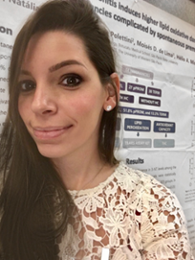
Biography

Dr. Laura Martin has been Graduated from 2011 as Biologist. In 2013 she received her Master's Degree in Pathology and in 2018 she received the Doctoral’s Degree also in Pathology from São Paulo State University, UNESP. During her post-graduation, Dr. Martin had the honor of realize a research internship at University of Texas Medical Branch with Dr. Ramkumar Menon to learn about his tissue science research.
Presently she has been working at São Paulo State University (UNESP) – BRAZIL and the focus of her researches is on inflammatory and oxidative process in labor and the differences between preterm labor with intact membranes and premature rupture of membranes preterm.

Keywords: Maternal Fetal Medicine, Fetal Membranes, Preterm Labor, Inflammation, Oxidative stress, Antioxidant capacity

Desired presentation: _ Oral / _ Poster / X either

Topic: Tissue Science

Corresponding Author Details: Laura Fernandes Martin
laura_fmartin@outlook.com
São Paulo State University
Botucatu, São Paulo, Brazil
+55 14 997713816

