5th International Conference on Advances in Skin, Wound Care and Tissue Science
October 15-16, 2018 Rome, Italy
How are we going to pay for advanced therapeutics in wound care?
Marissa J. Carterª*

ªStrategic Solutions, Inc., Cody, WY, 82414, USA

Abstract (300 word limit)
Although wound care is not a recognized specialty, the cost of treating wounds, especially chronic wounds, is phenomenal. Most wound care products categorized by the FDA as devices have been approved as adjunctive treatments based on the concept that these products may accelerate wound healing directly or indirectly. Many new products such as CTPs (cellular and/or tissue-based products) are expensive, and may need to have several applications. At the same time, in the USA the Centers for Medicare and Medicaid are exerting pressure in regard to reimbursement amounts for these products. Current reimbursement amounts for the application of some products may not be sufficient to keep a dedicated wound care clinic profitable when half of all patients are on Medicare or Medicaid and a further 10-15% have no medical insurance. Indeed, some patients may not receive any such products due to poor or no medical insurance. The majority of device clinical trials are post-market because of 510(k) approval and are frequently limited to non-severe wounds in indication (although many patients may have serious comorbidities). Thus, and most important, the performance of many products used to treat more severe wounds is unknown due to a scarcity of randomized controlled trials. Payers are also fixated on “episodes of care,” which is hard to define when half of all patients have multiple wounds that overlap over long periods of time (many years). Part of this chaos has resulted from lack of will at the national level to officially use health economic studies to weed out cost-inefficient products, and lack of understanding of health economics by payers. The situation will only get better when trials involving more severe wounds are commonplace, we have more FDA–approved endpoints appropriate for some products, and we are willing to formally include health economic analyses in our decision-making.

Image
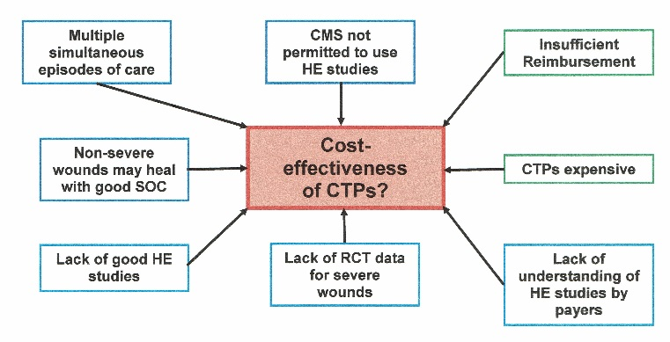
Figure 1: Factors that may affect the cost-effectiveness of CTPs (cellular and/or tissue-based products)
Recent Publications (minimum 5)
- Fife CE, Eckert KA, Carter MJ (2018). Publicly reported wound healing Rates: The fantasy and the reality. Adv Wound Care (New Rochelle) 7:77-94.
- Nussbaum SR, Carter MJ, Fife CE, DaVanzo J, Haught R, Nusgart M, Cartwright D (2018). An economic evaluation of the impact, cost, and Medicare policy implications of chronic nonhealing wounds. Value Health 21:27-32.
- Carter MJ (2014). Economic evaluations of guideline-based or strategic interventions for the prevention or treatment of chronic wounds. Appl Health Econ Health Policy 12:373-89.
- Carter MJ (2013). Health economics information in wound care: The elephant in the room. Adv Wound Care (New Rochelle) 2:563-570.
5. Carter MJ, Fife CE, Walker D, Thomson B. (2009). Estimating the applicability of wound care randomized controlled trials to general wound-care populations by estimating the percentage of individuals excluded from a typical wound-care population in such trials. Adv Skin Wound Care 22: 316-324.

Biography (150 word limit)

Dr. Marissa Carter is the President of Strategic Solutions, Inc., and has an extremely broad science background, which includes work in several medical fields, as well as physical and engineering disciplines. Her expertise includes health economics modeling, evidence-based medicine, biostatistics, and clinical trial design and analysis. Although she works mostly in wound care research, Dr Carter has also worked in epidemiology, ophthalmology, orthopedics, neurology, and psychology. Dr. Carter holds an MA in biochemistry from Oxford University and a PhD in chemistry from Brandeis University. She is the author or coauthor of over 100 peer-reviewed articles and book chapters in medicine and her studies have won several awards.

Keywords: cost, health economics, wound care, advanced therapeutics, evidence-based medicine; FDA–approved endpoints.

Desired presentation: Oral

Topic: Advances in Skin and Wound Care

Corresponding Author Details: Marissa J. Carter PHD MA; tel/fax: (+1) 307-587-5352
Strategic Solutions, Inc., 1143 Salsbury Ave, Cody, WY 82414, USA; email: mcarter@strategic-solutions-inc.com

