5th International Conference on Advances in Skin, Wound Care and Tissue Science
October 15-16, 2018 Rome, Italy
Novel wound assessment using in vitro wound models with mass spectrometry imaging

E. E. L. Lewis^{1,2}, M. R.T. Barrett¹, L. Freeman-Parry², A. Chapman¹, R. A. Bojar¹ and M. R. Clench²
- Innovenn UK Ltd, National Agri-Food Innovation Campus, Sand Hutton, York, YO41 1LZ
- Centre for Mass Spectrometry Imaging, Biomolecular Sciences Research Centre, Sheffield Hallam University, Sheffield, UK

Abstract (300 word limit)

Introduction:

The normal wound healing process is a highly ordered and structured process involving overlapping four main phases: haemostasis, inflammation, proliferation and remodelling. Damage to the skin’s integrity, which is caused trauma or injury initiates the wound healing process. Infections are known to disrupt the normal wound healing and have a detrimental effect on this process, which has shown to induce chronic wound formation. The western world is currently facing a public health crisis due to the increasing number of people suffering from chronic wounds. Identifying biomarkers associated with the wound healing process may aid early detection of a wound developing into an infected or chronic wound. The use of Labskin, a living skin equivalent model to imitate non-infected and infected wounds will provide the opportunity to assess wound healing process in-depth. Combining Labskin with Mass Spectrometry Imaging (MSI) would allow simultaneous multi-analyte detection in situ to help identify specific markers linked to wound healing.

Method and Results:

Labskin was wounded with scalpel blade, which was either non-infected or immediately infected with S. aureus and left for up to 4 days. Samples were snapped frozen, sectioned at wound site, coated in MALDI matrix and analysed for lipids (mass range: 400-1200 m/z) whereas, histology samples were stained with haematoxylin and eosin. Principal component analysis (PCA) was performed on regions of interest (dermis, epidermis and wound site/infection). MS/MS profiling and database search was able to putatively identify ions of interest in the non-infected sample where a glycosylceramide was shown to be present in the epidermis across the wound site.

Conclusion:

The wounded Labskin model with MSI was able to putatively identify a glycosylceramide within the wound site and epidermis, which may be used a biomarker associated with the wound healing process.
Image
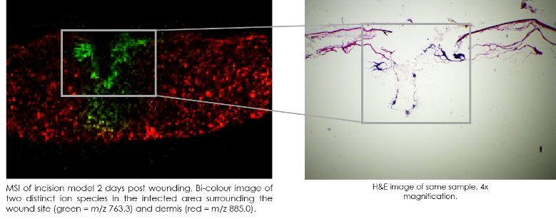
Recent Publications (minimum 5)
- Lewis, E. E. L., Child, H. W., Hursthouse, A. et al., (2015) The influence of particle size and static magnetic fields on the uptake of magnetic nanoparticles into three dimensional cell-seeded collagen gel cultures. Journal of Biomedical Materials Research Part B: Applied Biomaterials, 103, pp. 1294-1301.
- Lewis, E. E. L., Wheadon, H. , Lewis, N. et al., (2016) A quiescent, regeneration-responsive tissue engineered mesenchymal stem cell bone marrow niche model via magnetic levitation. ACS Nano, 10, pp. 8346-8354.
- Lewis, N. S., Lewis, E. E. L., Mullin, M., et al., (2017) Magnetically levitated mesenchymal stem cell spheroids cultured with a collagen gel maintain phenotype and quiescence. Journal of Tissue Engineering, 8, pp. 1-11.
- Lewis, E. E. L., Barrett, M. R. T., Freeman-Parry, L., et al., (2018) Examination of the skin barrier repair/wound healing process using a living skin equivalent model and matrix‐assisted laser desorption‐ionization‐mass spectrometry imaging. International Journal of Cosmetic Science, In Press.
- Russo, C., Lewis, E. E. L., Flint, L.., et al., (2018) Mass Spectrometry Imaging of 3D Tissue Models. Proteomics, In Press.

Biography (150 word limit)
Dr. Emily Lewis is an early career researcher with a background in Analytical Chemistry before moving into Biochemistry and Molecular Biology.
With 10 years experience in academic and commercial organisations, Emily understands the need to conduct research, which offers scientific and commercial value. Emily conducts research programmes in an organised fashion retaining a sense of urgency in delivering project goals.
Emily acts as a knowledge conduit between Sheffield Hallam University and Innovenn to create additional value for Labskin by combining cutting edge research with market demands.

Keywords: wound healing, infection, Mass Spec Imaging, Human Skin Equivalent.

Desired presentation: Poster

Topic : Wound Healing and Tissue Repair

Corresponding Author Details: Emily Lewis
Emily.lewis@innovenn.co.uk
Innovenn UK Ltd
York, UK
+44 (0)1904 404036

