5th International Conference on Advances in Skin, Wound Care and Tissue Science
October 15-16, 2018 Rome, Italy

Study of the molecular and functional effects of wound dressings on human dermal fibroblasts
MICHEL Laurence*ª, Armstrong Florence ^{b}, Ly Ka So Sophie ª, Da Silva Cindy ª, Proust Richard ^{b}, Samardzic Marina ^{b}, Bagot Martine ª, Bensussan A ª.

ªAffiliation Information: Inserm U976, Skin Research Center, Hôpital Saint-Louis, Univ. Paris Diderot, Sorbonne, Paris 75010, France.
^{b}Affiliation Information: Les Laboratoires Brothier, Nanterre 92735, France

Abstract (300 word limit)
The process of cutaneous healing/repair is characterized by three major phases, closely related: coagulation (A) and inflammation (B) during the first hours involving immune cells of the innate response, followed over time by a regeneration phase and a remodeling/maturation phase (C) mainly conducted by dermal fibroblasts [1-3]. To promote tissue repair, there is a multitude of dressings targeting the different phases of healing including calcium alginates and high absorbency fibers. The aim of the present study was to determine the effects of these wound dressings subtypes on human dermal fibroblasts, knowing that some of them do act on the coagulation and hemostasis phase as well as on the wound debridement [4,5].
Primary cultures of dermal fibroblasts were established from human surgical normal skin residues (n=6 to 12) and were studied for their molecular and functional responses to conditioned media from three wound dressings: calcium alginate Algosteril®, Biatain® Alginate and UrgoClean®.
The results showed that Algosteril® dressing among the 3 dressings significantly promoted the cell migration and consequently the closure of the dermal wounds as demonstrated by scratching experiments. No alteration of the viability of dermal fibroblasts was depicted with Algosteril® and Biatain® Alginate, whereas UrgoClean® did. Concerning gene macro-arrays induced in TGFβ-activated fibroblasts, Algosteril® significantly increased the synthesis of main collagens, extracellular matrix-remodeling enzymes, cytokines promoting fibroblast migration and proliferation, as well as allowing the recruitment of immune cells and thus promoting the development of an innate response that ensures the debridement of the wound. Biatain® Alginate was less efficient than Algosteril® Stimulation of pro-inflammatory cytokine production was also significantly increased with Algosteril® whereas it was not with other studied dressings.
Altogether, our results about these different parameters pointed out that Algosteril® among other dressings will facilitate the repair of the tissue matrix and prepare an effective healing phase.

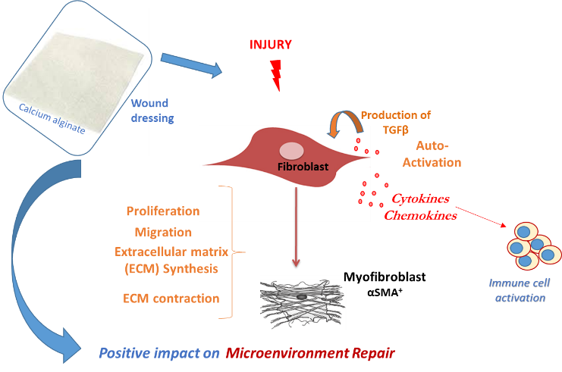
Image

Recent Publications (minimum 5)
- Reinke JM & Sorg H (2012). Wound repair and regeneration. Eur Surg Res. 49: 35-43.
- Brun C, Jean-Louis F, Oddos T, et al. (2016). Phenotypic and functional changes in dermal primary fibroblasts isolated from intrinsically aged human skin. Exp Dermatol. 25:113-9.
- Brun C, Maginiot F, Cras A, et al. (2016). Intrinsically aged dermal fibroblasts fail to differentiate into adipogenic lineage. Exp Dermatol. 25:906-9
- Dabiri, G, Damstetter, E, Phillips T. (2016), Choosing a Wound Dressing Based on Common Wound Characteristics. Advances in Wound Care 5: 32-41
5. Rinaudo M. (2014). Biomaterials based on a natural polysaccharide: alginate. TIP 17: 92-96.

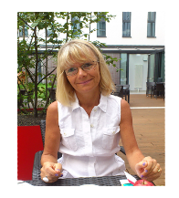
Biography (150 word limit)

Specialized in Dermatology and Pharmacology, Dr Laurence MICHEL is a team research group manager at Inserm Unit U976, Paris Saint-Louis Hospital. She works in the Skin Research Center conducted by Professor Martine BAGOT, head of the Saint-Louis Dermatology Department and director Dr Armand BENSUSSAN, U976 director. During her carrier, she has been carried out clinical research in collaboration with the hospital Clinic Investigative Center, studying mechanisms of allergic and inflammatory cutaneous diseases in patients and providing her expertise in pharmacology for in vivo testing of new therapies in collaboration with pharmaceutics/cosmetics laboratories. She also worked as a fundamental researcher studying the mechanism of signalling pathways involved in inflammatory skin disorders and cutaneous cell resistance to treatment. Focus has been done on skin aging, dermal fibrosis, xerosis (dry skin), hair greying, depigmentation and hair loss, besides cutaneous pathologies (atopy, cutaneous T cell lymphoma). External expert in national and international academic institutions. Author of 68 articles and 3 patents.

Keywords: nuclear medicine, accelerator produced isotopes, safety, quality assurance, etc.

Desired presentation: _ Oral / _ Poster / either

Topic : Skin repair, wound healing, dermal fibroblasts

Corresponding Author Details: Dr MICHEL Laurence
Email : laurence.michel@inserm.fr
INSERM U976. Centre Universitaire de Recherche en Dermatologie.
Pavillon Bazin. Hôpital Saint-Louis - 1 avenue Claude Vellefaux
75475 Paris Cedex 10
Tél : +33 (0)1 53 72 20 55 or 06 75 04 62 03.
Fax : +33 (0)1 53 72 20 51.

