5th International Conference on Advances in Skin, Wound Care and Tissue Science
October 15-16, 2018 Rome, Italy

Topical Medical Cannabis: A NEW Epigenetic Paradigm for Wound Management
Vincent Maidaª,^{b,} Runji Bill Shi^{b}, Jimmy Qui^{b}, Jason Corban^{b}

aWilliam Osler Health System, Toronto, Canada
^{bUniversity of Toronto, Canada}

Abstract (300 word limit)
Statement of the Problem: The endocannabinoid system is ubiquitous throughout the human body and has recently been found to have a significant representation throughout the integumentary system, both cutaneous membranes and mucous membranes. Topical Medical Cannabis (TMC) based medicines are intrinsically lipophilic and contain both delta-9-tetrahydrocannabinol (THC )and Cannabidiol (CBD) in varying proportions. Given that wound beds are largely lipophilic absorption of lipophilic agents, such as cannabinoids, is enhanced.
Methodology & Theoretical Orientation: A series of n=1 trials were initiated on a cohort of stalled recalcitrant wounds, composed of cases of greater than 12 months duration, were treated with TMC based medicines. All cases were previously afforded with all available Evidence-Based treatments that conformed with local best practices and wound-bed preparation principles. Ten cases were studies for wound analgesia, 10 cases for wound healing, and 4 cases for disease modulation. Etiologies represented within the cohort under study included: Pyoderma Gangrenosum, Leukocytoclastic Vasculitis, Cryoglobulinemia, Antiphospholipid syndrome, Sickle Cell Disease, Lichen Simplex Chronicus, Bowen’s Disease, and Squamous Cell Cancer. Clinically significant analgesia, wound healing, and disease was noted in all cases. The TMC medicines were applied directly applied to wound beds. TMC was very well tolerated and no adverse reactions were observed.
Conclusion & Significance: The highly positive results observed in a cohort of the most challenging recalcitrant cases provokes realistic interpolation that TMC based Medicines may be effective for a broader context within Wound Management. The endocannabinoid system is a viable Epigenetic target and platform for exploring therapeutic options for skin and wound conditions. Therapies based on Topical Medical Cannabis that interact at the level of the endocannabinoid system have significant potential to improve the 3 main target outcomes in wound management, namely, wound analgesia, wound healing, and disease modulation that includes antineoplastic actions.

Image
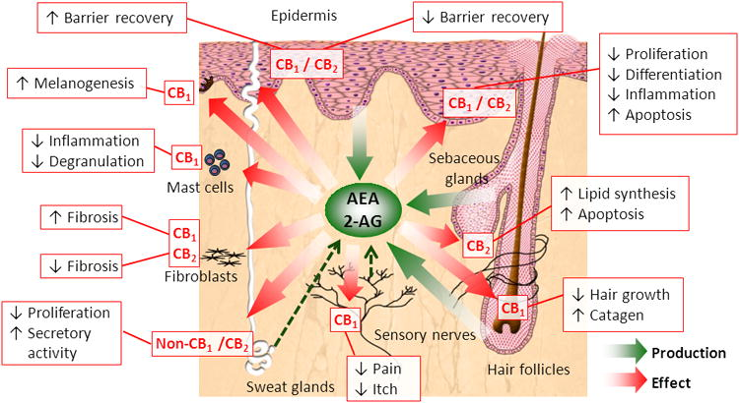
Recent Publications (minimum 5)
- Biro T et al. Trends in Pharmacological Sciences 2009;30(8):411-420
- Pucci M et al. Epigenetic control of skin differentiatiom by phytocannabinoids. Br J Pharm 2013;170:581-591.
- Maida V. TMC: A new treatment for Pyoderma Gangrenosum. J Pain Sympt Manag 2017;54(5):732-736.
- Maida V. Medical Cannabis in the Palliation of Malignant Wounds. J Pain Sympt Manag 2017;53(1):e4-e6.
- Oddi S et al. Endocannabinoids and skin barrier function: Molecular pathways and therapeutic opportunities. In: Wondrak G. (Eds.) CHAPTER 15, “Skin Stress Response Pathways 2016, pp301-323, Springer, Cham.doi 10.1007/978-3-319-43157-4
- Maccarone M et al. Endocannabinoid signaling at the periphery: 50 years after THC Trends in Pharmacologic Sciences 2015;36(5):277-296.
- Mouness JS et al. The role of cannabinoids in dermatology. J Am Acad Dermatol 2017;77:188-90.
- Dhadwal G, Kirchhof MG. The risks and benefits of Cannabis in the Dermatology Clinic. J of Cutaneous Med and Surg 2017;pp 1-6 DOI:10.1177/1203475417738971 jcms.sagepub.com

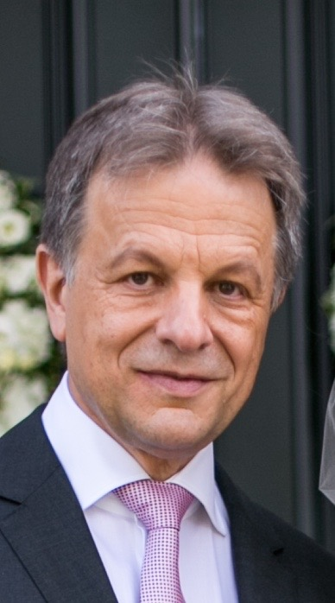Biography (150 word limit)
Dr. Vincent Maida is a consultant in Palliative Medicine & Wound Management at the William Osler Health System in Toronto. He obtained his medical degree from the University of Toronto. He was promoted to Associate Professor at the University of Toronto in 2011. Dr. Maida completed his MSc in Wound Management in 2010, his Medical Teachers Certificate in 2011, and his certificate in Patient Safety and Quality Improvement in 2014, all at the University of Toronto. Dr. Maida is an active researcher with particular interests in pain and symptom management, wound management, prognosis, and medical education. Over the past 10 years he has published 4 textbook chapters, over 30 original research papers, created numerous original conceptual innovations in Palliative Medicine and Wound Management, as well as delivering over 100 national and international presentations on 5 continents, 14 countries, and over 50 cities.

Keywords: Topical Medical Cannabis, Endocannabinoid system, wound analgesia, wound healing, disease modulation, THC, CBD

Desired presentation: +Oral / _ Poster / _ either

Topic : According to the list of topics provided on the web site

Corresponding Author Details: Dr. Vincent Maida
Vincent.maida@utoronto.ca
University of Toronto & William Osler Health System, Toronto, Canada
Cell 416-346-6829

