5th International Conference on Advances in Skin, Wound Care and Tissue Science
October 15-16, 2018 Rome, Italy
Development of In vitro skin models to investigate the effect of biocidal agents on skin infections
Beleid Gª, Shepherd J^{b}, Miller Kª and Le Maitre CLª

ª Biomolecular Sciences Research centre (BMRC), City Campus, Sheffield Hallam University, Howard Street, Sheffield, S1 1WB, UK
^{b} Academic Unit of Oral and Maxillofacial Pathology, School of Clinical Dentistry, University Sheffield, Sheffield S10 2TA, UK

Abstract
The management of wound infections presents a challenge to healthcare authorities both in terms of economic burden (Chan, B., et al 2017, Nussbaum SR M, et al 2017) and the need to reduce the use of antibiotics due to the rising global crisis of antibiotic resistance (Ventola, 2015). This has led to the search for alternative approaches. Previous studies have shown that ultrasound used in conjunction with antibiotic therapy is more effective than antibiotic treatment alone in reducing bacterial load (Guirro, 2016, Yu, et al 2012).
This study developed a 3D skin model utilizing HaCaT cells and fibroblasts which were seeded onto de epimerized dermis (DED) (Figure 1 A). This model was then subjected to a controlled burn and infected with S. aureus.
Effects of free radical generating antimicrobial strategies (Maillard, 2002): low-frequency ultrasound (LFU); Silver nitrate; 2-methyl-4- isothiazoline-3-one and Medical Grade Manuka honey were investigated. The cellular phenotype and toxicity of biocidal agents on mammalian and bacterial cells were investigated.
3D skin was generated which demonstrated keratinocyte (Cytokeratin 10 &14) and fibroblast (S100A4) markers and underlying collagen type IV in the DED skin layer (Figure 1A). In Bacterial biofilms, there was marked inhibition of S. aureus (SH1000), P. aeruginosa (NCIMB 8295), S. epidermidis and MRSA growth with all biocides. A decrease in S. aureus (SH1000) bacteria viability and number of CFU were observed in infected tissue-engineered skin models (Figure 1B).
This study describes the development of a well characterized skin model which can be utilized to develop and test biocidal agents for skin infections.

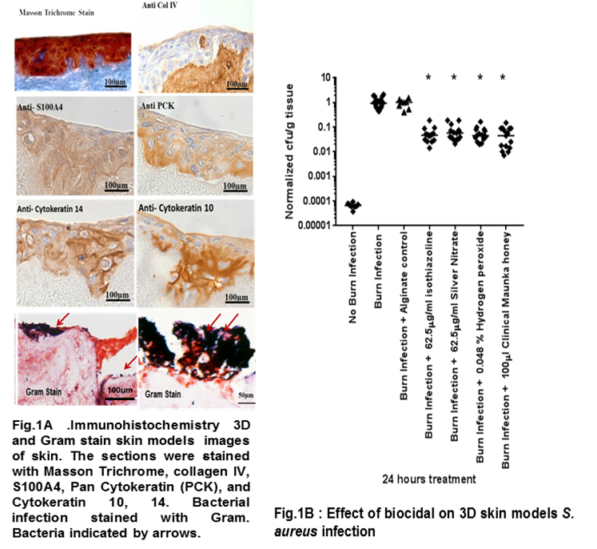

Publications

- Chan, B., Cadarette, S., Wodchis, W., Wong, J., Mittmann, N. and Krahn, M., 2017. Cost-of-illness studies in chronic ulcers: a systematic review. Journal of wound care, 26(Sup4), pp.S4-S14.
- Nussbaum, S.R., Carter, M.J., Fife, C.E., DaVanzo, J., Haught, R., Nusgart, M. and Cartwright, D., 2017. An economic evaluation of the impact, cost, and medicare policy implications of chronic nonhealing wounds. Value in Health..
- Ventola, C.L., 2015. The antibiotic resistance crisis: part 1: causes and threats. Pharmacy and Therapeutics, 40(4), p.277.
- Yu, H., Chen, S. and Cao, P., 2012. Synergistic bactericidal effects and mechanisms of low intensity ultrasound and antibiotics against bacteria: a review. Ultrasonics sonochemistry, 19(3), pp.377-382.
- de Oliveira Guirro, E.C., de Angelis, D.D.F., de Sousa, N.T.A. and de Jesus Guirro, R.R., 2016. Combination of therapeutic ultrasound with antibiotics interfere with the growth of bacterial culture that colonizes skin ulcers: An in-vitro study. Ultrasonics sonochemistry, 32, pp.284-289.
- Maillard, J.Y., 2002. Bacterial target sites for biocide action. Journal of applied microbiology, 92(s1).


Biography
Mr Guma Beleid graduated from the Faculty of medical technology, Derna, Libya, with BSC in Laboratory medicine and MSc in Clinical Microbiology from Academy of Graduate Studies, Tripoli, Libya. Mr Beleid worked as a lecturer assist in the Faculty of medical technology, Derna, Libya for four years. Mr Beleid is currently a PhD Student in the Biomolecular Sciences Research Centre at Sheffield Hallam University, Sheffield, UK.

Keywords: 3D skin models, Burned skin models, Biocides agent, Burned wound infection.
Desired presentation: _ Oral / _ Poster / _√ either

Topic: Skin Infections and Disorders

Corresponding Author Details: Guma Beleid
b4042226@my.shu.ac.uk
Sheffield Hallam University
Sheffield, UK
07405319067

