Treatment nonhealing wound using autologous platelet-rich-plasma
MITRA SHAHRIARI MSN-ETN, Dr. SAMAN MOHAMMADI POUR (SURGEON), AMIR ARZHANGIAN, IRAN
Abstract:
Non-healing ulcers are a major health problem worldwide and have great impact at personal, professional and social levels. They affect patient health, emotional state, and quality of life, causing considerable morbidity and mortality in addition to contributing to significant health care costs from lengthy hospitalizations to advanced home care and surgical care costs. The conventional treatment of these wounds can be slow due to their chronic inflammatory state and the senescence of local reparative cells.
Application of autologous Platelet Rich Plasma (PRP) has been a major breakthrough for the treatment alternative for non-healing ulcers, as it is an easy and cost-effective method, and provides the necessary growth factors that enhance tissue healing. PRP is a conglomeration of thrombocytes, cytokines and various growth factors which are secreted by α-granules of platelets that augment the rate of natural healing process with decrease in time.
In this study, we used PRP injection and PRP gel at the same time for healing a 6-yearold chronic pressure wound on left buttock site of a 76 -year-old man with 18- year history of c4 SCI, paraplegia impairment, 10 year history of diabetes with end-colostomy .
Initially he was admitted to hospital where he underwent surgical debridement and was started IV antibiotics for suspected osteomyelitis for 2 weeks .At the time of transfer to hospital, the pressure ulcer on the left buttock was noted to be stage IV with fibrous and necrotic base measuring 10 × 7.5 × 5 cm3 . at the beginning there was improvement in ulcer healing during 8 month management by vacuum therapy and using different kinds of products like collagen ,alginate and hyaluronic acid base dressing in addition modifying nutritional status, with wound measurements decreasing to 8 × 5.5 × 3.5 cm3, but over time the healing process slowed prompting applying PRP treatment as a last resort.
The patient underwent a total of 3 PRP treatments over a span of 6 weeks (performed bi-weekly).figure 2 and 3.
The wound improved without using further products and dressing. We found that PRP therapy (injection at the bed and the margins of wound and gel prp in combination) stimulate acceleration of healing installed pressure ulcers in SCI patients.
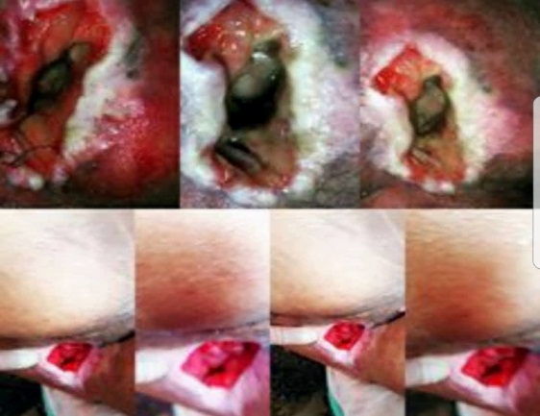
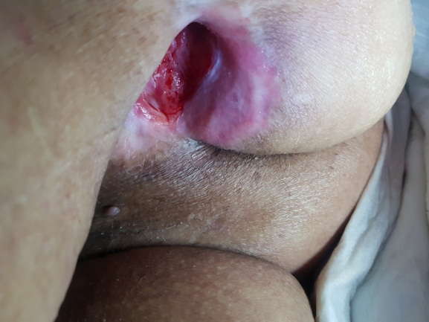
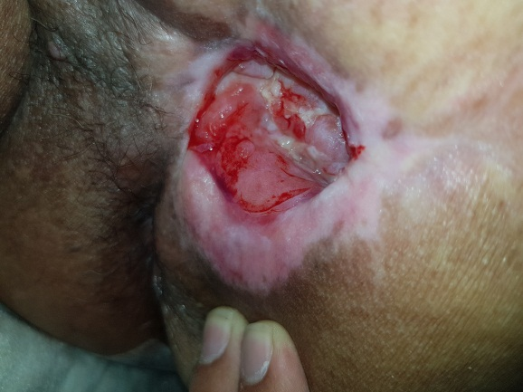

References:
1- Frykberg RG, m Banks J. Challenges in the treatment of chronic wounds. Adv Wound Care.2015; 4(9):560–82.doi: 10.1089/wound.2015.0635. [PMC free article] [PubMed] [Cross Ref]
2- Obolenskiy VN, Ermolova DA, Laberko LA, Semenova TV. Efficacy of platelet rich plasma for the treatment of chronic wounds. EWMA J. 2014;14(1):37–41.
3- Mehrannia M, Vaezi M, Yousefshahi F, et al. Platelet rich plasma for the treatment of non-healing diabetic foot ulcer: a case series. Can J Diabetes. 2014;38:5–8. doi: 10.1016/j.jcjd.2013.08.271. [PubMed][Cross Ref]
4-Aminian B, Shams M, Karim-Aghaee B, Soveyd M, Omrani GR. The role of the autologous platelet-derived growth factor in the management of decubitus ulcer. Arch Iranian Med. 1999;2:98–101
5- Martinez-Zapata MJ, Martí-Carvajal AJ, Solà I, et al. Autologous platelet rich plasma for treating chronic wounds. Cochrane Database Syst Rev. 2012;Issue 10:Art. No.: CD006899. [PubMed]
6- Lacci MK, Dardik A. Platelet-rich plasma: support for its use in wound healing. Yale J Biol Med.2010;83(1):1–9. [PMC free article] [PubMed]
7- Borzini P, Mazzucco L. Platelet gels and releasates. Curr Opin Hematol. 2005;12(6):473–9.doi: 10.1097/01.moh.0000177831.70657.e8. [PubMed] [Cross Ref]
8-Medina A, Scott PG, Ghahary A, Tredget EE. Pathophysiology of chronic nonhealing wounds. J Burn Care Rehabil 2005;26(4):306–19 [PubMed]
9- Kevy SV, Jacobson MS. Preparation of growth factor enriched autologous platelet gel. Presented at the 27th Annual Meeting of the Society for Biomaterials: St. Paul, MN. 2001

