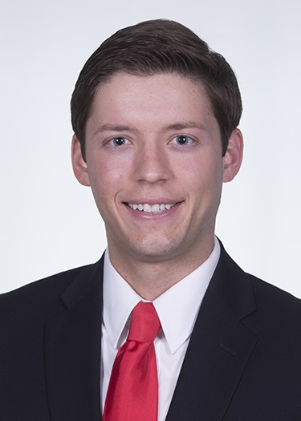


The Modified Lithotomy: A Novel Operative Position for Super Morbidly Obese Patients in Lower Extremity Wound Care Procedures
Googe B. Arnold PA, Vick L
University of Mississippi Medical Center
Division of Plastic Surgery
Department of General Surgery

Abstract:

Operative positioning for the morbidly obese patient can be arduous, especially when the operative field involves the proximal lower extremity or genitoperineal region. Wound surgery frequently involves working on these difficult to reach regions in this challenging patient population. We present a novel operative position we have termed “the modified lithotomy.”

Methods:
The patient is laid supine on the operative table. Foam padding is secured to the top and sides of two mayo stands and placed at distal thigh to knee level on lateral aspect of patient. The operative table is brought to this height and the legs are abducted and placed on the mayo stands. The legs are placed on the two tables and the footboard lowered to give allow easy access to the groin and medial thighs of the patient.

Results:
The modified lithotomy position has been used successfully in a variety of our morbidly obese wound care patients undergoing surgical intervention on the proximal thighs or genitoperineal region. Traditional lithotomy positioning can be difficult to achieve, risk nerve compression, or provide incomplete access to the desired operative region in the morbidly obese.

Conclusions:
The case presented represents one possible application of the modified lithotomy position for Sistrunk wedge resection of lymphedema. We have utilized this position in a variety of other situations including groin hidradenitis excision, perineal skin grafting, or alternated for use in the prone position. Its use should be considered when operating on the proximal lower extremity or groin area in the morbidly obese.

Images:
Example case
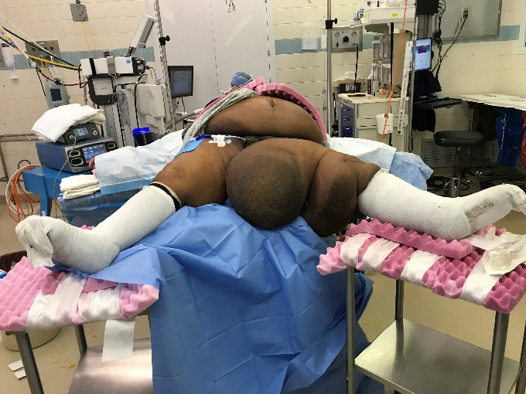 | 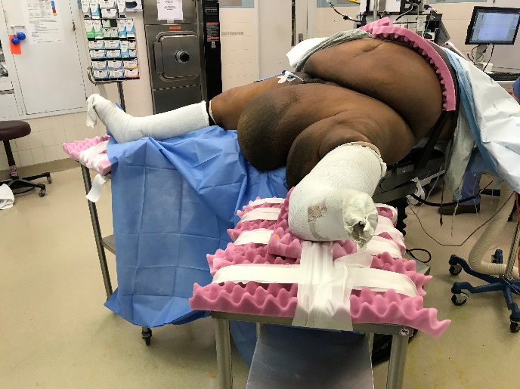
Patient positioned in the modified lithotomy for Sistruck wedge resection of a left thigh lymphedema mass.

Biography

Benjamin Googe completed his undergraduate education at Johns Hopkins University where he received a B.S. in biomedical engineering focusing in cell and tissue engineering. He went on to attend medical school in his home state at the University of Mississippi Medical Center in Jackson, MS. He is continuing his training at UMMC and is currently a plastic surgery resident and engaged in a variety of plastic surgery research from wound care to facial aesthetics. He has 7 peer-reviewed publications, 11 presentations, and 2 patents in the field of medical device design.
Presenting author details
Full name: Benjamin Googe, MD
Contact number: 662-316-5224
Email: bgooge@umc.edu
Category: Poster Presentation

