Negative pressure wound therapy for infected surgical site and mesh exposure with silver base foam
SAMAN MOHAMMADIPOUR MD, MITRA SHAHRIARI, Treata hospital, Iran
Abstract:
Surgical site infections (SSIs) are infections of the tissues, organs, or spaces exposed by surgeons during performance of an invasive procedure. The use of synthetic prosthetic mesh is well establish as the surgical treatment of choice for repair of ventral incisional hernias. Use of these mesh materials may result in specific complications that range from minor to potentially life-threatening.The definitive treatment for any infected prosthetic material in the body is removal and substitution. Sometimes you can manage the infected wound without removal the mesh with open abdomen dressing and irrigation and control the infection with parallel antibiotic therapy. NPWT has been demonstrated to significantly improve patient survival and facilitate earlier closure of the open abdomen. In this study we used npwt for management of open abdomen with infected mesh with silver-based foam. This article reviews the case of 64 year-old man with infected surgical wound and mesh with history of surgery due to big abdominal hernia and gastrointestinal fistula. After several irrigations, the wound was dressed by negative pressure wound therapy with a silver-based foam without removal the mesh. The wound improved without any further surgery. We found that negative pressure wound therapy with a silver-based foam could be used on infected prosthetic mesh in wound besides control of infection without further surgery for mesh removal.
Image:
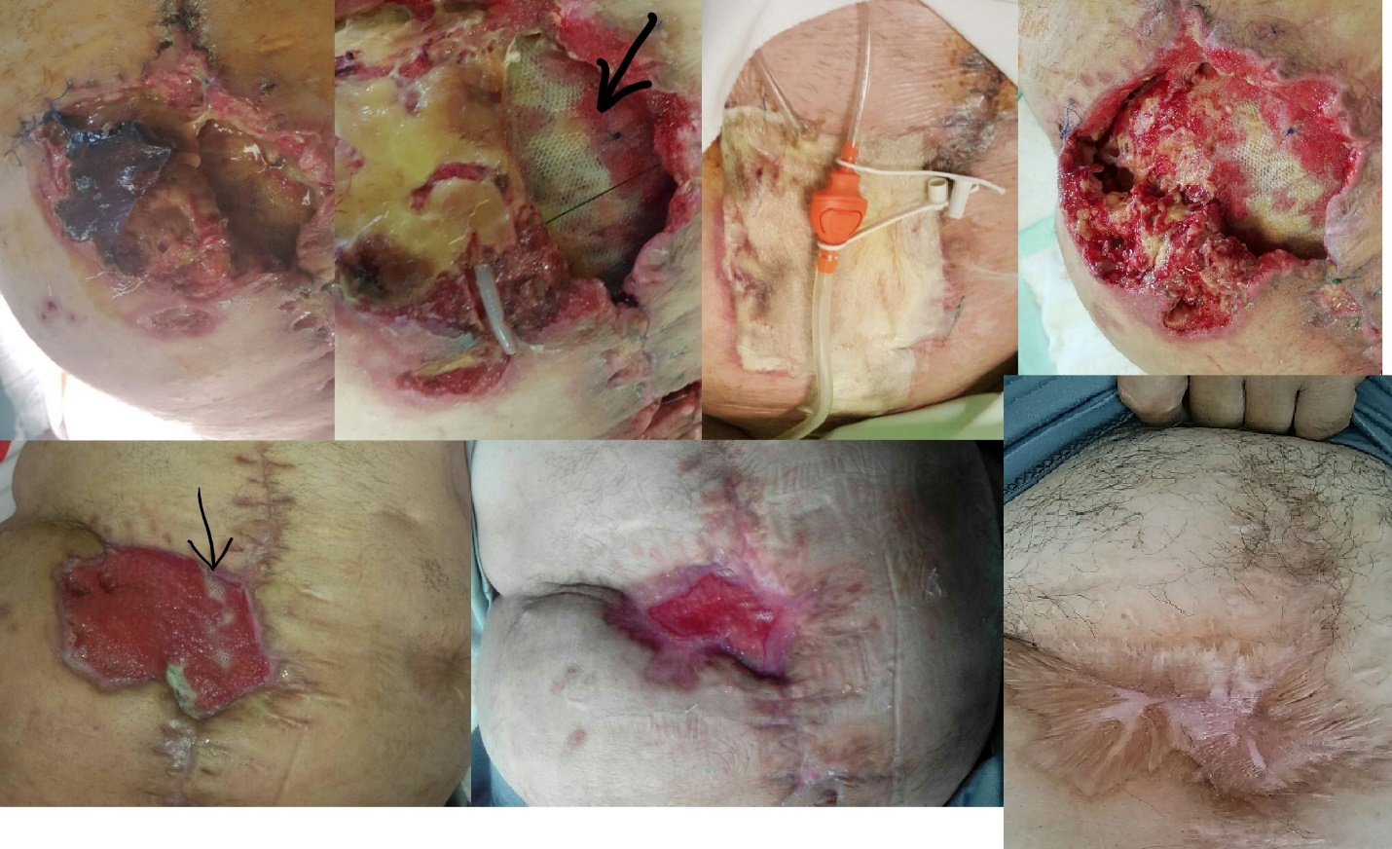
Recent publication:
- Ann Surg. 2003 Mar;237(3):437-41. Definitive surgical treatment of infected or exposed ventral hernia mesh. Szczerba SR1, Dumanian GA. Department of Surgery and the Division of Plastic Surgery, Emory University, Atlanta, Georgia, USA. PMCID: PMC1514321 DOI: 10.1097/01.SLA.0000055278.80458.D0
- Cheatham ML, Demetriades D, Fabian TC, et al. A Prospective Study Examining Clinical Outcomes Associated with the ABThera™ Open Abdomen Negative Pressure Therapy System and Barker’s Vacuum Packing Technique. World J Surg 2013; 37(9):2018-30
- Am J Surg. 2006 Feb;191(2):165-72, Management of abdominal wound dehiscence using vacuum assisted closure in patients with compromised healing, PMID: 16442940 DOI: 10.1016/j.amjsurg.2005.09.003
- J Wound Ostomy Continence Nurs. 2011 Jul-Aug;38(4):449-52. Use of negative pressure wound therapy with silver base dressing for necrotizing fasciitis. saman mohammadipour. doi: 10.1097/WON.0b013e31821e43f1.
- Int Wound J. 2011 Apr;8(2):118-25. Epub 2010 Dec 23. Use of negative pressure wound therapy in the management of infected abdominal wounds containing mesh: an analysis of outcomes. Baharestani MM1, Gabriel A. . doi: 10.1111/j.1742-481X.2010.00756.x.

Biography:



Saman mohammadipour is a colorectal surgeon with a decade experience in wound management .using silver combined with all methods is one of his favorites .vacuum therapy is one of best method to manage big wound combination with silver base gauze or foam .following his last article in wound therapy he presents this article as a method for managing surgical site infection with mesh.

Email: samanmp@yahoo.com

