Title: The Lived Experience of Suffering of Males After Blunt Trauma: A Phenomenological Study
Louis D Filhour PhD, RN Albany Medical Center, Albany, NY

Abstract (300 word limit)
Suffering is a subjective human experience that is both complex and unique. Although relieving suffering is a goal for nursing, the phenomenon of suffering is poorly understood and even goes unrecognized. Using a phenomenological design, the researcher explored the question of what is the experience of suffering as voiced by male patients seven to twelve months after hospitalization for blunt trauma. Seventeen male volunteers were interviewed and asked questions about how they suffered, what made their suffering more or less bearable, and how they were transformed through their suffering. Participants experienced changes in patterns resulting in a perception of suffering. Participants reported mostly experiencing physical, emotional, and social forms of suffering while fewer experienced economic and spiritual suffering. Experiences of suffering resulted from the threat to their normal state or sense of wholeness because of their injuries. Intrinsic and extrinsic factors were identified making the participants’ suffering more or less bearable as they regained their lost state of normal. Positive attitude and motivation were significant intrinsic factors while quality supportive care was the most significant extrinsic factor. Poor quality care was a significant negative extrinsic factor resulting in experiences of increased suffering. Through their experiences of suffering the participants were transformed, amending their previous state of normal. Knowledge gained through this phenomenological study may be useful to nurses in guiding their care to alleviate patients’ suffering.
Image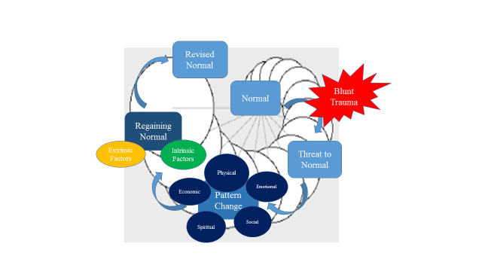

From The Experience of Suffering as Voiced by Male Patients Three to Twelve Months After Hospitalization for Blunt Trauma (Doctoral dissertation) (p. 70), by L. D. Filhour, 2016, Ann Arbor, MI: ProQuest. Copyright 2016 by L. D. Filhour. Adapted with permission.

Recent Publications:
- Filhour, L. D. (2016) The experience of suffering as voiced by male patients three to twelve months after hospitalization for blunt trauma (Doctoral dissertation). Retrieved from ProQuest. (Accession No. 10011617)
- Filhour, L. D. (2017) The lived experience of suffering of males after blunt trauma: A phenomenological study. Journal of Trauma Nursing, 24(3), 193-202.



Headshot photograph
Biography (150 word limit)
Louis Filhour has held executive positions as CNO and COO for more than 20 years. Although he is now the CEO for a system of hospitals and providers trying to transform care for the Medicaid population, he is also contributing to the science supporting the practice of professional nursing through his research. Working at a busy Level 1 trauma peaked his interest in the experience of suffering. He holds nursing degrees from Baylor University, Boston College, and the University of Phoenix.
Email: drXXXXXXX@xxxmail.com

Notes/Comments:

