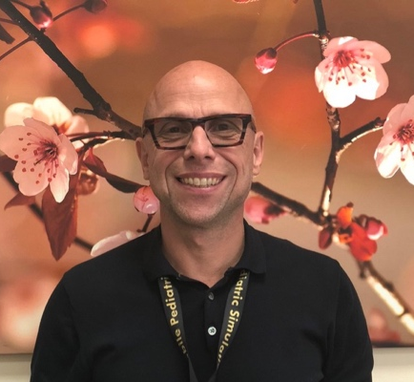
Title: Inserting central lines via the peripheral circulation in neonates: pointers for success and improved patient experience
Name: Roland (Matheus) van Rens
Hamad Medical Corporation, Doha, Qatar

Peripherally inserted central catheters (PICCs) are extensively used in neonatal intensive and high-dependency care settings. These intravenous catheters provide medium to longer-term access to the circulatory system for the delivery of medications, parenteral nutrition and the like. Catheters are available in a variety of bespoke designs and materials; each with their unique characteristics, benefits and limitations. PICCs are frequently inserted in a sterile zone cot-side procedure, one that requires an advanced knowledge base, technical skill and training. This abstract relates some important practical advice around managing minor complications that can be encountered whilst using the modified Seldinger technique (MST) to insert neonatal PICCs which can make this procedure a better experience for both infants and health professionals.

Key points
The modified Seldinger technique (MST) has many advantages for neonatal patients over more traditional direct introducer PICC insertion techniques, though these still have a place in practice.
Using the MST for neonatal PICC insertion requires bespoke education and training with exposure to real world practice in order to be successful. Neonatal PICC insertion practice and its evidence-base is still developing as new products and techniques which are suitable for the unique challenges faced in safely accessing neonatal vascular system become available.

Biography

Roland (Matheus) van Rens is the clinical Director of Nursing of the neonatal intensive care unit (NICU) at Women’s Wellness and Research Center. He works within a neonatal setting since 1991 and joined Hamad Medical Corporation back in 2013.

In 2005 he graduated as a Master of arts in Advanced Nursing Practice (Ma ANP) and worked for 8 years as a neonatal nurse practitioner at the Erasmus University in the Netherlands.

Within the NICU he developed and manages a dedicated vascular access team. Currently he is the primary investigator in several vascular access related studies.

Presenting author details
Full name: Roland (Matheus) van Rens
Contact number: +34 677 150 923
Twitter account:
Linked In account: https://www.linkedin.com/in/roland-vanrens-01571814a/
Session name/ number:
Category: Oral presentation

