Severe Acute Respiratory Syndrome Coronavirus 2 Antibodies Among Healthcare Workers After a Third Dose of Vaccine in an Intensive Care Unit

Cláudia Lemos, Intensive Care Department, Hospital Central do Funchal, Funchal, Portugal
Sofia Ferreira, Intensive Care Department, Hospital Central do Funchal, Funchal, Portugal
Cláudio Gouveia, Internal Medicine, Centro Hospitalar Lisboa Ocidental, Lisbon, Portugal
Filipa Côrte-Real, Intensive Care Department, Hospital Central do Funchal, Funchal, Portugal
Catarina Lume, Intensive Care Department, Hospital Central do Funchal, Funchal, Portugal
Cheila Plácido, Pathology, Hospital Central do Funchal, Funchal, Portugal
Mariana Rodrigues, Centro de Investigação Dra Mª Isabel Mendonça, Hospital Central do Funchal, Funchal, Portugal
José Alves, Pathology, Hospital Central do Funchal, Funchal, Portugal
Susana Chaves, Intensive Care Department, Hospital Central do Funchal, Funchal, Portugal
Graça Andrade, Pathology, Hospital Central do Funchal, Funchal, Portugal
José Júlio Nóbrega, Intensive Care Department, Hospital Central do Funchal, Funchal, Portugal

Abstract

The Coronavirus disease 2019 (COVID-19) and Severe acute respiratory syndrome coronavirus 2 (SARS-CoV-2) pandemic emerged in China in December 2019 as a public health crisis. Healthcare workers (HCWs) are a very important high-risk group of infection and the knowledge of SARS-CoV-2 antibody seroprevalence among this class is very important, not only to evaluate the success of public health interventions but also to comprehend the spread of COVID-19 among health institutions. The objective of this prospective study was to determine the seroprevalence of COVID-19 immunoglobulin G (IgG) antibodies after the third dose of vaccine administration and assess the symptomatology associated with the number of IgG antibodies. A total of 65 HCWs from an intensive care unit were studied at one month after the third administration of the COVID-19 vaccine. They were divided into two groups: IgG antibodies greater than 15.000 (group one) and less than 15.000 (group two). There was a seroprevalence of 78.5% (group 1) and 21.5% (group 2). Group 1 consisted mainly of male individuals (68.6%), unlike group 2 which consisted mainly of female individuals (92.9%). This was statistically significant (p<0.001). We also concluded that most of group 1 had more symptoms (94.1%) and a minority of group 2 had less symptoms (14.3%), being statistically significant (p<0.001). After the administration of the vaccine, group 1 had more symptoms (p<0.001). These symptoms were myalgias (50.8%), fever (27.7%), adenopathies (35.4%), asthenia (24.6%), vomiting (12.3%), diarrhea (10.8%), chills (6.2%), epigastric pain and arthralgia (1.5%). Our study concluded that male professionals with a higher number of IgG antibodies developed the most symptoms.

Image

Graph 1
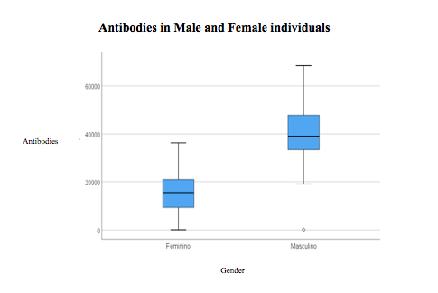

Graph 2

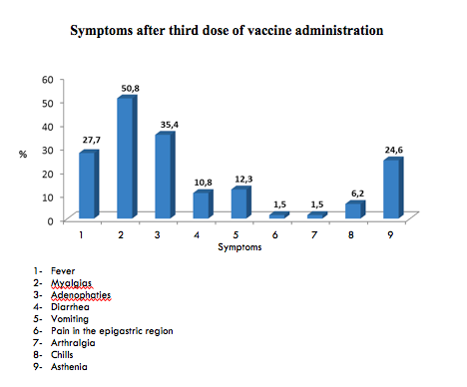

Graph 3
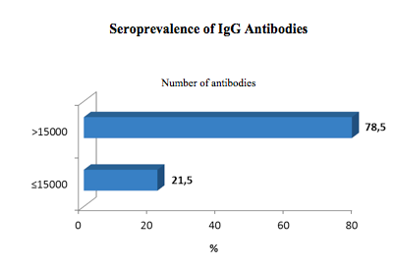

Recent Publications
- Hwang et al. Journal of Biomedical Science (2022) 29:1.
- A prospective study on rapidly declining SARS-CoV-2 IgG antibodies within one to three months of testing IgG positive: can it lead to potential reinfections? Nag DS, Chaudhry R, Mishra M, Rai S, Gupta M. Cureus. 2020;12:0.
- Waning of anti-spike antibodies in AZD1222 (ChAdOx1) vaccinated healthcare providers: a prospective longitudinal study. Mishra SK, Pradhan SK, Pati S, Sahu S, Nanda RK. Cureus. 2021;13:0.

- Antibody titres decline 3-month post-vaccination with BNT162b2. Favresse J, Bayart JL, Mullier F, et al. Emerg Microbes Infect. 2021;10:1495–1498.
- Waning of IgG, total and neutralizing antibodies 6 months post-vaccination with BNT162b2 in healthcare workers. Bayart JL, Douxfils J, Gillot C, et al. Vaccines (Basel) 2021;9:1092.
- Immunological memory to SARS-CoV-2 assessed for up to 8 months after infection. Dan JM, Mateus J, Kato Y, et al. Science. 2021;371:0.
- Neutralising antibody titres as predictors of protection against SARS-CoV-2 variants and the impact of boosting: a meta-analysis. [PREPRINT] Cromer D, Steain M, Reynaldi A, et al. Lancet Microbe. 2021
- Eliakim-Raz N, Leibovici-Weisman Y, Stemmer A, et al. Antibody Titers Before and After a Third Dose of the SARS-CoV-2 BNT162b2 Vaccine in Adults Aged ≥60 Years. JAMA. 2021;326(21):2203–2204.

- BenotmaneI,GautierG,PerrinP,etal.Antibodyresponseafterathirddose of the MRNA-1273 SARS-CoV-2 vaccine in kidney transplant recipients with minimal serologic response to 2 doses. JAMA. 2021;326(11):1063-1065.

10- Levin EG﻿, Lustig Y﻿, Cohen C﻿, et al. Waning immune humoral response to BNT162b2 Covid-19 vaccine over 6 months. ﻿ N Engl J Med. Published online October 6, 2021.

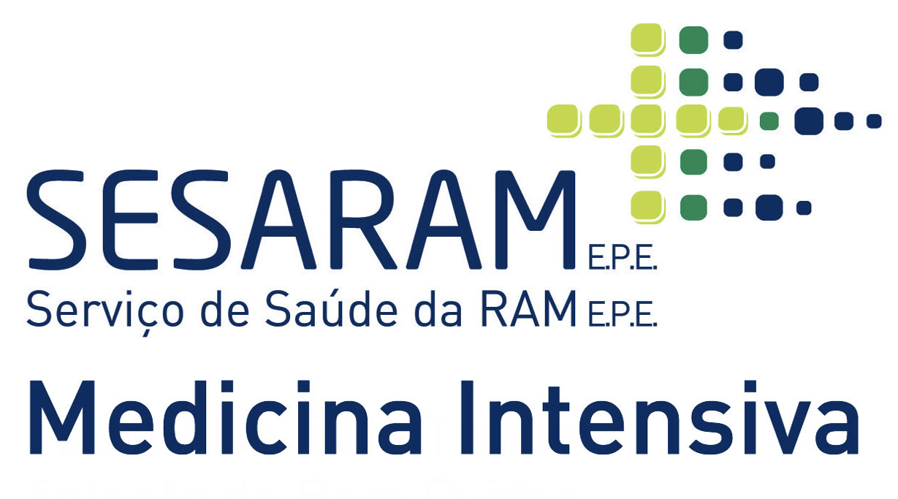

Biography

Cláudia Lemos is a forth-year intern with specific training in Intensive Care Medicine that has passion in vaccines research and clinical trials.
Email: claudial@campus.ul.pt

Notes/Comments:
Presenting author details
Full name: Cláudia Isabel Góis Lemos
Contact number: +351924168684
Session name/ number:
Category: (Oral presentation)

