Severe Acute Respiratory Syndrome Coronavirus 2 Antibodies Among Healthcare Workers After Vaccine Administration in an Intensive Care Unit

Cláudia Lemos, Intensive Care Department, Hospital Central do Funchal, Funchal, Portugal
Sofia Ferreira, Intensive Care Department, Hospital Central do Funchal, Funchal, Portugal
Cláudio Gouveia, Internal Medicine, Centro Hospitalar Lisboa Ocidental, Lisbon, Portugal
Érica Mendonça, Pathology, Hospital Central do Funchal, Funchal, Portugal
Mariana Rodrigues, Centro de Investigação Dra Mª Isabel Mendonça, Hospital Central do Funchal, Funchal, Portugal
Ana Marta Mota, Intensive Care Department, Hospital Central do Funchal, Funchal, Portugal
José Alves, Pathology, Hospital Central do Funchal, Funchal, Portugal
Susana Chaves, Intensive Care Department, Hospital Central do Funchal, Funchal, Portugal
Graça Andrade, Pathology, Hospital Central do Funchal, Funchal, Portugal
José Júlio Nóbrega, Intensive Care Department, Hospital Central do Funchal, Funchal, Portugal

Abstract
Severe acute respiratory syndrome coronavirus 2 (SARS-CoV-2) and coronavirus disease 2019 (COVID-19) emerged in China in December 2019. Healthcare workers (HCWs) are one of the high-risk groups of infection and knowledge of the seroprevalence of SARS-CoV-2 antibodies among this class is very important, not only to understand the spread of COVID-19 among health institutions but also to assess the success of public health interventions. The objective of this prospective study was to determine the seroprevalence of COVID-19 immunoglobulin G (IgG) antibodies after vaccine administration and assess the symptomatology associated with the number of IgG antibodies. A total of 75 HCWs from an intensive care unit were studied three and six months after the second administration of the COVID-19 vaccine. They were divided into three groups: IgG antibodies between 4,160 and 6,350 (group one), greater than 6,350 (group two), and less than 4,160 (group three). After the first administration of the vaccine, 80% had symptoms in both groups one and two, whereas only 13.8% had symptoms in group three. After the second dose of the vaccine, all elements of group one and 80% of group two developed symptoms, but only 40% of group three manifested symptoms. With the exception of one, all professionals showed a decrease in the number of IgG antibodies from three to six months. Our findings show that professionals with a higher number of IgG antibodies had more symptoms and that these rapidly declined over the three-to-six-month period.

Image
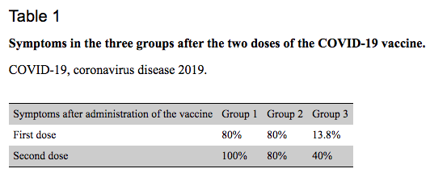

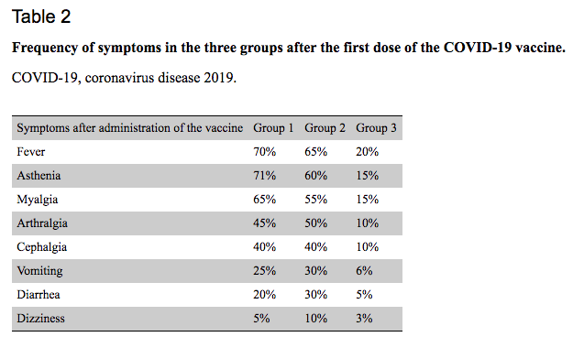

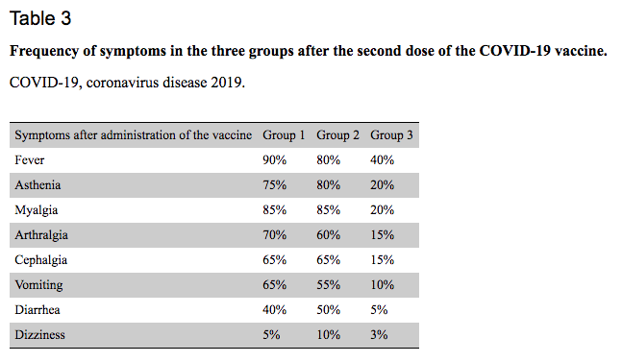
Recent Publications
1. Worldometer. COVID-19 coronavirus pandemic. [ Dec; 2021.
2. The long-term characteristics of immunity conferred by COVID-19 using antibody tests. Shoaib F, Ashraf M, Ghafoor H, Ahmad IN, Abbas G. Cureus. 2021;13:0.
3. Serological approaches for COVID-19: epidemiologic perspective on surveillance and control. Lee CY, Lin RT, Renia L, Ng LF. Front Immunol. 2020;11:879.
4. SARS antibody test for serosurveillance. Hsueh PR, Kao CL, Lee CN, et al. Emerg Infect Dis. 2004;10:1558–1562.
5. Asymptomatic SARS coronavirus infection among healthcare workers, Singapore. Wilder-Smith A, Teleman MD, Heng BH, Earnest A, Ling AE, Leo YS. Emerg Infect Dis. 2005;11:1142–1145.
6. Performance of the Abbott SARS-CoV-2 IgG II quantitative antibody assay including the new variants of concern, VOC 202012/V1 (United Kingdom) and VOC 202012/V2 (South Africa), and first steps towards global harmonization of COVID-19 antibody methods. English E, Cook LE, Piec I, Dervisevic S, Fraser WD, John WG. J Clin Microbiol. 2021;59:0.
7. Duration of antibody responses after severe acute respiratory syndrome. Wu LP, Wang NC, Chang YH, et al. Emerg Infect Dis. 2007;13:1562–1564.
8. T-cell response after first dose of BNT162b2 SARS-CoV-2 vaccine among healthcare workers with previous infection or cross-reactive immunity. Casado JL, Haemmerle J, Vizcarra P, et al. Clin Transl Immunology. 2021;10:0.
9. The role of antibody testing for SARS-CoV-2: is there one? Theel ES, Slev P, Wheeler S, Couturier MR, Wong SJ, Kadkhoda K. J Clin Microbiol. 2020;58:0–20.
10. Duration of serum neutralizing antibodies for SARS-CoV-2: lessons from SARS-CoV infection. Lin Q, Zhu L, Ni Z, Meng H, You L. J Microbiol Immunol Infect. 2020;53:821–822.

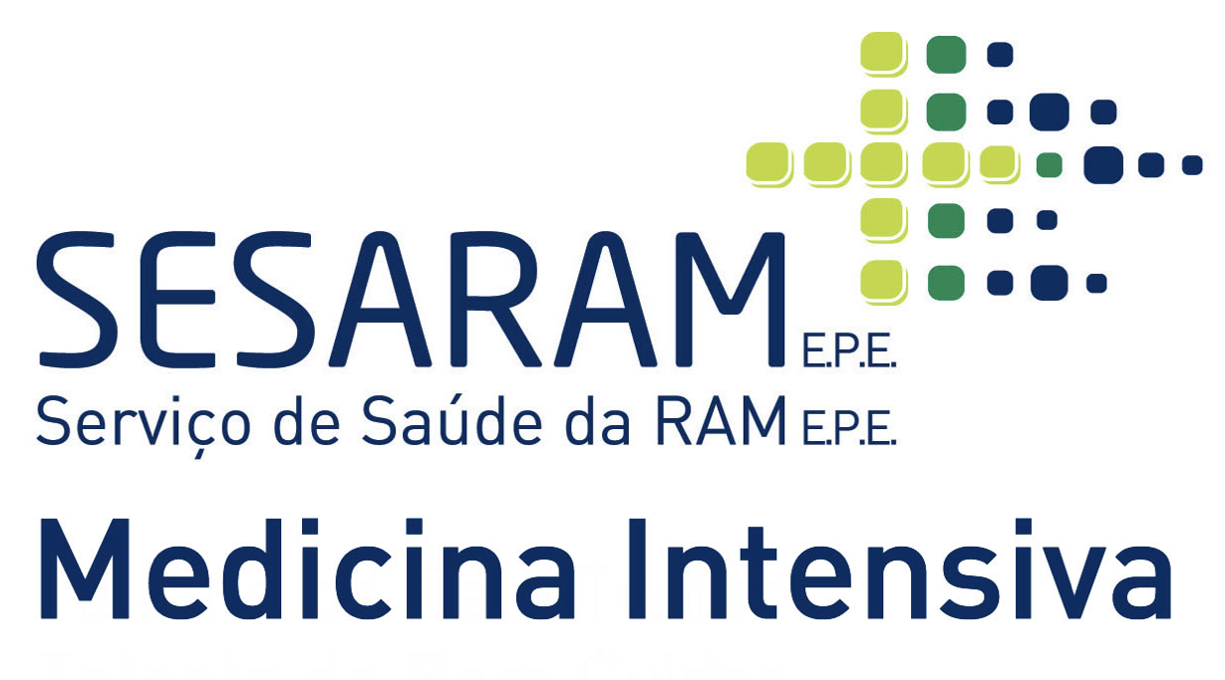

Biography

Cláudia Lemos is a forth-year intern with specific training in Intensive Care Medicine that has passion in vaccines research and clinical trials.
Email: claudial@campus.ul.pt

Notes/Comments:
Presenting author details
Full name: Cláudia Isabel Góis Lemos
Contact number: +351924168684
Session name/ number:
Category: (Oral presentation/ Poster presentation)

