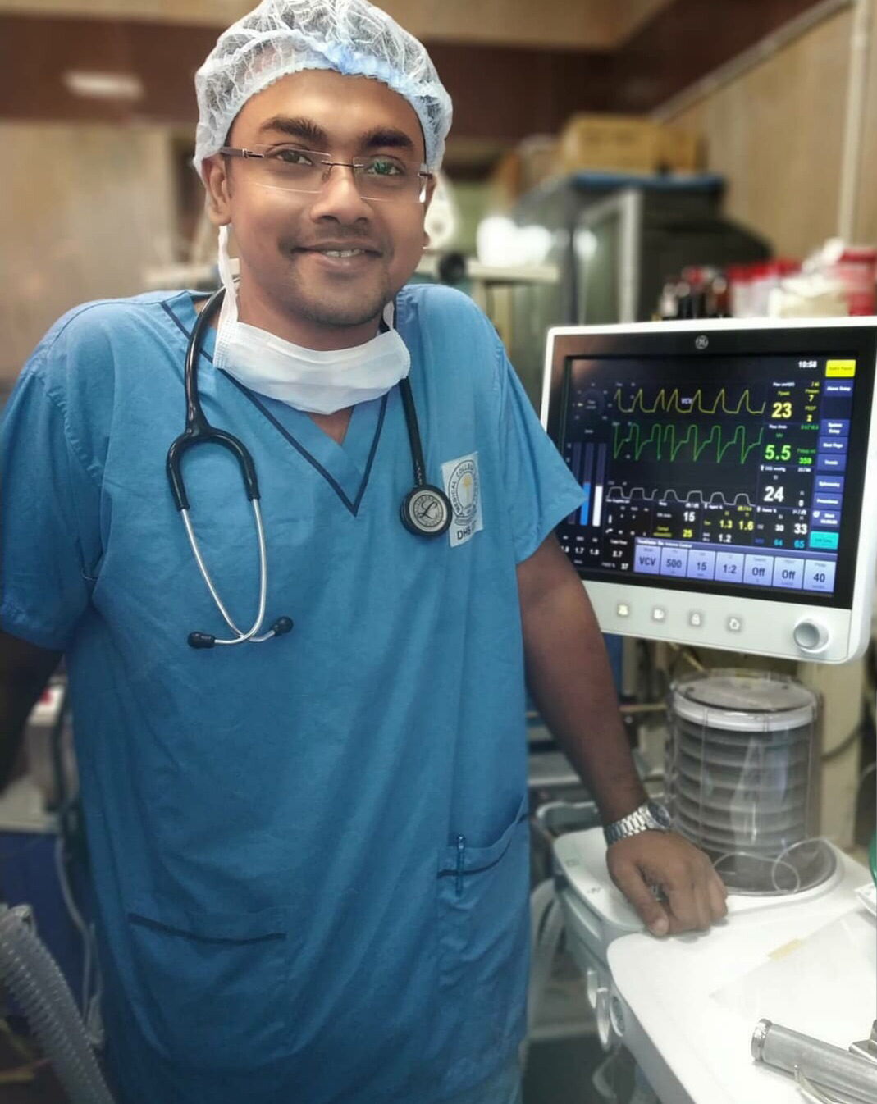
Title: “PROPHYLAXIS AGAINST REPERFUSION-INDUCED
VENTRICULAR FIBRILLATION: A COMPARATIVE STUDY
BETWEEN AMIODARONE, LIGNOCAINE AND MAGNESIUM
SULPHATE”
Name: Souvic Sarkar
Medical College,Kolkata,West Bengal,India
Reperfusion-induced ventricular fibrillation after aortic cross clamp is one of the important complications of open heart surgery. This study aimed toevaluate the efficacy of Amiodarone, Lignocaine and Magnesium sulphate by the way of pump circuit 3-5 minutes before ACC release and observe the haemodynamic alterations in intra-op and post op period and compare the results in randomised controlled trial.A total of 150 patients undergoing elective open heart surgeries under CPB was evaluated after dividing into 3 groups consisting of 50 patients in each group. Aortic cross clamp time,occurrence of VF,HR,ABP,CVP,Post operative arrhythmias will be analysed with statistical tests.There were statistically significant data which depicted that after 10 mins of releasing ACC the occurrence and persistence of irregular cardiac rhythm was much lower in Group A who received amiodarone 24%(12) than Group L who received lignocaine 44%(22) and than Group M who received magnesium sulphate 54%(27).The assiociation of rhythm at 10 mins interval vs group was statically significant(p value 0.0036).The occurrence of post operative arrhythmia was also lower in the study population of amiodarone(12%) than lignocaine(16%) and magnesium sulphate(24%).
Amiodarone also had a significant role in preventing cardiac arrhythmias in post-operative period. Though internal defibrillation is still considered as the standard technique for treating reperfusion induced cardiac arrhythmias but pharmacological agents like amiodarone when used prophylactically
before releasing acc can decrease the incidence of cardiac arrhythmia in the immediate intra-op and even post-op period and reduces the morbidity and mortality of patients undergoing cardiac surgeries.

Biography:
Dr.Souvic Sarkar completed his M.B.B.S from Medical College Kolkata,and doing MD in Anaesthesiology in Medical College Kolkata.He has presented cases and paper in national and state conferences.He has been co-author in an article published in Indian Annual Update of Anaesthesia 2019.

Presenting author details
Full name: Souvic Sarkar
Contact number:9748949267
Twitter account: @souvicthedoc
Linked In account:
Session name/ number: Cardiac Anaesthesia
Category:Oral presentation

