A Threatened Rupture Of Extracranial Right Internal Carotid Artery Mycotic Aneurysm- Successfully Managed With An Autologous Reverse Saphenous Vein Graft
Sriharsha B, Ajay Savlania, Sandeep M, Krishna Ramavath
Department of General Surgery
PGIMER, Chandigarh
INTRODUCTION: Mycotic aneurysm, (microbial arteritis with aneurysm) is an infectious break in the wall of an artery with formation of a blind, saccular out-pouching that is contiguous with the arterial lumen. Approximately 1% of all aneurysms are associated with an arterial infection. Arterial trauma leading to direct inoculation of the arterial wall has become an increasingly common mechanism by which an infected aneurysm develops. Once the artery is infected, rapid, focal progressive deterioration occurs, which results in the characteristic saccular or multilobulated appearance leading to formation of a false aneurysm which may rupture. If untreated, infected aneurysms typically lead to sepsis and can certainly rupture, causing life threatening haemorrhage. In the present case, patient had pulsatile swelling in the right side of neck with signs of impending rupture which was successfully managed with autologous reverse saphenous vein graft.
METHODS: We describe a case of mycotic aneurysm of the Right Internal Carotid Artery which was successfully managed by Common Carotid Artery to Internal Carotid Artery (CCA-ICA) reverse saphenous vein grafting following Aneurysmorrhaphy.
A 50year old male patient, a known diabetic and hypertensive on irregular medication with past history of left sided hemiparesis presented to surgical emergency with fever and painful pulsatile swelling on the right side of neck giving recent history of needle aspiration of the swelling. On examining, a firm tender pulsatile swelling was seen at the angle of right jaw with ecchymosis. Further investigations revealed elevated Total Leucocyte Count (27000/mm3), Computed Tomography angiogram showed saccular outpouching in posterior aspect of right ICA with surrounding multiple air foci and Computed Tomography head showing lacunar infarcts in corpus striatum on right side. Transthoracic echocardiography was normal. Patient was started on broad spectrum antibiotics and operated at the earliest. He underwent aneurysmorrhaphy along with right external carotid artery ligation followed by right CCA to ICA reverse saphenous vein autologous graft.
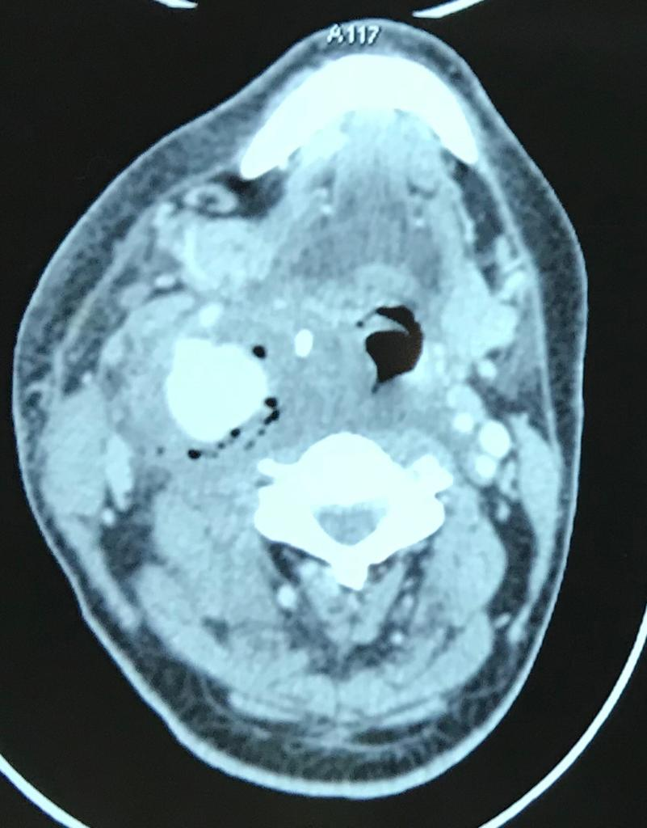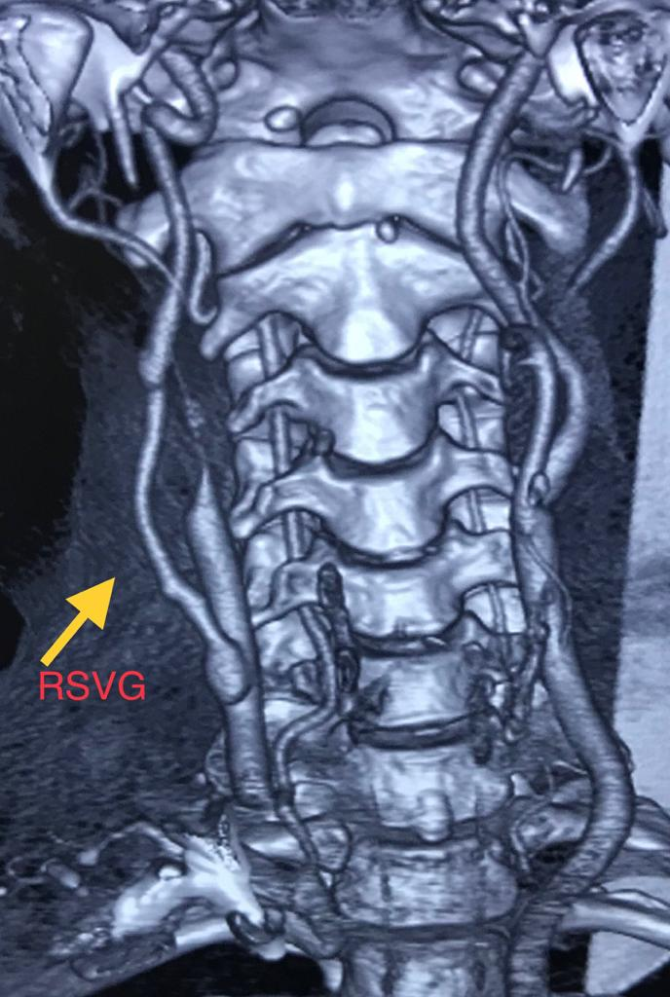
Pre-op CT showing saccular aneurysm in Right ICA Follow up CT showing Autologous Reverse
with surrounding multiple air foci Saphenous Vein Graft (RSVG)
RESULT: One month after surgery, patient is doing fine with no neurovascular deficits. Follow up CT angiogram showed graft is patent with intact repair of aneurysm and good distal outflow in ICA.
CONCLUSION: Untreated mycotic aneurysms pose threat to life. Early diagnosis and proper surgical treatment play a vital role in the management. Pre op and post op broad spectrum antibiotics until organism-specific antibiotic therapy should be instituted. Operative control of sepsis should be performed with excision of infected aneurysmal wall and surrounding tissues, judiciously, avoiding injury to underlying tissues, nerves and internal jugular vein. Revascularization should be performed preferably using autogenous conduit, if available, yielding good results.

