Balancing the immunity: Approach to prevent lung and retina injury in preterm infants.
Suchismita Acharya, PhD, AyuVis Research Inc, USA

Abstract (300 word limit)
Statement of the Problem: Secondary to preterm birth, Bronchopulmonary Dysplasia (BPD) is the most common chronic respiratory disease in infants that disrupts the developmental program of the lung. BPD occurs due to an interaction between genetic and environmental factors (hyperoxia, invasive mechanical ventilation and sepsis). The pathologic hallmarks of BPD are pulmonary inflammation and increased cell death leading to impaired alveolarization and dysregulated vascularization. This can result in fibrosis, asymmetric aeration, and respiratory insufficiency. Hyperoxia also induces vasoconstriction in the retina of the premature infants as an early response to oxygen leading to vasoobliteration, neovascularization, and retinopathy of prematurity (ROP). To date, there are no effective drugs available to treat these conditions. AyuVis Research has developed nanoencapsulated formulation of novel small molecules that have demonstrated promising results in developmentally-appropriate mouse models of BPD and ROP. Methodology: In BPD mice model, newborn pups (P0-saccular stage of lung development) were exposed to severe (100%) hyperoxia for 4 consecutive days (PN4- alveolar stage of lung development) followed by recovery in room air (RA) for the next days till P14. On PN2 and PN4, the test compound was administered intranasally at a dose of 20uM. On PN14, the pups were euthanized to collect the bronchoalveolar lavage (BAL), lungs, heart and serum for morphometry, flow cytometry, biochemical and physiological assays. In ROP mouse model, the PN7 pups were exposed to 75% oxygen for 10 days with or without test compounds via topical eye drops. On PN17, eyes were collected and retina was analyzed for angiogenesis markers. Conclusion & Significance- The small immunomodulatory compounds significantly decreased lung inflammation and lung dysfunction. Decrease in leaky blood vessels and angiogenesis was observed in treated eyes. The result demonstrated preventive and therapeutic potential of the compounds for these rare pediatric conditions.
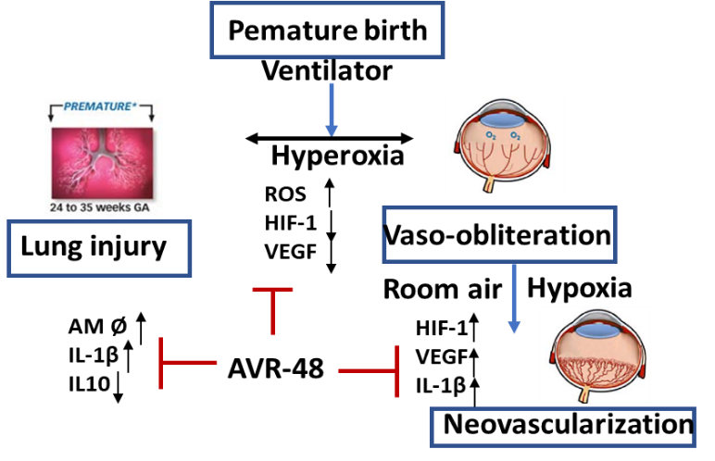
Recent Publications (minimum 5)
- Acharya S, Rogers P,Krishnamoorthy R, Stankowska DL, Rasika Dias R and Yorio T, Design and Synthesis of Novel Hybrid Sydnonimine and Prodrug Useful for Glaucomatous Optic Neuropathy, Bioorg Med Chem Lett. 2016, 26, 1490-1494.
- Le DQ, Kuriakose AE, Nguyen DX, Nguyen KT, Acharya S. Hybrid Nitric Oxide Donor and its Carrier for the Treatment of Peripheral Arterial Diseases. Sci Rep. 2017 Aug 18;7(1):8692.
- Acharya S, Panda SK, Das, Agarwal B. Novel compositions and therapeutics methods. US15/473,904, 2017, PCT/US17/24908.

 Biography (150 word limit)
Suchismita Acharya, PhD is a pharmaceutical scientist and entrepreneur. She has more than 15 years of drug discovery and development experience in large and start-up pharmaceuticals as drug discovery researcher and project leader. She is founder of AyuVis Research that actively developing small immunomodulating molecules for orphan and rare diseases. Her unique approach to drug discovery includes hybrid molecule design to target multifactorial pathobiology of the diseases and modification of naturally derived small molecules to achieve optimum safety profile. She has published several research publications, book chapters and patents and recipient of NIH federal funding. She also holds faculty position in University of North Texas Health Science Center, USA and enjoys teaching medical biochemistry and drug discovery courses.
Email: sacharya@ayuvis.com

Notes/Comments:

